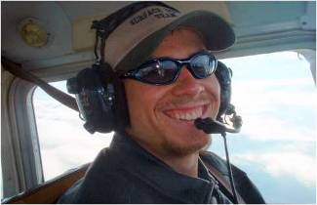
December 16, 2005

Hi Everyone!
These last few days have been some of the most costly and rewarding days of my whole life! But before I tell you why, I think I’ll give you some of the highlights of these last few months so you can see the big picture. As many of you know, I have been in Maine since early July, where I was taking flight lessons and spending some time with some good friends of mine, the Fernalds. Although the flight training was intense at times, it was very rewarding to invest in this knowledge and skill that will deeply affect the rest of my life.
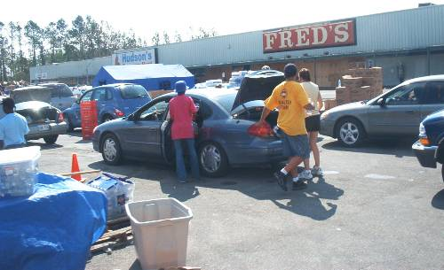
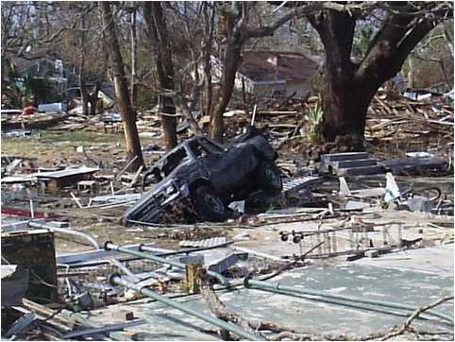
While in Maine, I watched with the rest of the country as Hurricane Katrina hit the Gulf Coast. Every fiber in me wanted to be there to help, rescue, and share. Shortly afterward I heard of a small church group which would be going down for a few days. That’s all it took - I was on my way! Although the three day bus ride was rather tiring, on impact our team was hard at work in the disaster zone and on the food and distribution lines, loading and unloading semi trailers, demolishing hazardous buildings, rebuilding and repairing others, and then my department, lots and lots of chain-saw work. After three or four days of work the rest of the group began packing up to go home. They said they didn’t have time to stay longer! Well, I just couldn’t go so soon after getting there, so I moved into a guest room at Bass Memorial Academy in Mississippi and continued working for the next 2½ weeks until more help arrived. It was a rewarding experience I will never forget.
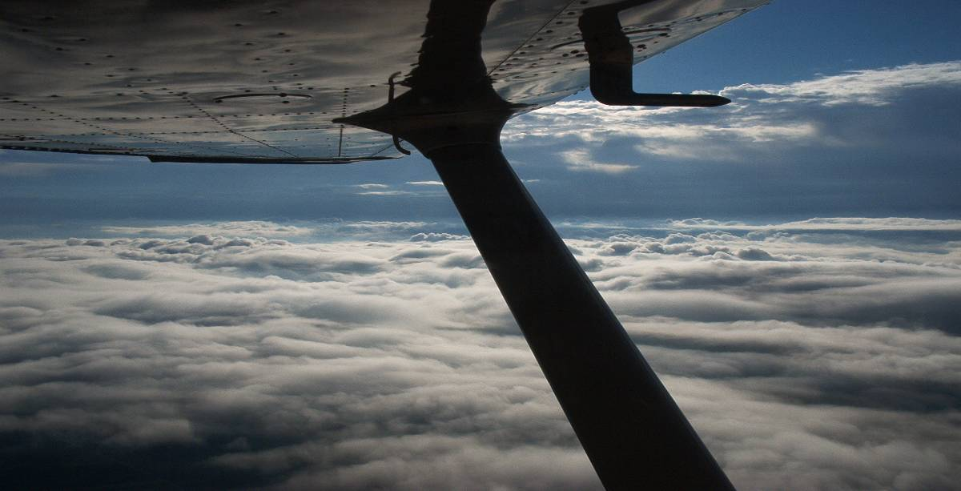
Back in Maine I was happy to find that my flying skills were still sharp. However, after reviewing my financial situation, I found that there was not going to be enough for me to finish my flight training, even though I was using ALL of my graduation money, everything I’d earned working, as well as some other donations given for that purpose. The fact that I had missed three weeks of work didn’t help the situation either. After some prayer and thought I felt impressed to continue training until my funds were completely depleted.
After several weeks of training and working had gone by, I began to feel a little down and discouraged, because the money just wasn’t there. It was at this time that my eighth grade teacher, Mrs. Mason, invited me to come and visit her with all expenses paid in the north-eastern part of Nova Scotia, Canada for a weekend and give “A mission talk” for her church. Imagine my surprise when she announced several days before I went, “O and by the way, I have two churches lined up who would like you to have the main service for them”! Here I was just getting to the point where I was comfortably miserable, and now I was supposed to give two sermons within a few days! It was just what I needed though, because it helped me see all the ways God had blessed me, and wanted me to share with those friendly little churches. Both events went far better than I had expected, and I left having a new group of friends whom I hope to see again someday.

Although my visit to Canada was a breath of fresh air, it still didn’t solve my dilemma, because time and money were running out - and fast! A few more weeks passed and it felt like things just couldn’t work. There wasn’t enough money, and even if there was, the weather was turning nasty to the point where I had to struggle to fly even once a week. Maine is COLD in the late fall! On top of this, some of the information I was trying to learn just didn’t make sense - try as I might I just couldn’t get it.
Everything came to a climax one afternoon when I was sitting in my corner of the quiet little airport and unsuccessfully trying to study. It was then that the airport manager, my flight instructor and I had an informal meeting about the week ahead. This was the point of decision. I had just over a week left before my departure date for California, and I was still short of money, even after cashing in my treasured coin collection. I had to make the “Go, no go” decision. Go, I could go for it and trust that the money would come in. No go, I could stay on the ground and complete my flight training elsewhere when I had the funds.
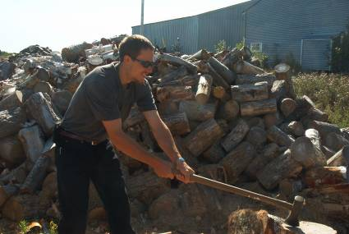
After the meeting I went out to split some wood and think through the decision which had to be made. “Lord” I prayed. “I know you sent me here to learn and prepare for life as a mission pilot, but things just aren’t working. You know I am out of money, and Lord, I need at least another $900 before I can finish.” I thought of all the stories I had heard about the ways in which God has provided for others. “Lord, You provided for their needs. Why haven’t You provided for mine?” I continued brainstorming. What do I have of any monetary worth? “Well Lord, I have a nice desktop computer I can sell. Um, I think I have a few hundred dollars in a CD savings account started by my great-grandmother when I was a baby to use only for emergencies. And then I have my laptop, but I need it for my flight training DVD’s.” Then it was as if the Lord was saying, “Are you willing to give up these last few things so you can finish your training and serve Me?”
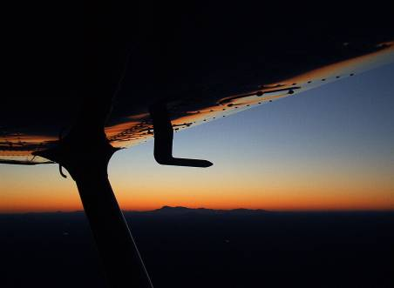
I left from splitting wood with a plan of action. I would sell my desktop and borrow from my emergency money, and then continue to pray the rest would show up. The next day wasn’t the best for flying but I was able to fly several hours anyway – hours of flying which I didn’t have money for. That evening as I was thinking and trying to relax in front of the nice warm fireplace, I got a phone call from my dad. “An unexpected check came for you in today’s mail from some friends, and it’s says $1,000 dollars on it!” Needless to say I was stunned! I just kept exclaiming, “Oh wow! Oh wow!” This was a direct answer to prayer! After returning God’s tithe, I was left with the exact $900 I had prayed for!
The next few days were a blur of training and flying. Before I knew it my time in Maine was up and it was the very last day. I took and passed my written test, then a few hours later I passed my check ride just as the sun went down. So now I am proud to announce that I am a Licensed Private Pilot!

I couldn’t have finished any later because I had to leave at 5:00 the next morning to catch my commercial flight back home to California! For me it was the perfect end to my time in Maine.
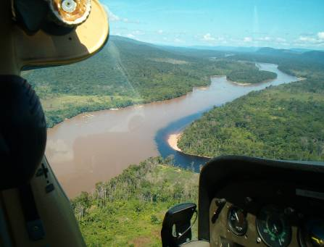

My current plans include visiting relatives here in California for a few days, going to the General Youth Conference (GYC) in Chattanooga December 28 to January 1, returning home for a couple weeks, then heading to Venezuela on January 22, where I will continue my training in the jungle as well as helping wherever needed (for more information, go to www.adamsamigos.net ). As with my flight training, I am moving forward in faith, working as much as I can, trusting God to provide for my needs and praying that I will be able to go. Though I will need hundreds more flight hours before I can become a jungle pilot, my time in Venezuela will give me experience in mission aviation as I work with pilot Bob Norton, participate in Union College’s International Relief and Rescue program, and help wherever I’m needed. After 6 months or so, I should have a pretty good idea of what areas I need further training, along with advancing my flight training, so that eventually I can return to the mission field to serve on a more permanent basis, as God leads.
I look forward to hearing from each one of you, and pray that this experience will help you trust Him more.

In His service,



Daniel Adams

P.S. – My e-mail address is theweimartian@yahoo.com. For monthly e-mail updates about my upcoming activities and adventures, contact my parents at fdadams@directcon.net.

Tax-deductible receipts are available for those who wish to partner with me while I'm serving in South America. Donations should be made out to:  Gospel Ministries International  P.O. Box 662  Hermitage, TN 37076  Include a separate note specifying "Adams Venezuela (Norton) fund." Please do not write my name on the check. | If you do not need a receipt, you may send your contributions to:  Fred Adams  3060 Lawyer Dr.  Placerville, CA 95667  Questions? Call 530-642-9441

