Vegan Cooking Class Recipes Session 15 (August 2013)
Summertime Garden Foods

- Drying Your Own Tomatoes (page 1)
- Cashew Ricotta Cheese (page 1)
- Garden Polenta Pie (page 2)
- Vegan Chicken Seasoning (page 3)
- Fake Feta Cheese (page 3)
- Greek Pilaf (page4)
- Perfect Baked Brown Rice (page 4)
- Mediterranean Style Stuffed Eggplant (page 4)
- Vegan Peach Crisp (page 5)
- Creamy Delicious Vegan Vanilla Coconut Ice Cream (page 5)

Drying Your Own Tomatoes
- Bring a large pot 2/3 full of water to a boil. Place several tomatoes at a time in the water. Leave for about 15 seconds and then take out of boiling water and place in another bowl. Continue until all the tomatoes you wish to dry have been scalded.
- Next, with a paring knife, cut out the center and then slip off the skin of each tomato. It should come off quite quickly and easily. Slice in rounds about 1/3 inch to ½ inch thick. Try to make all the tomato slices the same thickness so that they all finish drying at the same time.
- Arrange the slices on the trays of your dehydrator. Stack the trays and place the lid on top. Set the temperature to about 135° F. Turn on and let run for about 15 hours. Check after 12 hours if this is your first time. Dehydrators may vary in drying speeds. The tomatoes should be thin and leathery when they are done. They will still be soft, but will stiffen as they cool. Peel off the trays before they are all the way cool. Otherwise, they will be brittle and will snap into pieces as you pull them off.
- After they are completely cool, place in freezer zip lock bags or other airtight containers. Will stay fresher over long periods (years) of time in the fridge or freezer, but can also be stored at room temperature, especially if you use them up within a year.
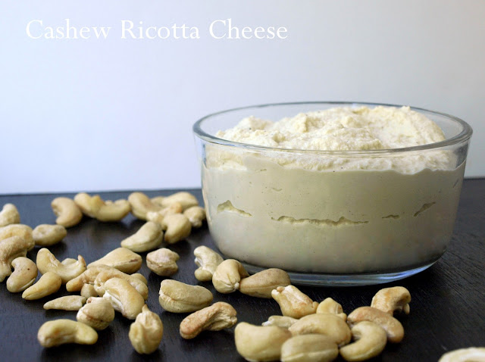
Cashew Ricotta Cheese
1½ c. raw cashews, soaked
½ c. water, or omit water if cashews are soaked a long time
Juice of 1 large lemon
1 Tbsp. nutritional yeast
1 garlic clove
½ tsp. onion powder
Sea salt to taste
- Wash and then soak the cashews for at least two hours in a bowl of water, covering the cashews with about an inch of water as they will puff up a bit.
- Drain cashews and place all remaining ingredients into a blender or food processor, blend scraping down sides as needed until creamy. Taste for flavors adding any additional ingredients. Some like a salty ricotta so feel free to add as much salt as you want.
- Store in refrigerator in an air tight container for an hour or two; this will stiffen the mixture a bit. You can also just prepare your dish with it straight away without refrigeration if needed.
Makes approximately 2 cups. Stores in refrigerator for up to a week.
Adapted from www.thesimpleveganista.blogspot.com/2012/10/cashew-ricotta-cheese.html
Garden Polenta Pie
You might want to make the Vegan Ricotta and Polenta ahead of time. Not so much to do in one “chunk” that way. Be sure to spread the polenta into your baking dish while it is still hot (see step #1), although it should still taste great even if you spread it in later. It just won’t hold together so well like a “piecrust” when you serve it out.

Polenta meal to make 1½ cups cooked polenta. Look for organic, non-gmo such as “De La Estancia” brand (I saw some at Raley’s; also available online at Amazon.com). Add vegan Chicken style seasoning to the water to make a broth before boiling and adding the polenta meal. Cook according to the directions (this varies depending on what brand of polenta you use.)

About ½ c. dried tomatoes, soaked in hot water to soften, cut into small pieces
1 large eggplant or equivalent. Remember to select young, shiny eggplant for best flavor.
2 medium zucchinis (can also use other summer squash such as yellow crookneck, etc.)
1 small head garlic – for baking
Oil spray for high heat such as avocado
1/8 cup of Kalamata or green olives, sliced
2 sprigs of fresh basil, chopped
1 can (4 oz.) mushroom slices
1 pack of frozen chopped spinach, thawed
1 tsp. of Italian Seasoning
Salt to taste – about ½ tsp.
1 Tbsp. olive oil (optional)
1/3 c. or so of Vegan Ricotta (see recipe – easy and good!)

- Premake the polenta following directions and while it's still hot, pour into a shallow Pyrex pie dish or 8x8 casserole dish. Set aside to cool. (It's good to have the polenta already made. It's easy to make in the morning, then just let it sit out, covered until ready to use.)
- Preheat oven to 400° F.
- Scatter sliced eggplant and zucchini (1/3” slices) in a single layer onto one or two cookie sheets that have been covered with parchment paper. Set the head of garlic on the cookie sheet. Lightly salt and oil spray tops of all the veggies with a high smoking point oil such as avocado. Then cover with parchment paper and aluminum foil. Bake at 400° F. for about 35 minutes. When tender, take off the paper and foil and bake for about another 15 - 20 minutes to evaporate some of the moisture and brown a bit. Set aside to cool. Note: Spraying with oil is optional. So is the salt. However, if the eggplant is on the mature side (has many dark seeds) you can salt the slices and let sit for about an hour. Then rinse and pat dry before baking. This is supposed to draw out any bitterness. If you are working with young eggplant (seeds are still white) this shouldn’t be a problem.
- When you can handle the garlic, pick off 4 cloves. (Save the rest for another recipe.) Drain the thawed spinach and place in a bowl. Squeeze out the garlic cloves into the spinach and discard the peelings. Squeeze the liquid from the canned mushrooms and add to the spinach mixture. Add the Italian Seasoning and some salt if desired and about 1 Tbsp. of olive oil (optional). Mix well and set aside.
- Note: Another option is to use fresh mushrooms and spinach. This adds a little more work, but is worth the effort! If you do, this is how to prepare them for the polenta pie: Optional #3 if using fresh mushrooms and spinach: Dry sauté the mushrooms on low heat, only using a small amount of water at first until its own juices begin to sizzle. Add the chopped spinach leaves and continue to stir fry until the leaves shrink down but are still a bright green. You can add a small amount of water if it is too dry. Turn off the heat and add the baked garlic. Squeeze the garlic cloves out of their casings. You may need to make a little slit. The garlic will come out somewhat like frosting out of an icing bag. Season with Italian herbs and salt if desired, and the olive oil and mix in well. Set aside.
Have dried tomatoes, basil and olives close by.
Putting it all together:
- Spread the dried, minced tomatoes on top of the polenta.
- Scatter the roasted vegetables, then the basil and olives, then the mushrooms and spinach.
- Nestle little spoonfuls of the ricotta in the folds of the spinach and mushroom top layer.
- Bake at 300° degrees until the topping is slightly bubbly – about 45 minutes. Serves 4 – 6.
Recipe adapted from Polenta Pie with Vegan Ricotta, Sun Dried Tomato Pesto and Roasted Vegetables by MADDY_AVENA at www.recipes.sparkpeople.com/recipe-detail.asp?recipe=702584

Vegan Chicken Style Seasoning
Here’s another version to add to your collection. This one is a little spicy, but very good!
2 c. nutritional yeast flakes
1/3 c. onion powder
1/3 c. salt
¼ c. Italian seasoning (no salt added)
1/6 c. dried parsley
1/8 c. Sucanat or cane juice crystals
1½ Tbsp. garlic powder
¾ tsp. celery seed
3/8 tsp. cayenne pepper
- Blend all ingredients in a blender until very fine.
- Store in an airtight container.
- To make broth, add 1 Tbsp. of Chicken Style Seasoning mix to 1 cup of water.
From “Give Them Something Better” by Sarah Frain & Stephanie Howard

Fake Feta Cheese
1 package water-packed tofu, firm or extra-firm
½ c. lemon juice
¼ c. water
2 Tbsp. olive oil
1 Tbsp. dried basil
2 tsp. salt
1 tsp. onion powder
½ tsp. garlic powder

- Rinse and drain the tofu. Place in a clean dish towel between two plates and place something heavy on top to help press out the water from the tofu. Leave it for about an hour or so. You want the tofu to be as dry as possible when making Fake Feta.
- Whisk the remaining ingredients together in a bowl.
- Add the tofu to the bowl, crumbling it up as you put it in to resemble feta cheese. Mix everything and refrigerate it for at least an hour. Overnight would be even better.
Makes about 2 cups.
Taken from “Give Them Something Better” by Sarah Frain and Stephanie Howard
Greek Pilaf
1 c. raw brown rice (long or short grain)
1 to 2 Tbsp. olive oil
1½ c. minced onion
1 small stalk celery, minced
½ t. salt
½ c. lightly toasted sunflower seeds or pine nuts
4 to 5 medium cloves garlic, minced
2 Tbsp. lemon juice
¼ c. freshly minced parsley (flat-leafed tastes the best!)
1 Tbsp. dried mint or 3 Tbsp. fresh, minced
- Cook up the rice. Use the Perfect Rice recipe method OR use a rice cooker. Make sure it has a setting for brown rice. Toast the rice lightly first in a dry skillet and then follow the directions for your particular cooker. You might want to use ½ again as much water as it calls for. For example, Susan’s cooker directions say to fill with water to the #5 mark. She fills it to #8 and it turns out great (7½ might work too). Try different amounts of water in yours and see which you like the best. They will all be good – so don’t worry about messing it up. The reason for adding more water is so that the starches are fully hydrated and cooked and better for you.
- Meanwhile in a skillet, sauté the onions and celery until clear. Then add the garlic and seeds/nuts and salt and sauté for another minute or so. Stir the sautéed mixture into the cooked rice along with the lemon juice and herbs and olive oil. Mix well.
Note: If you don’t enjoy the flavor of olive oil, you can substitute one you like or omit it entirely.
This is excellent used as a stuffing along with the Fake Feta for stuffed eggplant, stuffed zucchini, or whatever else you want to stuff!
By Mollie Katzen in “The New Moosewood Cookbook”

Perfect Baked Brown Rice (You can also use barley, millet etc.)
Ratio = 1 cup rice to 3½ cups water and 1 teaspoon of salt.
Yield = 3½ cups of perfect rice
- First dextrinize the grain to break down starch by putting it in a skillet over medium high heat, stir frequently until light brown; do this over dry heat, add no water.
- Then mix dextrinized grain with boiling water, add salt and bake covered for 90 minutes at 350 degrees.
- Bake in an oven type casserole pan with cover like Pyrex or Corning Ware.
This turns out perfect every single time!
By Susan Moskalets

Mediterranean Style Stuffed Eggplant
- Preheat oven to 375° F.
- Slice an eggplant in two lengthwise and place face down on a cooking sheet lined with parchment paper. Bake for about 30 minutes or until soft and sagging.
- Scoop out the eggplant with a spoon, being careful to keep the skins in one piece, and chop up the insides.
- Mix the chopped eggplant into some Greek Pilaf and some Fake Feta. Use this to fill the eggplant shells and then top with tomato slices.
- Bake at 350° F until heated through (about 30 minutes).
By Mollie Katzen in “The New Moosewood Cookbook”

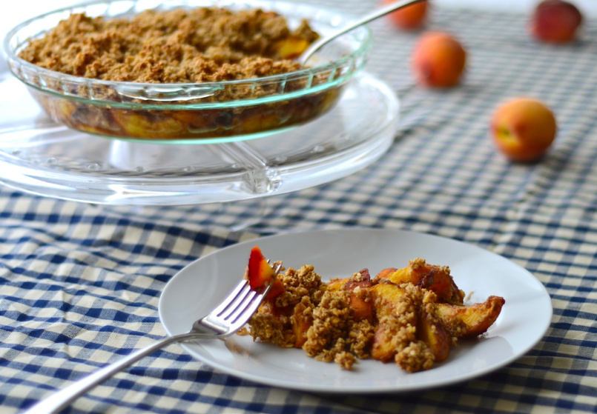

Vegan Peach Crisp
Topping:
¾ cup rolled oats
1 Tbsp. oil
½ cup pecans or walnuts
2½ Tbsp. maple syrup
¼ tsp. salt
Filling:
2 Tbsp. ground flax
1 tsp. cinnamon (Ceylon is best)
2 – 3 Tbsp. maple syrup
8 peaches (sliced)

- In a large bowl toss all the filling ingredients together.
- In the food processor, add all the topping ingredients.
- Process in the food processor until the mixture begins to stick together and the nuts are well chopped.
- Add the filling to a 9 inch pie plate.
- Top evenly with the topping.
- Bake at 350° for 30 minutes, or until the top is crunchy and golden.
- Serve!!
Adapted from a recipe at www.girlmakesfood.com/vegan-peach-crisp

Creamy Delicious Vegan Vanilla Coconut Ice Cream
We use a Cuisinart Frozen Dessert Maker which uses a pre-frozen bowl instead of ice.

In a blender combine the following until creamy:
1 can coconut milk (14 fl. oz. each)
1 can non-dairy milk (use the empty coconut milk can to measure)
½ c. mild honey (clover or orange is good)
2 tsp. vanilla (powdered white vanilla if you have it)
¼ tsp. salt

- Pre-freeze ice cream maker bowl for at least 12 hours.
- Place blender with mixture in refrigerator to chill.
- Pour into ice cream maker and turn it on. It should be ready in about 30 minutes.

Adapted from www.wholenewmom.com Vanilla Coconut Ice Cream

