Vegan Cooking Class Recipes Session 18 (November 2013)
Soups and Sandwiches

- Rice-Millet Batter Yeast Bread (page 1)
- Rice Pea Salad (page 2)
- Cashew Gravy (page 2)
- Vegan Chicken Style Seasoning (page 2)
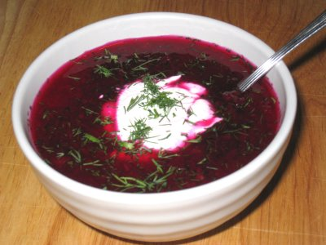
- Irresistible Creamy Vegetable Soup (page 3)
- Theresa’s Bread Recipe (page 3)
- Eggless Egg Salad (page 4)
- Mock Tuna Spread (page 4)
- Tofu Mayonnaise (page 4)
- No-Bean Hummus with Zucchini (page 5)
- Sweet Pea Hummus (page 5)
- Elizabeth’s Hot Carob Drink (page 5)
- Russian Borsch (page 6)
- Pumpkin Mochi (page 6)
Russian Borsch

Rice-Millet Batter Yeast Bread (Gluten-free)
2 Tbsp. flax seed mixed into
1½ c. water

1½ c. brown rice flour
1½ c. millet flour
1 Tbsp. psyllium seed husk powder
¼ c. arrowroot powder
1 tsp. salt

½ c. water
2 Tbsp. honey or other sweetener
½ Tbsp. active dry yeast
3 Tbsp. olive oil
- Boil flax seed in 1½ cups water for 10 minutes. Remove from heat and allow to cool completely.
- Meanwhile, measure rice flour, millet flour, arrowroot, psyllium powder, and salt into a mixing bowl and mix together.
- When flax mixture has cooled to lukewarm, pour it into a bowl large enough for using electric beaters. Add ½ cup of water, the honey, yeast, olive oil and 1 cup flour mixture and mix on low speed. Measure about ¾ cup of the flour mixture and set aside. Gradually add the rest of the flour mixture from the bowl. Beat at medium speed for 2 or 3 minutes, scraping sides of the bowl often with a spatula. Mix in the last ¾ cup of flour with a spoon.
- Cover bowl and place in a warm (85°) place to rise for 1 to 1½ hours, or until doubled in bulk. Stir down with a spoon for about one minute. Grease a bread pan, and fill with bread dough.
- Set in the oven which has been warmed slightly (about 85° F).
- In about 15 minutes, when the dough has risen to the top of the pan, turn the temperature up to 350°. Bake for 45-50 minutes until the bread is a nice golden brown.
- Take out of the pan immediately and cool on a rack.
Adapted from “The Complete Food Allergy Cookbook” by Marilyn Gioannini
Rice Pea Salad
3 c. cooked brown rice (cooled)
1 bag of frozen peas
1 c. whole-kernel corn
½ c. cilantro, chopped (optional)
1 large cucumber, chopped
½ c. red bell pepper, chopped
½ c. red onion, chopped
1 tsp. salt
1 tsp. cayenne

Mix everything together and add Vegenaise or homemade dressing to taste.
By Darla DeVargas

Cashew Gravy
½ c. raw cashew pieces
2 c. hot water (if you have boiled potatoes, use the potato water for this!)
2 Tbsp. McKay’s Chicken style seasoning (or something similar, to taste)
1 tsp. nutritional yeast flakes
2 tsp. Bakon smoked yeast
2 tsp. salt (optional)
Note: If you have homemade Vegan Chicken Style Seasoning (see recipe below), you can use 2 Tbsp. of that instead of the last 4 ingredients.

- Place all the ingredients except the water in the blender.
- Add 1 cup of the water, blend on slow, increasing to highest speed.
- Blend to creamy consistency, then add remaining water.
- Cook over low fire, stirring as needed until it reaches desired thickness.
By Diana Adams

Vegan Chicken Style Seasoning
2 c. nutritional yeast flakes
1/3 c. onion powder
1/3 c. salt
¼ c. Italian seasoning (no salt added)
1/6 c. dried parsley
1/8 c. Sucanat or cane juice crystals
1½ Tbsp. garlic powder
¾ tsp. celery seed
3/8 tsp. cayenne pepper, optional

- Blend all ingredients in a blender until very fine.
- Store in an airtight container.
- To make broth, add 1 Tbsp. of Chicken Style Seasoning mix to 1 cup of water.
Adapted from “Give Them Something Better” by Sarah Frain & Stephanie Howard

Irresistible Creamy Vegetable Soup
1 potato, peeled and cut into ½ inch cubes
Boil in enough water to cover until just tender – about 10 - 15 minutes.
Strain out the potato water to use in the Cashew Gravy if you haven’t made it yet.
You will need to use 1 whole recipe of Cashew Gravy.

Put the gravy in a saucepan on the stove. Add:
¼ tsp. onion powder
½ stalk of celery, diced
¾ c. mixed frozen vegetables (thawed will take less time cooking) or can use fresh, any mixture that you like.
1 clove fresh garlic, minced or put through a garlic press

- Heat to boiling. On low, stirring occasionally, to prevent burning.
- Add the cooked potatoes, lower the heat and continue to boil until vegetables are tender. (About 5 minutes, but depends on what kind of vegetables and what size chunks). Some vegetables (such as peas and corn) cook quickly enough that you can just add them to the boiling soup base and then take it off the heat immediately. Makes about 3 cups.
By Diana Adams

Theresa’s Bread Recipe
Makes one loaf
1 c. + 3 Tbsp. hot water (120°)
1 pkg. yeast
2 tsp. honey
1 tsp. salt
2 Tbsp. oil
1 c. whole wheat flour
2 c. unbleached flour

- Melt honey in hot water and stir in yeast. When yeast foams to the top, add salt and oil. Mix well.
- Add whole wheat and stir until dough becomes stringy.
- Slowly mix in 1½ c. of unbleached flour. Mix well.
- Add the last ½ c. of flour until the dough is no longer sticky. Knead for several minutes. The more you work the dough, the better the consistency. Cover with a cloth and let rise in warm place.
- After the dough has doubled in size, knead down and form into loaf.
- Place in greased bread pan, cover and let rise until it is just above the top of the pan.
- Bake in 350° oven for 30 minutes. It should be browned and have a hollow sound when thumped on the top.
- Remove from pan and allow to cool. Place in plastic bag and refrigerate.
By Theresa Clifton

Eggless Egg Salad
12.3 ounce package extra firm silken tofu
¼ c. Tofu Mayonnaise (see below)
¼ c. minced celery
¼ c. finely diced white onion
2 tsp. apple cider vinegar
½ tsp. turmeric
¼ tsp. onion powder
¼ tsp. garlic powder
¼ tsp. dill weed
¼ tsp. salt

- Place the tofu in a bowl and mash with a fork or bean masher until crumbled, but not smooth.
- Add remaining ingredients and mix well. Cover and chill at least 2 hours before serving.
By Heather McDougall from drmcdougall.com.

Mock Tuna Spread
15-ounce can garbanzo beans, drained and rinsed
1 stalk celery, finely chopped
¼ c. finely chopped onion
¼ c. finely chopped green onions
1 Tbsp. lemon juice
¼ c. Tofu Mayonnaise
Salt to taste

- Place the beans in a food processor and process until coarsely chopped, or mash with a bean masher. Don’t let them get to a smooth consistency.
- Place in a bowl and add remaining ingredients. Mix well.
- Add a bit more Tofu Mayo if you want a creamier spread.
- Add salt to taste. Chill to blend flavors.
Two tablespoons of pickle relish may be added to this spread to jazz it up.
By Heather McDougall from drmcdougall.com.

Tofu Mayonnaise
12.3 oz pkg. silken tofu
1½ Tbsp. lemon juice
1 tsp. sweetener
½ tsp. salt
¼ tsp. dry mustard
- Combine all ingredients in food processor and process until smooth.
- Cover and refrigerate. Will keep for up to 1 week.
By Heather McDougall from drmcdougall.com.

No-Bean Hummus with Zucchini
2 zucchini, peeled and chopped
¾ c. tahini
½ c. fresh lemon juice
¼ c. olive oil
4 cloves garlic, peeled
2 tsp. sea salt
½ Tbsp. ground cumin

Combine all of the ingredients in a blender and blend until thick and smooth.
By Jeanie Davis at www.amazinghealth.com.

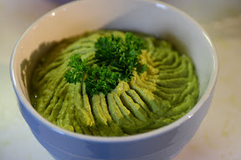
Sweet Pea Hummus
3 c. sweet peas
1 large avocado
6 cloves garlic
2 tsp. sea salt
¼ c. olive oil
½ c. lemon juice
2 Tbsp. ground cumin

Combine all of the ingredients in a blender and blend until thick and smooth. Delicious eaten as is, or enjoy as a dip with fresh veggies, a spread in sandwiches, or on salad.
By Jeanie Davis at www.amazinghealth.com.

Elizabeth’s Hot Carob Drink
1 Qt. soymilk (the kind that is sold as a liquid is best – not the powdered)
¼ c. roasted carob powder
2½ Tbsp. Dandy Blend powder
3 Tbsp. honey
¾ tsp. vanilla
1/8 tsp. salt

Mix all together and warm in a pan on the stove. Be careful not to let it scorch on the bottom.
By Elizabeth Hovanski

Russian Borsch (also Borscht, Bortsch, Borstch, Borsh, Borshch)
- In a large frying pan put 2 large onions, chopped, plus 2 Tbsp. garlic. Use 1 tsp. olive oil and a little water, or omit oil and use only water to fry. Fry onion & garlic covered until half soft, then uncover and fry (adding water as needed to keep from scorching). About 10-12 minutes till nice & light brown.
- While doing this, peel and grate 1 very large beet or 3 small or 2 medium beets, 2 large carrots and 1 big parsnip. Chop finely all beet tops and stems, add 1 can diced tomatoes, 6 cups water, 2 Tbsp. Sea salt, 2 Tbsp. organic cane sugar, 1 Tbsp. parsley flakes and 1 bay leaf (optional).
- Bring to a boil, cover and reduce to a simmer for 40 minutes.
- While cooking beet mixture, add to a large stock pot 5 Qts. water and heat to boiling. Chop very long and thinly a large cabbage and peel 2 large or 4 medium potatoes. When boiling, add 3 Tbsp. McKay’s Beef Style Seasoning or Dr. Bronner’s Instant Protein seasoning and add all cabbage. Boil partially covered for 5 minutes as you chop potatoes into 1” squares. Add potatoes and boil (turn heat down a little) till potatoes are firm/soft, about 20 minutes.
- Dump in beet mixture from first pot and add a second can of diced tomatoes (dice very finely), 2 cans of cooked, rinsed kidney beans and about 2 Tbsp. fresh finely chopped dill or ½ Tbsp. dried dill, 1/8 tsp. liquid hickory smoke (optional) and 3 Tbsp. Bakon Flavor Bits (optional). Add salt to taste (about 1 extra Tbsp.). Yum!
- Serve hot with a dollop of vegan sour cream and whole grain bread.
The flavor is even better by the second day! Serves 60.
By Susan Moskalets

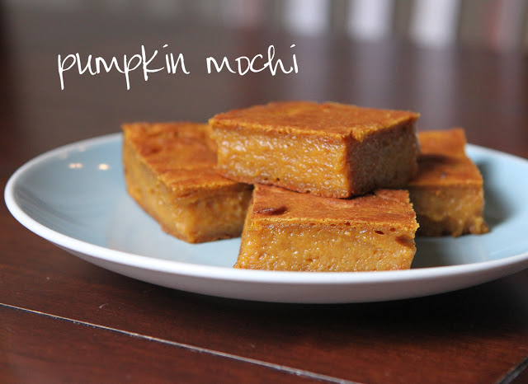
Pumpkin Mochi
1½ c. brown sweet rice flour
2 tsp. cinnamon (Ceylon is best)
1 c. coconut sugar
2 Tbsp. cornstarch
1 heaping Tbsp. Dandy Blend or other coffee substitute powder

1 15 oz. can pumpkin puree
½ can (13.5 oz. size) coconut milk
1/3 c. melted margarine
1 tsp. vanilla extract

- Preheat oven to 400° and oil an 8” x 8” in pan.
- In a medium bowl, stir through a strainer and mix the rice flour, coconut sugar, cornstarch, cinnamon and Dandy Blend.
- In another bowl place the pumpkin, coconut milk, margarine and vanilla. Blend until smooth with eggbeaters. Into this add the bowl of dry ingredients and mix with a spoon until moistened. Then beat on high with egg beaters and scraping the sides with a rubber spatula until all the ingredients are well mixed and smooth.
- Pour into prepared pan.
- Bake at 400° for 15 minutes. Then turn down the heat to 350° and bake another 45 minutes.
- Remove from oven cool completely before cutting. Store in refrigerator.
Adapted from: http://chasingsomebluesky.blogspot.com/2011/11/pumpkin-mochi.html.

