Vegan Cooking Class Recipes Session 19 (December 2013)
Holiday Foods

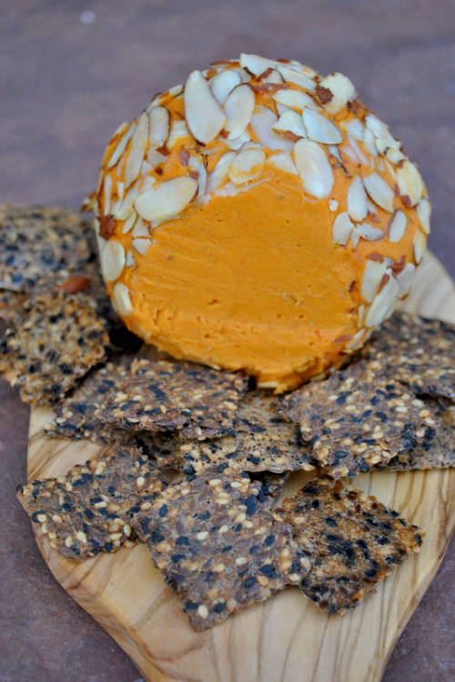

- Special Holiday Loaf (page 1)
- Pasta Salad (page 2)
- Pesto Sauce (page 2)
- Vegan Parmesan Sauce (page 2)
- Big Stick Pepperoni (page 3)
- Wheat-Free Banana Bread (page 3)
- Extra Sharp Vegan Cheddar Cheese Ball (page 4)
- Vegan “Cheese” Ball (page 5)
- Easy Vegan Gluten-Free Crackers (page 6)
Ch

Cheese Ball with Crackers

Special Holiday Loaf
(A healthier version of an old Adventist favorite: Special K Loaf)
Adapted from “Special K Roast” by the Micheff Sisters

1 medium onion, minced
1 c. walnuts or pecans or a mixture of both
¼ c. olive oil (opt.)
1 package of Mori Nu Tofu, firm or extra-firm, mashed (or water pack tofu)
½ - 1 Tbsp. Chicken Style Seasoning
1 tsp. salt (or to taste)
¼ tsp. celery salt
2 Tbsp. nutritional yeast flakes
1½ c. crumbled Rice Chex
1½ c. baked brown rice that was prepared in soy milk (no vanilla) instead of water
- Sauté the onion in 1 Tbsp. of the olive oil until slightly brown and caramelized. When almost done, you can add the seasonings to intensify their flavors.
- Cool slightly. Add the rest of the oil, tofu and rice and mix well to absorb seasonings.
- Combine the rest of the ingredients (nuts, crumbs and yeast flakes) in a separate bowl and then add to wet mixture and mix well. May add about 2 T water or soy milk if it doesn’t stick together well.
- Spray a 9 x 9 casserole dish with oil and spread in mixture (or double the recipe for a 9 x 14 dish).
- Bake at 350° for 35 – 45 minutes until just lightly browned. Some of the rice kernels will get hard if baked too long.
- Enjoy plain, or with healthful catsup or gravy. Good cold in sandwiches too!

Pasta Salad
1 pkg. Garden Rotini pasta, cooked and rinsed
Add tomatoes, broccoli, zucchini, sliced olives, grated carrots, or whatever veggies you want. Mix in pesto sauce, chill and serve.
By Theresa Clifton

Pesto Sauce
2 c. fresh basil, firmly packed ¾ c. Vegan Parmesan Cheese ¼ c. pine nuts ½ c. olive oil, or oil of choice 3 cloves of garlic
Place basil in food processor and blend well. Add other ingredients and blend until well processed.
Adapted by Theresa Clifton from a Betty Crocker online recipe

Vegan Parmesan Cheese
Mix: 1/3 c. Nutritional yeast flakes ½ c. ground almonds, w/o skins
Add: 2 Tbsp. Soymilk powder, plain 1 tsp. garlic powder 1 tsp. onion powder 2 tsp. Chicken-style seasoning
Coat or Spray Evenly With: 2 Tbsp. fresh lemon juice mixed with 1 tsp. water

- Mix with hands until crumbs are very small.
- Toast on a cookie sheet at 200° F, stirring every 30 minutes until dry and crispy. Avoid browning.
- If desired, return toasted “parmesan cheese” to the blender and process until mixture resembles fine crumbs.
- Store in a closed container. Keeps for many weeks in the refrigerator.
From “Tastefully Vegan” by Kathryn McLane, RN and Gerard McLane, DrPH

Big Stick Pepperoni
1 c. wheat gluten flour
¼ c. nutritional yeast flakes
3 Tbsp. tapioca flour
1 Tbsp. smoked paprika
1 tsp. ground fennel seed
¾ tsp. garlic powder
¾ tsp. onion powder
½ tsp. whole fennel seeds
¼ tsp. ground cayenne
½ tsp. salt
¾ c. water
2 Tbsp. ketchup
2 Tbsp. olive oil
1 Tbsp. soy sauce
1 tsp. liquid smoke

- Mix in a bowl all the dry ingredients. In another bowl mix the wet ingredients.
- Preheat the oven to 350° F.
- Add the wet ingredients to the dry ingredients and mix well.
- Knead for a few minutes and then divide in half.
- Roll each piece into a 7 inch log and wrap in foil, twisting the ends to seal.
- Place the logs in a baking pan with about ½ inch water on the bottom.
- Tightly cover with foil and bake for 1 hour, turning halfway through.
- Unwrap and cool. Then refrigerate to firm up for 1 to 2 hours.

Adapted from “Vegan on the Cheap” by Robin Robertson

Wheat-Free Banana Bread
2 c. wheat-free flour mix (I used 1 part millet flour, 1 part rice flour, and ½ part arrowroot flour)
1 Tbsp. baking powder
½ tsp. salt
½ c. chopped nuts

2 medium ripe bananas, mashed
¼ c. applesauce
2 Tbsp. ground flaxseeds
½ c. honey
- Mix the top 4 ingredients in a bowl separately.
- In another bowl mix the bottom 4 ingredients.
- Preheat the oven to 350° F.
- Mix all the ingredients together well and put the batter into an oiled loaf pan.
- Bake at 350° F. for 20 minutes. Then lower the temperature to 325° F. for about another 30 minutes.
- Remove the banana bread from the pan immediately after taking it out of the oven and cool on a cooling rack.
By Diana Adams

Extra Sharp Raw Vegan Holiday Cheddar Cheese Ball
1½ c. raw cashews, soaked in purified water for 4-6 hours
2 packed Tbsp. dry pack sun dried tomatoes, snipped into small pieces with kitchen scissors then soaked in the purified water with the cashews
¼ c. nutritional yeast
1 heaped Tbsp. mellow white miso (use chickpea miso if you are sensitive to soy)
1 Tbsp. lemon juice
1 tsp. sea salt
1 tsp. onion powder
½ tsp. dry ground mustard powder
½ tsp. smoked paprika
¼ tsp. turmeric
Dash of cayenne
½ c. organic unrefined coconut oil (optional – some of us prefer it without coconut oil)

- Pour the soaking water off the cashews and sun-dried tomatoes and then rinse them with fresh purified water. Drain well. Place the cashews and the tomatoes in a food processor or high powered blender and pulse until they start to form a paste, scraping down the sides as necessary.
- Add all of the seasonings and pulse until thoroughly combined. Add the coconut oil. Blend or process until the mixture is completely smooth, scraping down the sides occasionally. This process takes up to 10 minutes in a food processor and a few minutes in a power blender.
- Scrape the soft cheese into a container. Cover and refrigerate for 4-6 hours or until the cheese is quite firm.
- Scrape the cheese out of the container and place onto a clean surface. With your hands, form the cheese into a ball.
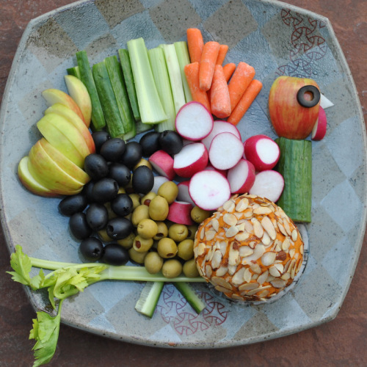
Notes: The organic unrefined coconut oil does leave a very slight coconut flavor in the finished product. If you prefer, you can use refined coconut oil for no coconut aftertaste.
The cheese ball can be served as is, or rolled in any variety of chopped nuts and or herbs. Sliced almonds, walnut pieces or pecan pieces with some fresh minced parsley, thyme or sage would be amazing.
The cheese ball gets softer as it reaches room temperature, so it’s best if kept chilled until immediately before use.
Adapted from http://vedgedout.com

Vegan “Cheese” Ball

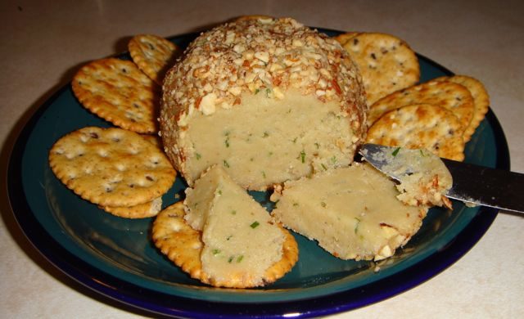
I am very excited about this recipe! I wanted to make an appetizer type thing that would be enjoyable to non-vegans. I love my cashew cheese so I thought that maybe I could make a cashew cheese ball. It worked! This is officially approved of by cheese eating friends.

Scant ¼ c. dry roasted almonds (to roll in when finished)
1½ c. raw cashews
¾ tsp. salt
1 Tbsp. nutritional yeast
1-2 Tbsp. lemon juice
¼ tsp. liquid smoke
1-2 Tbsp. fresh chives (cut into bits)

- Soak cashews in water for about an hour prior to beginning recipe.
- Use a food processor to pulverize the almonds. Spread almonds on a dinner plate.
- Drain and rinse cashews. After rinsing, drain well. You don’t want extra moisture on them.
- Add cashews to food processor. Process until smooth.
- Add salt and process.
- Add lemon juice slowly. Watch the consistency. It needs to be moldable, not too thin. Use less juice to keep it dryer. It will solidify in the fridge.
- Lastly add liquid smoke and fresh chives, and process lightly (too much and it will be a green spread, still tasty, but odd).
- Scoop out “cheese” with your hands and roll into a ball. It will be oily and soft. Roll the ball in the almonds.
- Place on a plate and cover with a bowl. Refrigerate for at least 3 hours, overnight is best.
- Spread on crackers or crusty bread.
Adapted from: www.chetroy.com/healthyvegan/?p=75

Easy Vegan & Gluten-Free Crackers
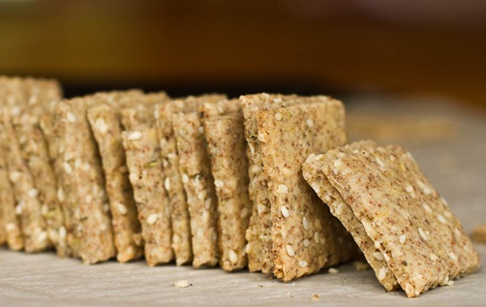
½ c. brown rice flour*
½ c. whole almonds*, ground into flour
(or use 3/4 cup almond flour)
2 Tbsp. ground flaxseed
1 Tbsp. nutritional yeast
¼ tsp. garlic powder
½ tsp. (or less) kosher salt
½ tsp. dried thyme
1 tsp. dried (or 1 Tbsp. fresh) rosemary
2 Tbsp. sesame seeds
¼ c. water
½ tsp. olive oil

- Preheat oven to 350° F and line a baking sheet with parchment.
- In a high-speed blender or processor, grind almonds into a flour. Do not over process or almonds will release oils. Sift flour before using to remove larger pieces. OR you can use store-bought almond flour.
- In a large bowl, mix together the dry ingredients. Add wet ingredients and mix well with spoon. Knead dough with hands until it comes together. Shape into a ball.
- Place ball of dough on parchment paper or a non-stick mat. Roll out dough until it’s about 1/8th inch thick, or as thin as you can get it without ripping. With a pastry wheel or pizza slicer, slice into crackers.
- Bake at 350° F for 18-20 minutes until slightly golden in color.
- Cool on baking sheet for 10 minutes. Store in air-tight container once fully cool.

*Note: Other flours might work in substitution for brown rice flour and almond flour, although keep in mind the flavor will change.

Source: http://ohsheglows.com/2011/10/17/easy-vegan-gluten-free-crackers

