Vegan Cooking Class Recipes Session 29 (November, 2014)
A New Twist on Thanksgiving

- Mashed Potatoes (page 1)
- Cashew Gravy (page 1)
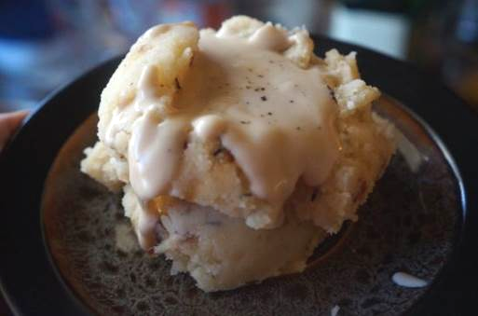
- Not Chicken Nuggets (page 2)
- BBQ Sauce (page 3)
- Healthy Homemade Ketchup (page 3)
- Super Simple Kale Salad (page 3)
- Vegan Pumpkin Bread Pudding (page 4)

No Added Oil Mashed Potatoes and Gravy
4 Potatoes (Russets work well)
½ c. Almond Milk, no added oils or sugar or vanilla (homemade is great using 1 c. soaked almonds to 2 c. water)
1 tsp. salt or to taste

- Peel and cut potatoes into approximately 1½ inch chunks.
- Boil in water until potatoes are soft.
- Take off stove and drain out the water into another pan – save it for the gravy.
- Set back on stove just for a minute until all drops of water remaining in pan are gone. Take off heat.
- Add a little almond milk and salt and beat with egg beaters. Add more almond milk a little at a time if it’s too thick.
- Taste and add salt until it’s just right.
Now make the gravy! Remember to use the potato water you saved for the water.
By Diana Adams

Cashew Gravy
½ c. raw cashew pieces
2 c. hot water (if you have boiled potatoes, use the potato water for this!)
2 Tbsp. McKay’s Chicken style seasoning (or something similar, to taste)
1 tsp. nutritional yeast flakes
2 tsp. Bakon smoked yeast
2 tsp. salt (optional)
Note: If you have homemade Vegan Chicken Style Seasoning, you can use 2 Tbsp. of that instead of the last 4 ingredients.

- Place all the ingredients except the water in the blender.
- Add 1 cup of the water, blend on slow, increasing to highest speed.
- Blend to creamy consistency, then add remaining water.
- Cook over low fire, stirring as needed until it reaches desired thickness.
By Diana Adams
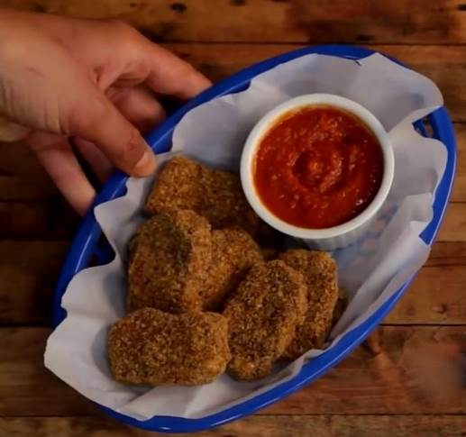
Not Chicken Nuggets

Coating/breading:
1 c. ground flaxseed
1 tsp. smoked paprika
1/2 tsp. salt

Nuggets:
3 Tbsp. maple syrup
1 Tbsp. lemon juice
1 Tbsp. chia seeds, soaked 10 minutes in ¼ cup of water
1 clove garlic
1 Tbsp. chili powder
1/2 Tbsp. miso (I used garbanzo miso, available in refrigerator section at health food store)
1/2 tsp. smoked paprika
1/2 tsp. cumin
1/2 tsp. salt
1/2 c. sun dried tomatoes, soaked 1 hour in water
1/2 red bell pepper
1/4 onion
3/4 c. corn kernels (fresh or frozen)
1/2 c. nutritional yeast
1 c. ground sunflower seeds
1 c. ground sesame seeds (toasted 10 minutes at 350° in oven - optional)

- Get your dried tomatoes soaking at least an hour ahead of time before you start. Also the chia seeds should be put in water at least 10 minutes before you start.
- Grind the flaxseed and place in a shallow bowl. Mix in the smoked paprika and salt. Set this bowl aside.
- Grind sunflower and sesame seeds in a high-speed blender or coffee grinder.
- Place the ground seeds in a large bowl and stir in ½ c. of nutritional yeast.
- Add the maple syrup and lemon juice to the blender and pulse.
- Next add in the garlic, chili powder, miso, smoked paprika, cumin, salt, and soaked chia seeds. Blend again.
- Add onion, sun-dried tomatoes, and corn. If you start having problems blending, just use a spatula to move the mixture down and make sure everything is getting blended.
- Pour this mixture into the bowl with the seed mixture and stir it all together well.
- To make the patties, use a large soup spoon to scoop it up, drop into the breading mix, coat and carefully shape each patty with your breading mixture, then lay it on your dehydrator sheet, or on a cookie sheet.
- Dehydrate overnight, or bake in an oven for about an hour at 200°, flip them, and then bake for one more hour.
Enjoy! Serve with BBQ sauce (see next recipe for homemade).
HEALTH BENEFITS
* high in omega 3s
* great source of fiber
* good for immunity
Adapted from www.youtube.com/watch?v=mI_qLEjwzQE

BBQ Sauce

In a saucepan add and mix the following:

1 c. ketchup (I used homemade – see next recipe)
4 t. cornstarch (mix it into a little of the 1 cup water below to make a paste then add into the rest)
1 c water
1/4 c maple syrup
1/2 t. salt
1/8 t. smoked paprika
1/4 t. liquid smoke

Stir and bring to a boil. Let simmer for a few minutes on low with the lid on. Enjoy!
By Diana Adams

Healthy Homemade Ketchup
Two 12-oz cans tomato paste
1/3 c. maple syrup
3 Tbsp. lemon juice
1 garlic clove, minced
2 tsp. fine ground sea salt
1/8 tsp. cayenne pepper OR smoked paprika

Mix all ingredients together well. Done!
Can be diluted with a little water if too thick or too strong.
By Diana Adams

Super Simple Kale Salad (Only 3 ingredients!)
Place in a food processor:
1 bunch Kale - boned and dry - put in food processor to top
1 apple cored and sliced - place on top of kale
1 handful of walnuts - place in food processor

Pulse a few times to make sure everything is chopped.

For serving, you can add cranberries and sunflower seeds on top!
By Linda Lange
Vegan Pumpkin Bread Pudding
1 16 ounce loaf French bread
1/2 cup raisins
1½ cup soymilk (or other non-dairy milk), vanilla or plain
1 cup pumpkin (canned or cooked and pureed)
1/4 cup maple syrup
1/4 cup organic cane juice crystals (or coconut sugar)
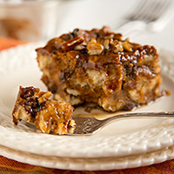
1 tablespoon Ener-G Egg Replacer, packed (may substitute 2½ tsp.
potato or corn starch plus ½ tsp. baking powder)
2 teaspoons vanilla extract
1½ teaspoon cinnamon
1/2 teaspoon ginger powder
1/2 teaspoon nutmeg
1/4 teaspoon allspice
1/8 teaspoon ground cloves
1/4 teaspoon salt (optional)

SAUCE
1/2 cup apple cider or juice
1/4 cup maple syrup
1 teaspoon cornstarch mixed with 1 tablespoon apple juice
1/4 cup chopped pecans or walnuts (optional)

- Cut or tear the bread into bite-sized pieces. If the bread seems moist or dense, spread it out on a cookie sheet and toast it for a few minutes in the oven. Place it in a large bowl and add the raisins.
- Put the non-dairy milk into the blender along with the pumpkin, maple syrup, sugar, Ener-G, vanilla, spices, and salt. Blend until smooth. Pour it over the bread, using a silicone spatula to get out every drop. Stir well to completely coat all of the bread. Set aside to soak for a few minutes while you ready the pan and preheat the oven.
- Preheat oven to 350F. Line an 8×8-inch baking dish with parchment paper or oil lightly. Pour the bread pudding into the pan in an even layer. Bake for about 45 minutes or until top is set and beginning to brown. Remove from oven and allow to cool for at least 15 minutes.
- While the pudding is cooling make the sauce. Place the apple cider and maple syrup in a small saucepan over medium heat, and bring to a simmer, stirring often, until reduced to about half. Carefully add the cornstarch mixture, bring to a boil, and cook for another couple of minutes, stirring constantly, until mixture is no longer cloudy and thickens slightly. Remove from heat. Stir in the nuts. Poke a few holes in the top of the bread pudding with a toothpick, and pour the sauce over the top, distributing nuts evenly. Cut into squares and serve warm.
Notes
If you’re trying to cut down on sugar, try replacing the maple syrup in the pudding with 1/4 cup non-dairy milk mixed with a little stevia. You’ll save about 20 calories. Leaving out the nuts will reduce it another 20 calories and 2 grams of fat.
Preparation time: 20 minutes | Cooking time: 1 hour(s)
Number of servings (yield): 8
Nutrition (per serving): 315 calories, 35 calories from fat, 4.1g total fat, 0mg cholesterol, 404.8mg sodium, 318.7mg potassium, 60.6g carbohydrates, 3.6g fiber, 24.6g sugar, 8.3g protein.

Adapted from http://blog.fatfreevegan.com/2013/11/vegan-pumpkin-bread-pudding.html
Faux Peanut Butter Cookies
½ c. grapeseed or avocado oil
½ c. sunflower seed butter
1 c. coconut palm sugar
1 tsp. vanilla
1 egg replacer
¾ tsp. Sea salt
1 tsp. aluminum-free baking soda
½ c. almond meal
½ c. brown rice flour
¼ c. + 2 Tbsp. coconut flour
1/3 c. chopped toasted almonds for extra crunch, optional

- Preheat oven to 350°. Spray a baking sheet with grapeseed oil or cooking spray.
- In a bowl, whisk oil, sunflower seed butter, coconut sugar and vanilla together. Rest batter a few minutes until coconut sugar has dissolved.
- Stir in remaining ingredients.
- Drop tablespoonfuls onto baking sheet, then press down gently with fingers to form a round, slightly thick shape.
- Press a fork into cookies just enough to make the traditional crosshatch pattern. Dip fork in brown rice flour occasionally to keep it from getting too sticky.
- Bake 7 minutes for chewy cookies and 9 minutes for crunchy ones.
Adapted from “Delightfully Free” by Tracy Hill

