Vegan Cooking Class Recipes Session 34 (April, 2015)
Scalloped Potatoes, Sauerkraut, Hot Dogs and More

- Simple Salad (page 1)
- Potatoes Au Gratin (page 1)
- Vegan Hot Dogs (page 2)
- Quick Fresh Sauerkraut (page 3)
- Baked Apples (page 3)
- Natural Shampoo (page 4)
- Vegan Vanilla Coconut Ice Cream (page 5)

Simple Salad
Cucumbers
Garbanzos
Black olives
Sun dried tomatoes

Dressing:
Bragg’s
Avocado oil
Tomato juice
The amounts for the above ingredients can vary, according to your taste.
By Darla DeVargas

Potatoes Au gratin
2-3 pounds of Yukon gold potatoes peeled and thinly sliced. Or you can leave the skins on.
Sauce:
1 c. cooked and mashed butternut squash
¾ c. plain, unsweetened nondairy yogurt
1¼ c. water
½ onion, quartered
5 Tbsp. nutritional yeast flakes
¼ c. raw cashews
3 Tbsp. tapioca flour
1 tsp. salt

- Put all the ingredients in a blender, except the potatoes. Process until smooth and creamy.
- Preheat the oven to 425º F. Lightly brush or spray a 13"x9" baking pan with oil.
- Neatly layer half of the potatoes in the pan, overlapping them slightly.
- Pour enough sauce over the potatoes to cover them. Repeat with the remaining potatoes and sauce.
- Cover and bake for 40 minutes. Uncover and bake for 15-20 minutes, until the potatoes are tender and the sauce is thick and bubbling.
Adapted from "Artisan Vegan Cheese" by Miyoko Schinner

Vegan Hot Dogs

1 small onion, chopped in large chunks
2 garlic cloves, mashed and peeled
¼ c. water
2 Tbsp. Worcestershire Sauce (or Bragg’s Aminos – but decrease salt by ½ tsp. then)
1 Tbsp. liquid smoke
1 tsp. onion powder
1 tsp. mustard powder
1 tsp. raw sugar
1 tsp. coriander, ground
1 tsp. rosemary, dried and ground
2 tsp. paprika
1½ tsp. sea salt
½ tsp. nutmeg, ground
½ tsp. cardamom, ground
½ tsp. smoked paprika
¼ tsp. dried basil
¼ tsp. cumin

Place all the above ingredients in a food processor and whiz until onion is liquefied (or almost).

Scrape off lid and sides into processor and add:
1 box Morinu tofu, firm, pressed in a cloth to remove extra water
OR regular water packed tofu, 9 oz.
OR 1 can of white beans (rinsed and drained) or 1 c. home cooked
Mix well in processor until all is creamy.

Scrape mixture into bowl and add:
5 Tbsp. almond meal
3 Tbsp. oil

Mix well. Then add:
1 c. + 2 Tbsp. gluten flour
1 Tbsp. cornstarch (or other starch of your choice)

- Mix and then knead lightly together until all is of uniform texture. Divide dough into 12 parts.
- Make 12 pieces of parchment paper about 6” x 8”. You can do this if your roll is 12” across by pulling out six 8” pieces and then cutting them in half.
- Do the same with aluminum foil.
- Set a steamer to boil.
- Form each piece of dough into a hot dog shape (it doesn’t have to be perfect) and wrap in first parchment paper and then aluminum foil. You can roll them up like a burrito. Be sure to tuck in the ends so that all is enclosed.
- Set all the “hot dogs” in the steamer and steam for 45 minutes. Take off lid when time is up and off heat and let set in pan at least another 15 minutes before removing.
Adapted from www.vegkitchen.com/recipes/veggie-hot-dogs

Quick Fresh Sauerkraut

½ Tbsp. oil (opt.)
1 onion, thinly sliced
1 med. green cabbage, shredded
½ c. apple juice
½ c. lemon juice
1 Tbsp. sea salt

- In a large pan, sauté the onion in the oil or a little water until soft and translucent.
- Add the rest of the ingredients and simmer, stirring occasionally until cabbage is soft and most of the liquid has evaporated – about ½ hour.
Adapted from recipe by Dwynnie at www.food.com

Oatmeal-Brown Sugar Baked Apples
Serves 4, easily multiplied for larger crowds
4 apples, like Jonagold, Fuji, Gala or Honeycrisp
¼ c. brown sugar (dark or light) Diana used coconut palm sugar
¼ c. old-fashioned rolled oats
½ tsp. cinnamon
¼ tsp. nutmeg
Pinch cloves
1 Tbsp. vegan butter, divided in four
1 c. hot water
Optional extras: orange zest, lemon zest, grated ginger, candied ginger, raisins or other dried fruit, chopped nuts, cream cheese, mascarpone, peanut butter, Nutella
To serve: add vegan ice cream or coconut whipped cream, etc.

- Pre-heat oven to 375° F with a rack in the lower-middle position.
- Remove the core of the apples, cutting to within a half inch of the bottom of the apple and creating a well roughly 3/4-inch wide. This is easy to do with an apple corer, but can also be done with a melon baller, grapefruit spoon, or a paring knife.
- Mix the brown sugar, oatmeal, cinnamon, nutmeg, cloves, and any extras in a bowl. Divide this mixture between the apples, packing the wells firmly.
- Arrange the apples in a baking dish (like an 8x8 Pyrex dish), and top each one with a pat of butter. Pour the water into the bottom of the dish and cover loosely with aluminum foil.
- Bake for 20 minutes and remove foil. Continue baking uncovered until the apples are soft and the brown sugar has melted into a syrup, an additional 20 to 30 minutes. You can test the apples by poking a paring knife through the oatmeal mixture and into the interior of the apple; it should slide into the apple easily with no resistance. The skin on the apples will also become wrinkled and soft by the end of cooking.
- Serve with a scoop of ice cream or whipped cream. Leftovers will keep for up to a week and can be reheated in the microwave or eaten cold.
Recipe note for Gluten-Free Baked Apples: Be sure to use a gluten-free brand of oatmeal if making this for someone with a Celiac or gluten intolerance. Adapted from: www.thekitchn.com
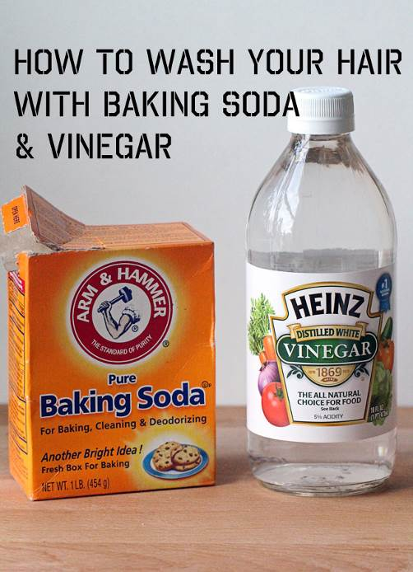
WHY THIS METHOD? By Sonnet

Baking soda and vinegar is an incredibly simple and easy way to clean your hair without shampoo. Since I am always on a mission to reduce my exposure to potentially harmful chemicals and simplify my beauty routine, it felt right to be using a natural, time-tested method to clean my hair.
Now, you might be asking, what’s so bad about shampoo? Shampoos can contain a lot of harmful ingredients.

METHOD – PART 1: BAKING SODA
It might be hard to adjust to the lack of shampoo foaming action at first, but I promise this is worth it in the end.
Start by mixing 1 part baking soda with 3 – 4 parts water. I was making a large batch of this and then keeping it in my shower, but I noticed it wasn’t as effective as the individual batches I used to make. Then a reader informed me that water activates baking soda and so now I am back to mixing individual batches in travel-sized squeeze bottles.
I have shoulder length hair and use about 2 tablespoons of baking soda with 1/2 cup water. You can adjust this depending on your hair length.
TO APPLY:
Apply the baking soda and water mixture to dry or wet hair by applying it to the roots at the scalp. I like to rub it into my scalp for about a minute and give myself a mini head massage. It feels great and it helps to make sure I get my scalp clean. I don’t wash the ends with this mixture because the rest of my hair doesn’t get super oily. Rinse with warm water.

METHOD – PART 2: VINEGAR
After washing and rinsing with the baking soda mixture, you’ll want to apply a vinegar rinse. I’ve found that white vinegar does not leave as strong of a smell compared to apple cider vinegar so that is what I use in my rinse. Mix 1 part white vinegar with 4 parts water.
To minimize the vinegar smell, I like to add a variety of essential oils to the vinegar mixture. Here are my favorite combos:
Rose Mint (heartsong blend essential oil and mint essential oil)
Vanilla Lavender (lavender essential oil and vanilla essential oil)
Orange Rosemary (orange essential oil and rosemary essential oil)
Sandalwood Lavender (sandalwood essential oil and lavender essential oil)
I usually mix a big batch of this ahead of time and keep it in a squeeze bottle in the shower.
TO APPLY:
Tilt your head back, close your eyes (to avoid getting this mixture in your eyes), and distribute through your hair. After a few seconds, rinse with cold water.
One of the ways that I’ve changed my method recently is rinsing my hair with cold water after the vinegar rinse. The cold water helps to seal in moisture, smooth the hair, and add shine. I have straight hair and have noticed that this really made a difference with eliminating frizz and static.
Since my hair is longer than when I used to use this method, I first noticed the vinegar smell leftover in my hair much more. To remedy this, I simply add two drops of lavender essential oil to my hair brush and run it through my hair as I blow dry it. Works like a charm!

Source: www.insonnetskitchen.com/baking-soda-vinegar-hair-care-update

Creamy Delicious Vegan Vanilla Coconut Ice Cream
We use a Cuisinart Frozen Dessert Maker which uses a pre-frozen bowl instead of ice.

In a blender combine the following until creamy:
2 cans coconut milk (14 fl. oz. each)
½ c. mild honey (clover or orange is good)
2 tsp. vanilla (powdered white vanilla if you have it)
¼ tsp. salt

- Pre-freeze ice cream maker bowl for at least 12 hours.
- Place blender with mixture in refrigerator to chill.
- Pour into ice cream maker and turn it on. It should be ready in about 30 minutes.

Adapted from www.wholenewmom.com Vanilla Coconut Ice Cream

