Vegan Cooking Class Recipes Session 35 (May, 2015)
Mexican Foods

- Corn & Flour Tortillas (page 1)
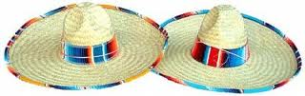
- Enchilada Sauce (page 1)
- Vegan Manchego Cheese (page 2)
- Brown Fried Rice (page 3)
- Chicken Style Seasoning (page 4)
- Salsa & Avocado Dip (page 4)
- Enchilada Pie (page 4)
- Caramel Mocha Bars (page 5)

Tortillas

For corn tortillas: follow instructions on the Masa Harina flour bag and always use warm water.

For flour tortillas:
4 c. flour
Salt to taste
1/8 tsp. baking powder
1/3 c. oil
Cold water – enough to make a piecrust consistency

- Mix ingredients and work up well. Cover with a damp towel and let it sit for about ½ hour.
- Squeeze off small amounts and form small balls. Keep them covered with a damp cloth.
- Roll them out. As you get each tortilla rolled thin, place it on a hot skillet. As they start to bubble up, turn them over and cook until done.
- Place inside a dry dish towel on a plate covered with foil to keep them warm.

Enchilada Sauce
Begin with 1 quart water in a 2 quart pan

Add the following:
8 large Calif. type chili pods - just drop them in whole (sold in plastic bags – dried)
1 or 2 red peppers (I like to use Japones)
1 clove garlic
2 large Roma tomatoes

- Bring to a boil and cook until the stems pull off the chili pods easily. Remove the stems.
- Pour all the contents of the pan with the water into a blender or VitaMix. Blend well.
- In the just-emptied pan, put a small amount of oil. Heat until hot. Then strain the contents of the blender back into the pan. Bring to a boil over medium heat, and then keep on low.
- I use Tampico brand peppers. Depending on how hot you want your sauce, you can use from 1 to as many to attain the hotness you want.
By Delayne Estes
Vegan Mexican Manchego Cheese, Smokey Style

(Make at least a day ahead of when you need it. It takes at least 8 hours to culture, so start it just before you go to bed or first thing in the morning. You don’t want to have to get up at 2 AM to check on your cheese!)

Thank you to Miyoko Schinner for this revolutionary method of making more authentic tasting vegan cheese. She has a whole book of vegan cheeses plus some yummy recipes for using that cheese titled “Artisan Vegan Cheese.”

When we lived in Mexico, we liked to eat Manchego cheese (back before we became vegan.) This recipe tastes a lot like it, as well as I can remember, kind of like a mild Monterey Jack. It is a variation from Miyoko’s “Meltable Muenster.” See her book for many more wonderful vegan cheese recipes.

1 c. almond or soy yogurt, plain unsweetened (homemade is best)
½ c. water
1/3 c. avocado oil
1 tsp. salt, non-iodized (Iodine can interfere with the culturing process.)

1 tsp. liquid smoke
1 Tbsp. carrageenan powder (you may substitute arrowroot powder if you wish)
¼ c. potato starch

In a blender on low or medium speed, mix the first 4 ingredients until smooth. Place mixture in a glass bowl and cover. Let it sit out at room temperature 8 to 12 hours to develop some tanginess. (It’s the good bacteria in the yogurt that are multiplying and forming lactic acid.) Taste the yogurt mix to check on the flavor now and then. The less time it cultures, the more mild it will be.

Then place the yogurt mix in a good quality saucepan (that doesn’t scorch easily). Whisk in the last 3 ingredients. Be sure you have a heat-safe glass dish ready to receive the finished cheese out and ready.

Then heat the cheese mixture on medium/high heat, stirring fairly constantly with a flat bottomed utensil or silicon spatula until thick, smooth and very shiny. You can pause every now and then to scrape down the sides too. It doesn’t seem to scorch as easily as a sauce or gravy, but I wouldn’t leave it for too long. Be sure and cook it long enough or the cheese might be slightly chalky in texture. It usually takes 6 – 8 minutes total. The mixture will go through a stage where tiny lumps appear. This is normal. Just keep stirring and they will melt away in a couple more minutes.

It is usually about 3 or 4 minutes after the lumps melt away that the cheese actually begins to act like melted cheese. It clings together and is slightly stringy/stretchy, gets very shiny and seems to be slightly more liquid again too. That’s when it is done. If you want to be sure, you can eat a tiny piece (it cools almost instantly) and see if it has lost that chalky feeling. With practice, you will easily recognize this stage.

Now quickly scrape the mixture out of the pan and into the dish. Since it will begin to harden right away, you have about 15 seconds if you want it to look perfect (Of course, it is going to taste delicious no matter what!) Finish it by smoothing the top down all around. Allow it to cool before covering and refrigerating. It will harden more in the fridge.
Adapted from “Artisan Vegan Cheese” by Miyoko Schinner

Brown Fried Rice
Start this a couple of hours before you eat. Brown rice takes longer to cook.

2 c. brown rice (not instant)
1 Tbsp. avocado oil
1 tsp. vegan butter (optional)
½ of a medium white or yellow onion, chopped
½ of a bell pepper, any color, chopped
2 tsp. garlic powder, or 2 garlic cloves minced
1¼ c. tomato puree
2 tsp. sea salt, or less if broth is salty
3¾ c. vegan chicken style broth (See following recipe for homemade)
¼ tsp. chili powder, or more if desired

- Add the oil and butter to the pan and heat over medium high heat. Add the rice and stir, cooking for 5 to 10 minutes or until a nice golden brown.
- Browning the rice is very important for flavor. Yes the rice is already brown but brown it some more. Then add the chopped onion and bell pepper and cook an additional 3 to 5 minutes.
- If you are using fresh minced garlic, add it and cook and additional 1 to 2 minutes.
- Now you are going to add all the rest of the ingredients starting with the vegan chicken broth (Heat it up first and add slowly to avoid a lot of spattering).
- Continue adding the tomato puree, garlic powder, if not using fresh, and salt. Stir everything until it is well mixed and turn the heat to high.
- You want everything to come to a nice rolling boil. Let it roll for about a minute then cover and lower the heat to simmer for somewhere between 40 to 55 minutes.
- Check the rice after 40 minutes. Put your spoon in there without stirring it and see how much liquid is left if any and then take a little taste to see if the rice is done.
- If you see the rice is floating around in some liquid and the rice is a little hard, cover and cook another 10 – 15 minutes. If the liquid dries up and the rice is still hard in the center, add a little more water and replace the lid and let it simmer another while. (When Diana made this, it took about 1½ hours to cook.) Sometimes you just have to be patient! Rice that has been in storage longer takes longer to cook. Be careful not to stir it. The more you move the rice around, the more sticky it may become.
- If the rice seems done but there is still too much liquid in the rice (unusual) take the lid off the pan and continue to cook until the liquid has evaporated. With the lid off the liquid will cook off quicker.

Adapted from Rockin Robin at www.cooking-mexican-recipes.com/homemade-spanish-rice.html.
Her family used to run a Mexican restaurant and this website has some really yummy recipes as well as fun demo videos.

Chicken Style Seasoning (Non-Spicy No-Salt)
2 c. nutritional yeast flakes
1/3 c. onion powder
¼ c. Italian seasoning (no salt added)
1/6 c. dried parsley (half of a 1/3 cup measure)
1/8 c. Sucanat or cane juice crystals
1½ Tbsp. garlic powder
¾ tsp. celery seed

- Blend all ingredients in a blender until very fine.
- Store in an airtight container.
- To make broth, add 1 Tbsp. of Chicken Style Seasoning mix to 1 cup of water.
Adapted from “Give Them Something Better” by Sarah Frain & Stephanie Howard

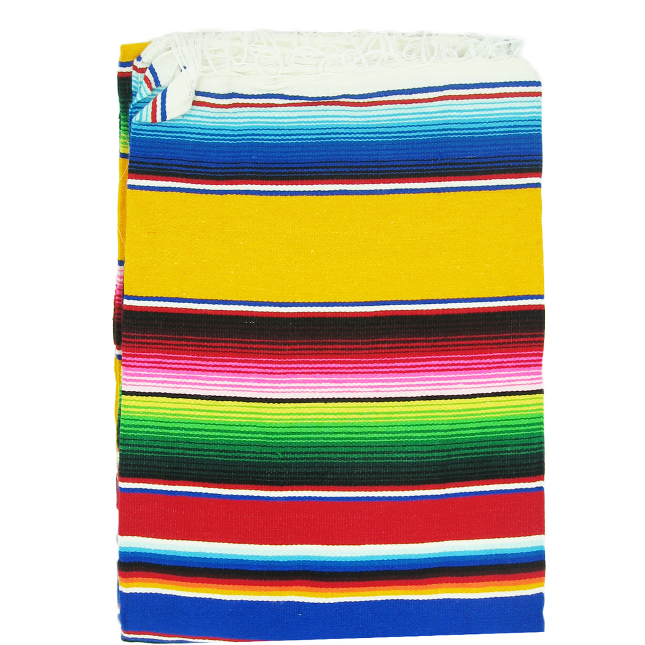
Salsa for 5
4 medium tomatoes
½ c. cilantro chopped fine
1medium onion
1medium pepper, mild or personality
2 cloves garlic
Salt to taste
Use salsa maker or food processor to blend.
Avocado Dip for 5
3 large or 4 small avocados
1 Tbsp. Vegenaise
¼ c. of salsa, more if desired
Salt to taste
Mash it together and serve fresh.
By Darla DeVargas

Enchilada Pie
To make a basic Enchilada Pie, you only need 3 ingredients:
Tortillas
Enchilada Sauce
Vegan Cheese

- In a casserole dish make a layer of tortillas that have been dipped in the enchilada sauce.
- Next make a layer of the cheese.
- Follow with another layer of dipped tortillas and then cheese.
- Continue until the dish is almost full and sprinkle cheese on the top.
- Can be warmed in a hot oven until the cheese melts, if it hasn’t melted already.
Of course you can always add other ingredients to the layers of your pie. Ingredients such as vegeburger, olives, chopped onions, corn, etc. Have fun being creative!
By Delayne Estes

Caramel Mocha Bars
For people who love rich and sweet treats
1 c. raw almonds
1 c. pitted dates
1 Tbsp. coconut oil

TO MAKE THE CRUST:
- Pulse the almonds into flour in your food processor, then add the dates and process until it all begins to stick together, then mix in coconut oil until thoroughly combined.
- Press into the bottom of a baking pan and refrigerate until you add the next layers.

CARAMEL
½ c. raw cashew butter
½ c. coconut oil
1 c. pitted dates
Pinch of salt
1 tsp. vanilla extract
½ c. unsweetened shredded coconut (optional)

MOCHA LAYER
1/3 c. cocoa butter
1 to 2 Tbsp. carob powder
1 to 2 Tbsp. Dandy Blend (or any powdered coffee substitute)
¼ c. preferred liquid sweetener (agave)

TO MAKE BOTH THE CARAMEL AND MOCHA LAYERS:
- Blend the ingredients in each list until smooth.
- Spread the caramel onto your crust, followed by the mocha layer.
- Refrigerate until completely set, preferably overnight.
- Slice, bite and revel in healthy dessert happiness. YUM!
Adapted from “Rawsome Vegan Baking” by Emily von Euw
Her website is www.ThisRawsomeVeganLife.com. Typed by Yasha Moskalets

