Vegan Cooking Class Recipes Session 36 (October, 2015)
Pizza & Dessert

- Cauliflower Pizza Crust (page 1)
- Melty Vegan Mozzarella (page 2)
- Carrot Hot Dogs (page 3)
- Healthy Caramel Dip (page 3)
- Apple Rose Pastry Dessert (page 4)

Cauliflower Pizza Crust (Vegan and Gluten Free)
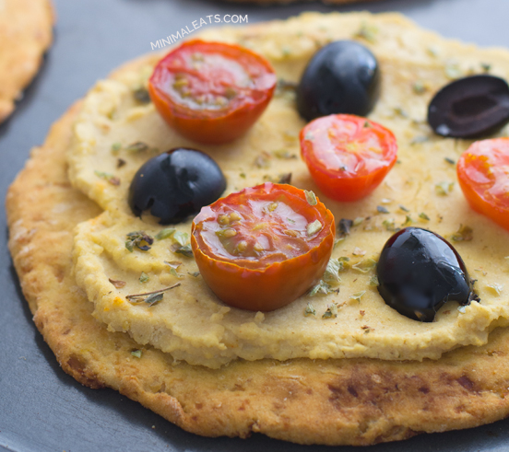
I love this cauliflower pizza crust because is delicious, tasty, crispy, healthy and the ingredients are really easy to get.
3 cups cauliflower crumbs
3 tablespoons ground flax seeds OR 1 tablespoon ground chia seeds
1 cup rice flour
1 or 2 cups chickpea (garbanzo) flour
1 teaspoon Italian seasoning
1 teaspoon salt (optional)
Water as needed for dough

- Preheat oven to 390º F.
- Cut off the florets of the cauliflower, you don't need much stem. Place the florets in a blender or food processor and pulse until you get cauliflower crumbs.
- Place the cauliflower crumbs in a non-stick pan (with no oil) and cook them over medium heat for about 5 minutes. Stir constantly.
- When the cauliflower cools enough, place it in a napkin, cheesecloth or strainer and squeeze out as much water as you can. Alternately, spread a dish towel or cheese cloth in a colander, add cauliflower and smoosh down with a bowl to get as dry as possible.
- In a big bowl, add the cauliflower crumbs, ground flax or chia seeds, rice flour and 1 cup of chickpea flour. You can also add salt, spices or herbs. Mix all the ingredients with your hands, wetting fingers as needed to keep dough from sticking. If the dough is sticky, add more chickpea flour (we've used 2 cups). If the dough is too dry, add some water, one tablespoon at a time. You can also knead the dough on a floured board. Wait 5 minutes for ground seeds to soak up water and add more if needed.
- Spread out to about ¼” thick on a baking sheet with parchment paper, using wet fingers to keep from sticking.
- Bake for about 25 minutes or until golden brown.
- Spread with toppings of your choice and bake another 10 minutes.
Adapted from http://simpleveganblog.com/cauliflower-pizza-crust-vegan-gluten-free

Melty Stretchy Gooey Vegan Mozzarella
½ Cup Raw Cashews
1 Cup Hot Water
2 Tablespoons + 2 teaspoons Tapioca Starch (also known as Tapioca Flour)
1 Tablespoon of Nutritional Yeast
1 teaspoon Lemon Juice or Apple Cider Vinegar
½ teaspoon Salt
¼ teaspoon Garlic Powder

- Soak the cashews for four hours or overnight. Or if you are impatient like me, just boil them for 10 minutes until soft. Drain before using.
- Add the cashews the hot water, and all the remaining ingredients to a blender, and blend until smooth. It will be very watery.
- Pour into a small sauce pan and heat over medium high heat, while stirring. If you don't have a high powered blender, you may want to pour the liquid through a fine mesh strainer or cheese cloth into the pot, to remove any cashew bits that didn't grind up. This will ensure a smooth cheese texture.
- As you stir it will start forming clumps, and then all of a sudden it will become a cheesy gooey mass of yumminess. This takes about 5 minutes. Continue to cook and stir for an additional 2 minutes to make sure it has firmed up completely.
- Use for anything you like! Scoop up with tortilla chips, dollop onto pizza before baking, make a grilled cheese sandwich, or whatever your heart’s desire.
- Store in an airtight container in the fridge. Freeze for shredding.

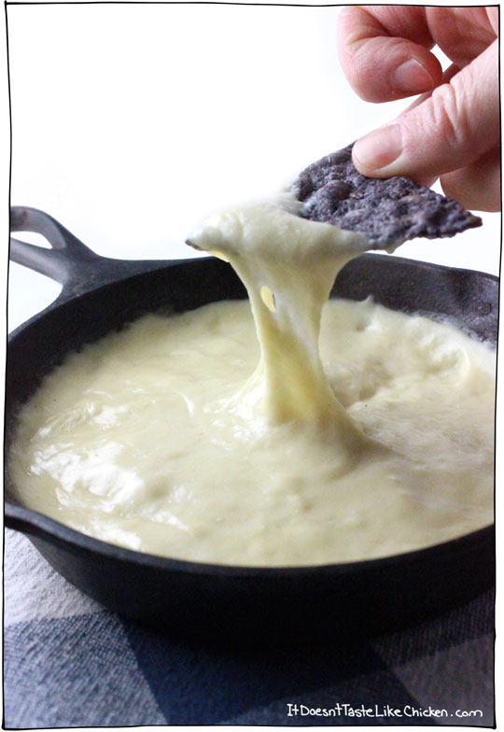
Note: If you want to return the cold mozzarella back to dipping consistency, reheat over medium heat while stirring constantly so it doesn't burn. Once it is hot and bubbling it might have thickened up too much. You can thin it out by adding a tablespoon of water at a time, stirring it in until desired consistency is reached.
Adapted from: http://itdoesnttastelikechicken.com/2015/01/23/melty-stretchy-gooey-vegan-mozarella

Carrot Hot Dogs
(Makes 6 cups of marinade sauce)
½ cup apple cider vinegar
1¼ cup Coconut Aminos (or Bragg’s)
3 cloves of garlic
¼ cup extra-virgin olive oil or similar oil
1 whole bottle of liquid hickory smoke (3.5 oz)
2 tablespoons salt
¾ cup blackstrap molasses
1/3 cup coconut sugar
4 cups water
20 to 30 hot dog sized carrots
- Boil carrots until ALMOST cooked through but do not overcook to where they break apart. Drain them.
- Blend together all ingredients for the marinade and pour over carrots and allow them to sit for at least 24 hours and up to 48 hours in the refrigerator, then they are actually ready to eat.
You can fry them a little or warm them a little or even put them on the grill! They freeze very well and serve them with all the fixin’s for hot dogs! Ingenious!

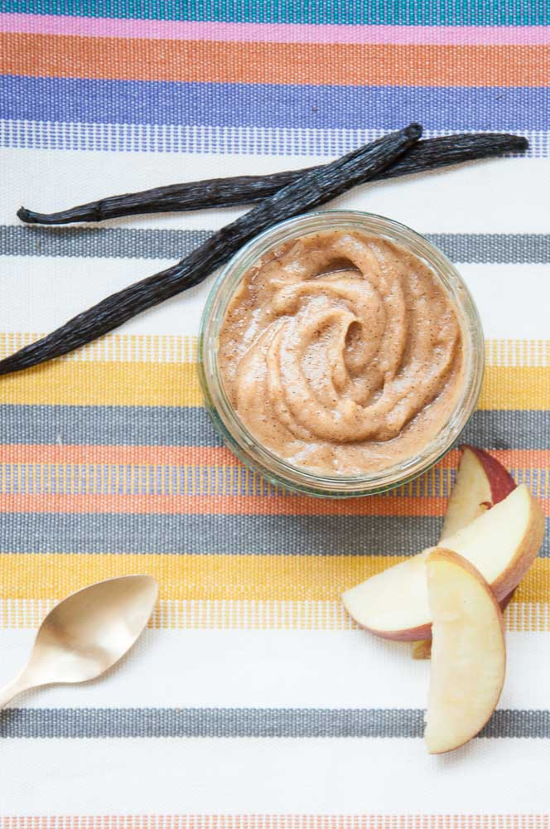

Healthy Caramel Dip
8 Medjool Dates or 16 regular dates (pitted)
Vanilla caviar from 2 Vanilla Beans (alternatively use ½ to 1 teaspoon Vanilla Extract)
½ cup unsweetened Almond or other vegan milk
Pinch of Salt
¼ cup melted Coconut Oil
- Place all ingredients in a blender or food processor.
- Pulse until no date chunks remain and smooth, scraping down sides if needed.
- Eat with apples or other fruit, or even pretzels!
- Store in fridge for up to 5 days.
Note: Coconut Oil will harden in the fridge. Heat the caramel dip in a water bath to soften it again.
Adapted from:
http://www.veganfamilyrecipes.com/2015/02/healthy-caramel-dip.html

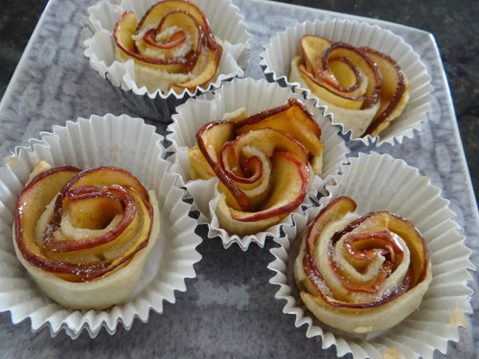
Apple Rose Pastries Dessert
This is a frugal, light, tasty and beautiful dessert or appetizer for any occasion. They are also easy to make!
1 cup of flour (or gluten-free flour for a GF version)
1 red apple
2 Tbsp. natural sugar
1 Tbsp. honey
3 Tbsp. water
½ stick of vegan butter, softened
Vegan caramel or fruit jam
Dashes of natural sugar and cinnamon for the finishing touch

- Slice the apple very thinly
- Place the apple slices in the pot with the sugar, honey and water.
- Cook on medium for about 5 minutes, or until the apples are soft. You will want to stir them gently as they cook.
- Then pull the slices out and let them cool on a plate while you make the dough. NOTE: Keep the liquid in the pan as you will need this for the dough! Don't drain or rinse it yet!
- In a medium bowl, place the butter in the bowl and break it up a little.
- Then add the 1 cup flour.
- Then, using the "apple water" from the pan that you cooked the apples in, gather 3 Tbsp. of this water and add to the flour/butter mixture.
- Mix the dough until smooth (by hand is best).
- Then cut the dough in half.
- With each half, roll the dough out into a square/rectangle approximately 6x10 inches.
- Once you rolled it out to get it as square as possible, clean up the square by cutting the edges to make it "more square."
- Then, using a pizza cutter (knife works too), cut 2" wide strips from about 10" in length. With this dough, each half should make about 5-6 flowers for 10-12 total flowers per batch.
- Spread a thin layer of caramel (diluted with 2 Tbsp. almond milk) or fruit jam on the dough strip.
- Place 5-6 cooked apple slices on the strip of dough, fold over the bottom half of the dough to cover the bottom edge of the apples.
- Then "roll up" the dough to form the rose!
- Place in a sprayed muffin pan.
- Repeat with the second half of the dough.
- Then bake for 15-18 minutes at 350 degrees. They will not really get brown. You just want the dough cooked, but it won't turn brown.
- Pull them out of the oven, while still hot/warm, brush them with honey and sprinkle with natural sugar and cinnamon!
- Let them cool and serve later, but you can also serve them warm. We have eaten them both ways and they are fabulous warm and cooled!
Adapted from: http://thethriftycouple.com/2014/09/17/apple-rose-flower-pastries-dessert-recipe-delicious-easy-and-beautiful

