Vegan Cooking Class Recipes Session 37 (November, 2015)
Soup, Patties & Quiche
- Pumpkin Soup (page 1)
- Roasted Potatoes & Turnips (page 1)
- Vegan Quiche with Potato Crust (page 2)
- Sweet Pea Patties with Sweet Mustard Sauce (page 3)
- Vegan Parmesan Cheese (page 3)
- Chicken Style Seasoning (page 4)
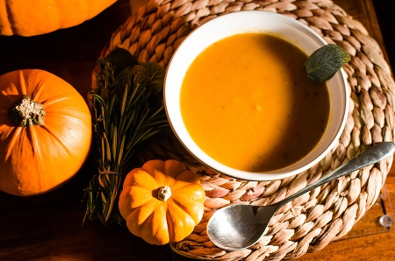
- Mustard Vinaigrette (page 4)
- Italian Dressing (page 4)
Pumpkin Soup
2¼ cups whole pumpkin
1 tablespoon oil
½ tsp. salt (or to taste)
1/8 tsp. Nutmeg
1 medium onion, sliced
1 garlic clove, sliced
1 cup potatoes, peeled and cut into big cubes
3 cups vegetable stock
½ cup walnuts
- Preheat oven to 400° and line a baking tray with aluminum foil.
- Cut the pumpkin in half and scoop out the seeds.
- Place the pumpkin halves on the baking tray, skin side down. Season with salt and nutmeg.
- Roast in the oven for 50 minutes to 1 hour, until the flesh is golden and completely soft. Let slightly cool down while preparing the rest.
- Heat the oil in a medium saucepan over medium-high heat.
- Fry the onion and garlic until translucent, about 5 minutes.
- Scoop out cooked pumpkin flesh with a spoon and add to the saucepan. Discard pumpkin skin.
- Add the cubed potatoes, walnuts and vegetable stock and bring to a boil.
- Cover, reduce heat to low, and let simmer for 30 to 40 minutes until the potatoes are cooked.
- Purée the soup with a handheld blender and adjust seasoning with salt and nutmeg.
- Serve the soup in bowls topped with some chopped walnuts.
By Theresa Clifton

How to Roast Potatoes and Turnips
- Wash well with plenty of water and a brush or scrub pad to make sure there is no dirt on them.
- Cut out any green places or sprouts (on potatoes) or bad spots. You don’t have to peel them.
- Cut into chunks, about 1½ in. or so across. They should still be wet from washing. If they have dried out, wet them again and drain well.
- Put in bowl and add a little oil, about 1 tsp. for the whole pan full, also some salt. It is best not to use olive oil for this recipe, since it is going to bake at a high temperature. Use an oil with a high smoke point – such as avocado oil, grapeseed oil or coconut oil.
- Mix well with your hands until all the pieces are evenly coated.
- Put on baking trays. The pieces should not be too crowded together. Bake at 400° until toasty, about 35 to 45 minutes.
Vegan Quiche with Potato Crust (for 10 inch pie plate, 1½ in. deep)

For the crust:
- Whiz up about 3 cups of baked or roasted potatoes (peelings are ok) in a food processor, with a little extra salt if needed, until the consistency of bread crumbs. Starchy potatoes work best.
- If your potatoes start to get sticky as they chop, stop the machine at once and use the potatoes even though there are bigger chunks still. It’s better that way than to leave it too long and become a gummy ball.
- Place contents in the oiled pie dish and pat it out with hands to make crust about ¼ inch thick on bottom and sides of the dish.
- If you are working with big chunks, perhaps use a fork to smash those down a bit. Set aside and prepare filling.

For the Filling:
In blender add and blend until creamy:
¼ c. raw cashews, soaked after measuring
1 c. warm water

Pour contents into a medium size bowl and whisk together with:
1 c. plain, non-dairy milk
1 tsp. lemon juice
1 c garbanzo flour
2 Tbsp. + 2 tsp. Tapioca flour
Set bowl and contents aside.

Next, in a med./large saucepan add:
1½ c. plain, non-dairy milk
1 Tbsp. chicken style seasoning (I used non-salted) See recipe elsewhere in this handout.
1 tsp. onion powder
¼ tsp. liquid smoke
1½ tsp. sea salt
½ tsp. sage
½ tsp. turmeric
¼ c. nutritional yeast flakes
¾ tsp. garlic powder
½ tsp. black salt (the eggy flavored one, optional)

Whisk the ingredients in the pan together and heat to boiling. Then stir in the contents of the bowl into the pan. Stir continuously until boiling again and then boil on low heat for another 3 or 4 minutes to make sure the starches are well cooked. Use a heatproof spatula to scrape the bottom of the pan often so it doesn’t burn.

Take off heat and mix in:
½ c. of cooked and chopped greens such as turnip greens or spinach. Be sure to squeeze out water before measuring.
½ c. or so of sliced and cooked mushrooms; fresh or canned is fine

Now scoop out the filling from the pan into the pie dish prepared with the potato crust. Smooth it out and add:
Fresh tomato slices
Arrange on the top of the quiche and slightly press into the filling.

Bake in a preheated oven at 400° for about 25 minutes. You may brush with a small amount of melted vegan butter to bake for the last 5 minutes if desired.
Adapted from “Can’t tell the difference” Quiche at www.theveganhousehold.com/mains/the-gourmet-vegan-cant-tell-the-difference-quiche
Sweet Pea Patties with Sweet Mustard Sauce
Made using chickpeas, what we normally call garbanzos
Get the sweet potatoes baking first (see below). Then prepare the mustard sauce and refrigerate.

Sweet Mustard Sauce

Place in blender and process until smooth the following:
¼ c. cashews, boiled, rinsed well and drained
¼ c. water
½ tsp. sea salt or to taste
¼ to ½ tsp. mustard powder
1 tsp. onion powder
¼ tsp. garlic powder
¼ tsp. dried parsley
2 tsp. coconut palm sugar
Juice from 2 lemons
1 tsp. oil
Place in container in refrigerator to chill until mealtime.

Patties

2 large sweet potatoes, poked with fork and baked at 400° for an hour until juicy and caramelized
2 15-oz cans garbanzo beans, drained and rinsed OR 3 cups home-cooked (save some of the juice)
3 Tbsp. liquid from cooked garbanzo beans OR water
½ c. vegan parmesan cheese (see recipe in this handout)
2 tsp. ground chia seeds
2 tsp. onion powder
1 tsp. chili powder
2 tsp sea salt
2 c. bread crumbs (can be gluten free)
¼ c. flour (gluten-free if desired)

- Peel the sweet potatoes and place in a large mixing bowl. Add the rest of the ingredients. Mash with potato masher until well mixed, but with some chunks still. You don’t want it all mushy.
- Form thick patties from golf ball size portions and place on skillet (if using electric, about 300° works well). Oil is not necessary. Turn when they are browned about 5 minutes each side, depending.
- Enjoy with the Sweet Mustard Sauce and a green salad. Yum!

Vegan Parmesan Cheese
3/4 c. raw cashews
3 Tbsp. nutritional yeast
3/4 tsp. sea salt
1/4 tsp. garlic powder
Add all ingredients to a food processor and mix/pulse until a fine meal is achieved. Store in the refrigerator to keep fresh. Lasts for several weeks.

Chicken Style Seasoning (Non-Spicy No-Salt)
2 c. nutritional yeast flakes
1/3 c. onion powder
¼ c. Italian seasoning (no salt added)
1/6 c. dried parsley (half of a 1/3 cup measure)
1/8 c. Sucanat or cane juice crystals
1½ Tbsp. garlic powder
¾ tsp. celery seed

- Blend all ingredients in a blender until very fine.
- Store in an airtight container.
- To make broth, add 1 Tbsp. of Chicken Style Seasoning mix to 1 cup of water.
Adapted from “Give Them Something Better” by Sarah Frain & Stephanie Howard

Mustard Vinaigrette
1/3 cup Stone Ground mustard (or yellow mustard, if you prefer)
1-3 Tablespoons apple cider vinegar
1 teaspoon agave or maple syrup
2-4 Tablespoons water
Salt to taste

Blend all ingredients in a small blender. Adjust seasonings to taste.
Inspired by www.onegreenplanet.org

Italian Dressing
1 cup vegetable stock
1/4 cup lemon juice
1 teaspoon Dijon mustard
1 teaspoon agave or maple syrup
1 clove garlic
1 teaspoon dry Italian seasoning
1/8 teaspoon paprika
1 teaspoon chia seeds
Salt to taste

- Place all ingredients in a blender and blend together at high speed.
- Adjust seasonings to taste.
- Keep in refrigerator for chia seeds to thicken the mixture a bit.
- Add more seeds if you want it thicker or less if you want it thinner.

Inspired by Kim Campbell's “The Plant Pure Nation Cookbook.”

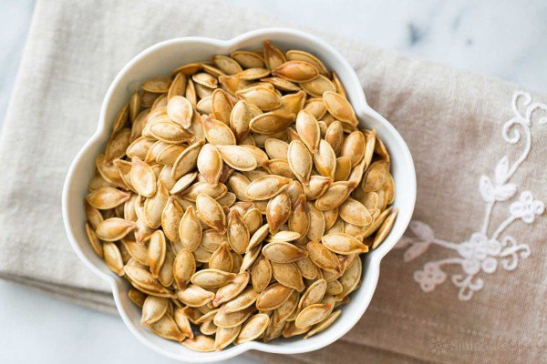
Roasted Pumpkin Seeds

Don't throw away the pumpkin seeds from your pumpkin! Roast them for a delicious healthy snack.
If you want to jazz up your pumpkin seeds, sprinkle with spices such as smoked paprika, cumin, or chile powder before they go into the oven.

Prep time: 10 minutes
Cook time: 35 minutes

INGREDIENTS
One medium sized pumpkin
Salt
Olive oil

METHOD
- Cut open the pumpkin by cutting a circle around the stem end with a sharp knife (knife blade angled in), and pulling off the top.
- Use a strong metal spoon to scrape the insides of the pumpkin and scoop out the seeds and strings.
- Place the mass of pumpkin seeds in a colander and run under water to rinse and separate the seeds from everything else.
- Measure the pumpkin seeds in a cup measure. Place the seeds in a medium saucepan. Add 2 cups of water and 1 tablespoon of salt to the pan for every half cup of pumpkin seeds. Add more salt if you would like your seeds to be saltier.
- Bring the salted water and pumpkin seeds to a boil. Let simmer for 10 minutes. Remove from heat and drain.
- Preheat the oven to 400°F. Coat the bottom of a roasting pan or thick baking sheet with olive oil, about a teaspoon or so. Spread the seeds out over the roasting pan in a single layer, and toss them a bit to coat them with the oil on the pan. Bake on the top rack until the seeds begin to brown, 5-20 minutes, depending on the size of the seeds.
- Small pumpkin seeds may toast in around 5 minutes or so, large pumpkin seeds may take up to 20 minutes. Keep an eye on the pumpkin seeds so they don't get over toasted. When lightly browned, remove the pan from the oven and let cool on a rack. Let the pumpkin seeds cool all the way down before eating.
- Either crack to remove the inner seed (a lot of work and in my opinion, unnecessary) or eat whole.

Read more at: www.simplyrecipes.com/recipes/toasted_pumpkin_seeds/#ixzz3rFEFmZth

