Vegan Cooking Class Recipes Session 38 (December, 2015)
Holiday Ideas

- Dried Cranberries (page 1)
- Potato & Tofu Hash Browns (page 2)
- How to Boil Whole Potatoes (page 2)
- Vegan Meatballs with Sauce (page 3)
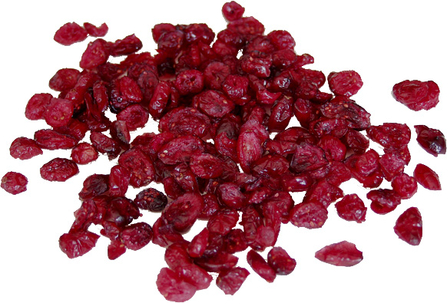
- Raw Carrot Cake (page 3)

Dried Cranberries Sweetened with Coconut Sugar
2 cups cranberries
¾ cup water
1/3 cup coconut sugar

- Rinse cranberries and take out any that don’t look right.
- Put in a pot with the water and sugar. Stir and bring to a boil.
- Lower heat to simmer and cook for about another ½ hour, until most of the berries have popped open.
- Use a potato masher to mash the hot cranberries. Try to mash down any remaining whole cranberries.
- Allow to cool a bit. It will thicken as it cools and be easier to work with.

Next you need to dehydrate the sauce. If you have a dehydrator, use that. To dehydrate in the oven, follow the directions below:
- Prepare baking sheet with 2 layers of paper towel and a layer of parchment paper on top.
- Spread the cooked sauce out on the prepared baking sheet.
- Let dehydrate in a low heated oven (170°) for about 4 hours, until it dries and holds together.
- Flip it over and leave in oven for another 4 hours or until totally dried through.
- Set out at room temperature for another few hours or overnight. Roll up in some wax paper or tear in pieces and store in a Ziploc bag or an airtight container.
- These are great in salads or trail mix or anywhere you would use dried fruit.
Source: http://thehonoursystem.com/2014/01/06/how-to-make-dried-cranberries

Potato and Tofu Hash Browns

You can use leftover mashed potatoes for this or cook some up ahead of time. An easy way to cook potatoes is to boil them whole. See following recipe. Please note also that this recipe is very flexible. You can pretty much adjust each ingredient used and the amounts to taste or to what you have on hand.

1 Tbsp. cooking oil (such as Avocado or Grapeseed)
1 onion, chopped or thinly sliced
1 red or green sweet pepper (not hot unless you want that)
4 potatoes
3 cloves garlic, minced
½ tsp. each of cumin, turmeric and smoked paprika
1 Tbsp. fresh chopped rosemary (or 1 tsp. dry)
1 box of firm or extra-firm water-pack tofu, drained
1 tsp. salt, or to taste

- Sauté the onion and sweet pepper in the oil until they begin to brown.
- Stir in the garlic for just one more minute.
- Mash the potatoes through your fingers into the fry pan (or if using mashed, just add them in.) Stir it all together.
- Next, add in the tofu. Mash it up through your fingers again, just like you did the potatoes.
- Also add the cumin, turmeric, smoked paprika, rosemary and some salt at this time.
- Mix well and let cook until the mixture browns on the bottom. Then scrape and flip over with a spatula so that the other side browns as well. You can do this several times if you are not in a hurry and they will have more crunchies that way. Stir well and let cook until the liquid from the tofu evaporates. Be careful it doesn’t burn on the bottom.
- Taste and adjust the seasonings.
- Serve with salsa or healthy ketchup. (Also good wrapped up in tortillas!)
Adapted from Potato and Tofu Breakfast Hash at: www.thewholeingredient.com

How to Boil Whole Potatoes

- Prepare the potatoes: Scrub the potatoes clean.
- Transfer the potatoes to a saucepan and cover with cold water: Cover the potatoes with an inch or two of cold water. Starting the potatoes in cold water helps them to cook more evenly.
- Stir in a teaspoon of salt: Stir the salt into the water so that it dissolves.
- Bring to a boil, and then reduce to a simmer: Set the pan over medium-high heat and bring the water to a boil. Once boiling, reduce the heat to a bare simmer to cook the potatoes. Do not cover. (Covering changes the environment in the pot and can make the potatoes turn mushy.)
- Check the potatoes after 10 minutes: Begin checking the potatoes after around 10 minutes of boiling; most potatoes will be done in 10 to 20 minutes.
- Potatoes are done when tender: The potatoes are done when they are tender all the way through. You can test this by poking the potato with a fork, paring knife, or skewer. If the utensil slides easily all the way to the center, the potatoes are done.
- Drain the potatoes: Lift whole potatoes out with a slotted spoon and let cool. If your recipe calls for cold potatoes, you can run the potatoes under cold water or dunk them in an ice water bath to cool them down more quickly.
Source: www.thekitchn.com/how-to-boil-potatoes-cooking-lessons-from-the-kitchn-64716

Vegan Meatballs with Sauce
2½ c. tortilla chips (non-GMO)
1½ c. ground walnuts
1½ c. vegan shredded fine cheese
1 large onion
3 cloves garlic
6 Tbsp. parsley, minced
½ large container of extra-firm water-pack tofu
¼ c. of flax seed in hot water
Crush chips fine. Mix ingredients together and form into balls and freeze.

Sauce
1 c. apricot jam
½ c. barbeque sauce
Cook briefly. Pour over vegan balls and bake 45 minutes at 350°.
By Darla DeVargas

Raw Carrot Cake
For the cake
1 generous cup walnuts
1 generous cup dried unsweetened coconut
1 full cup dates, pitted and ground
¾ c. raisins, ground
¼ c. flaxseed, ground fine in coffee grinder
5 c. finely ground carrots (grind in food processor until finely ground & juicy)
1 tsp. coriander
½ tsp. cardamom
Grind the walnuts in a food processor and pour into the bowl with the carrots, leaving some in the food processor. Grind dates and raisins in the food processor with the small amount of nuts until it forms a ball. Add this to the carrot mixture along with the flax seed, coriander, and cardamom. Mix by hand, kneading for smoothness. Press the mixture into a spring-form pan or cake pan. Refrigerate overnight.
For the frosting
2 c. raw cashews, soaked for up to 1 hour
2 lemons, juiced
2/3 c. raw honey
Process the cashews, lemon juice, and honey in a food processor until very smooth. Remove cake from pan and pour frosting over the top and spread down the sides. Refrigerate for at least one hour before serving.
By Theresa Clifton

