Vegan Cooking Class Recipes Session 39 (February, 2016)
Raw and Gluten-Free Options

- Greek Salad with Nuts (page 1)
- Spanakopita (Spinach Pie) (page 2)
- Zucchini with Alfredo or Marinara Sauce (page 3)
- Homemade Herbamare Seasoning (page 3)
- Crispy Quinoa Cakes (page 4)
- Greens and Seasonings (page 5)
- Raw Apple Pie (page 6)
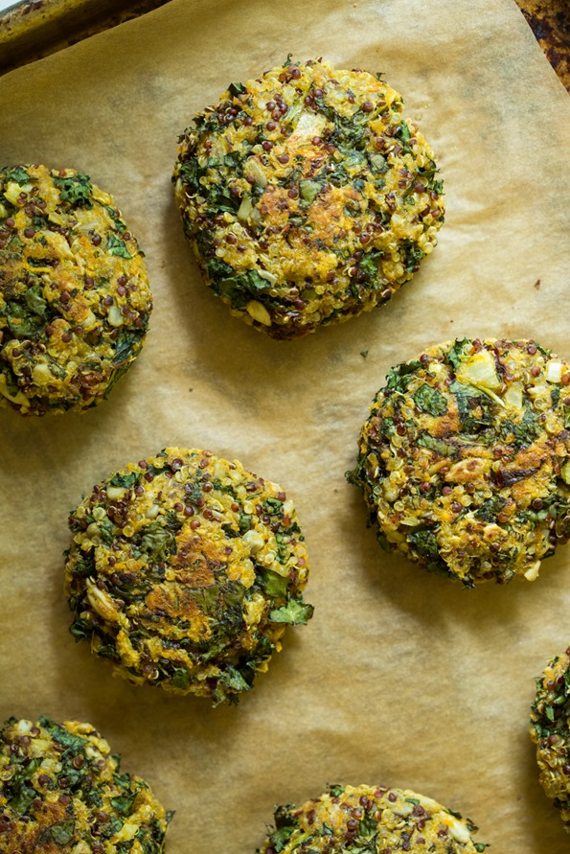

Greek Salad with Nuts

For the salad:

6 c. salad greens
1 red onion diced
1 red bell pepper, seeded & diced
½ c. cherry tomatoes, quartered
1 large cucumber, sliced ¼ c. chopped Kalamata olives Crispy Quinoa Cakes
¼ - ½ c. chopped walnuts (page 4)

Combine salad ingredients in a large salad bowl

For the dressing:

½ block of extra firm tofu crumbled
½ c. apple cider vinegar
2 tsp. lemon juice
1 tsp. maple syrup
½ tsp. salt
1 tsp. oregano
¼ tsp. thyme

Mix the dressing ingredients in a bowl and allow tofu to marinate for 1 hour.
Then pour over salad and toss to coat.

(Shared by Al & Edith Tsacle)
Credit for this recipe goes to Leanne Campbell (The China Study Cookbook)

Spanakopita (Spinach Pie) Recipe
For the filling:
- 2 bunches fresh spinach, washed, dried, trimmed, and coarsely chopped
- 1 bunch chard
- 1 leek (white part only) finely chopped
- 1 onion finely chopped
- 1 bunch green onions finely chopped
- 1/3 c. veggie broth
- 8 oz. Heidi Ho herb cheese (non-dairy) (or substitute any cashew/herb cheese)
- 1 package soft tofu (drained)
- 1/2 c. finely chopped fresh dill
- 1/3 c. finely chopped fresh flat-leaf parsley
- 1/4 tsp. freshly grated nutmeg
- Kosher or fine sea salt

For the assembly:
- Extra-virgin olive oil for brushing
- Twenty four 9” x 12” sheets frozen filo dough, thawed and at room temp

Cooking Instructions:
- Sauté onion, leek, green onions, & chopped chard stems in veggie broth.
- Add chopped spinach, chard leaves & parsley and cook for 15-20 minutes.
- Drain mixture and let cool.
- Mix soft tofu, non-dairy cheese, dill, nutmeg & salt.
- Add the spinach mixture and stir well.
- Lightly brush 9” x12” pan with olive oil.
- Add 1 sheet of filo at a time to the pan brushing each sheet lightly with oil. (Repeat this step for 12 sheets).
- Add the filling.
- Repeat step 7 to cover filling with 12 filo sheets.
- Cover pan with aluminum foil & bake at 350 degrees for 20 minutes.
- Remove foil & bake for an additional 10-15 minutes until filo is golden brown.

The credits for this authentic Greek/Vegan recipe go to Angelo Kourkoumelis,
Yiayia Nitza, and Lefteri (Shared by Al Tsacle)
Zucchini Pasta with Alfredo or Marinara Sauce
Pasta
Choose small, firm zucchinis. Wash and cut into 3 inch pieces. Run through spiral slicer to make spaghetti, or through a Spirooli to make linguini. Serve with the following sauce. This pasta is also delicious with a fresh tomato sauce or with a fresh basil pesto!

Alfredo Sauce
½ cup raw cashews
1 Tbsp. nutritional yeast
1 tsp. light miso
¾ tsp. Herbamare seasoning
2 tsp. onion powder
1 tsp. garlic powder
Blend all ingredients in blender with enough water to make a thick cream, and serve over zucchini pasta.

Marinara Sauce
1 ripe tomato, chopped (about ½ c.)
½ c. sun-dried tomatoes, soaked
½ red bell pepper, chopped (about ½ c.)
2 Tbsp. extra-virgin olive oil
1 Tbsp. minced fresh basil, or 1 tsp. dried
1 tsp. dried oregano
½ tsp. crushed garlic (1 clove)
¼ tsp. plus 1/8 tsp. salt
A dash of cayenne
2 Tbsp. sliced black olives
Place all the ingredients in a food processor fitted with the S blade and process until smooth. Stop occasionally to scrape down the sides of the bowl with a rubber spatula.
Stored in a sealed container in the refrigerator, Marinara Sauce will keep for three days.
A Jeanie Davis recipe, found on http://www.baysidenaturalhealth.com/id121.html

Substitute for Herbamare – A Seasoned Salt Recipe
½ c. sea salt
¼ c. dried parsley
2 tsp. onion powder
2 tsp. garlic powder
1 tsp. oregano
1 tsp. rosemary
1 tsp. thyme
1 tsp. sage
1 tsp. basil
1 tsp. celery seed
1 tsp. marjoram
1 tsp. dried kelp
- Place all ingredients in a food processor and chop until smooth and blended.
- Let the spices settle, then remove from the food processor and store in an airtight container.
Use as called for in recipes. Author: Alea Milham on http://premeditatedleftovers.com/recipes-cooking-tips/how-to-make-a-substitute-for-herbamare-at-home-seasoned-salt-recipe
Crispy Quinoa Cakes
Vegan, gluten-free, nut-free, refined sugar-free, soy-free.

Crispy quinoa cakes packed with vegetables like kale, sweet potato, sun-dried tomatoes, and more! Enjoy these as part of breakfast, lunch, or dinner. They are great with roasted home fries and avocado toast, on top of a salad, in a wrap, or enjoyed all of their own. It's important to make sure the vegetables are finely chopped for this recipe. If the pieces are too large, the patties won't stick together as well.
1½ c. cooked quinoa
2 Tbsp. ground flax (or 2 tsp. ground chia) + 6 tablespoons water
1 c. destemmed and finely chopped kale (or other greens)
½ c. rolled oats, ground into flour (use certified gluten-free if necessary)
½ c. finely grated sweet potato
¼ c. finely chopped oil-packed sun-dried tomatoes
¼ c. sunflower seeds
¼ c. fresh basil leaves, finely chopped
2 tsp. finely diced onion
1 clove garlic, minced
1 Tbsp. runny tahini paste
1½ tsp. dried oregano
1½ tsp. red or white wine vinegar (or apple cider vinegar)
½ to 1 tsp. fine grain sea salt, or to taste
3 Tbsp. gluten-free all-purpose flour or regular all-purpose flour
Red pepper flakes, to taste

- Preheat oven to 400°F. Line a large baking sheet with parchment paper.
- Mix the ground flax and water in a small bowl and set aside for 5 minutes or so to thicken.
- Combine all ingredients together in a large bowl, including the flax mixture and the 1.5 cups cooked quinoa. Stir well until the mixture comes together. Don't forget the flour because it helps bind the patties.
- Shape mixture into ¼ cup patties with wet hands. Pack tightly so they hold together better. Place on baking sheet.
- Bake for 15 to 20 minutes, then carefully flip cakes, and bake for another 8-10 minutes until golden and firm.
- Cool for 5 minutes on the sheet and then enjoy!
- Store leftovers in a container in the fridge for up to 5-6 days. To reheat, preheat a skillet over medium heat, add a bit of oil, and cook patties for about 3 minutes per side, or until heated through.

Tips:
1) To cook quinoa, rinse 1 cup uncooked quinoa in a fine mesh strainer. Place quinoa in a medium pot and cover with 1½ cups water. Bring to a low boil, reduce heat to medium-low, and then cover with a tight fitting lid. Simmer covered for 14-17 minutes until most of the water is absorbed and the quinoa is light and fluffy. Remove from heat, fluff with a fork, and then place lid back on to steam for another 4-5 minutes. Note that this makes almost 3 cups of cooked quinoa and you only need 1½ cups for this recipe, so you will have leftover quinoa.
2) To make oat flour, add the oats into a high speed blender and blend on the highest speed until a fine flour forms. You can also use store-bought oat flour if desired.
www.vegetariantimes.com/recipe/crispy-quinoa-cakes

How to Keep Greens Fresher Longer

Just recently, a friend showed me this easy way to keep that big bunch of cilantro, or fresh parsley, or kale or spinach etc. fresh and ready to eat.

Wash the greens well in clean water. Spread out a big clean dishtowel on the table. Spread out your washed greens on it in a single layer, taking care that no ends go beyond the edge of the towel. Then roll it all up! From one end to the other, like a sleeping bag. Put that roll in a plastic grocery sack and wrap it up loosely.

Keep it in the refrigerator until you’re ready to use it. Each time you take some out, check for yellowing pieces and remove them. If the towel becomes dry, remove the greens, rinse and wring the dishtowel tightly. Then wrap the greens up again. If you still have them after two weeks, you may want to change out the dishtowel for a fresh one (be sure to rinse and wring it before rolling up the greens again).

It’s so great to not waste greens anymore when they rot before I get around to using them. Also, since they are already washed and ready to go, I find I am much more likely to use them often, like we are supposed to for good health!

All Purpose Seasoning
4 tsp. onion powder
2 tsp. garlic powder
2 tsp. mustard powder
¼ tsp. dried thyme
1 tsp. sea salt

Smokey Southwest Seasoning
1 Tbsp. chili powder
2 tsp. ground cumin
1 tsp. coriander
½ tsp. onion powder
½ tsp. garlic powder
½ tsp. dried oregano
½ tsp. smoked paprika
1 tsp. sea salt

Mediterranean Seasoning
4 Tbsp. dried parsley, crushed
4 tsp. dried onion flakes
2 tsp. dried basil, crushed
1 tsp. ground oregano
1 tsp. ground thyme
1 tsp. garlic powder
1 tsp. sea salt

Better-than-Baked Raw Apple Pie

Crust: In a food processor add 2 c. raw pecans
½ c. pitted dates
Process until crumbly, press in pie pan, chill.

Filling: 6 medium organic apples, peeled
½ c. Medjool dates
¼ c. of craisins or raisins
¼ tsp. ground coriander
½ tsp. anise
¼ inch stick of fresh Ceylon cinnamon (soft bark cinnamon)

- Put through the food processor with larger-size slicer.
- Mash 1 banana and mix with apple mixture.
- Scoop in pie crust and chill.

Serve with homemade Vegan ice cream or soy whipped topping. YUMMY!!!
By Darla DeVargas

