Vegan Cooking Class Recipes Session 42 (October, 2016)
Tacos, Barbecued Zucchini Chips, Crackers, Apple Crisp & Ice Cream

- Quinoa Taco Meat (page 1)
- Tangy Smoky Cream (page 2)
- Better Vegan Butter (page 2)
- Gluten-Free Whole-Grain Flour Mix (page 2)
- Barbecued Zucchini Chips (page 3)
- Chicken-Style Seasoning (page 4)
- Fabulous Crackers (page 4)
- Gluten-Free Vegan Apple Crisp (page 5)
- Vegan Vanilla Coconut Ice Cream (page 5)

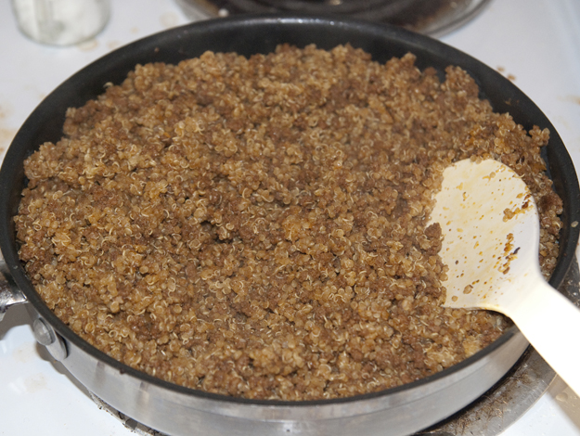
Quinoa Taco Meat
1 c. dry quinoa
1 c. vegetable broth
¾ c. water
½ c. salsa (mild if you don’t want spicy taco meat)
1 Tbsp. nutritional yeast flakes
2 tsp. cumin powder
2 tsp. chili powder
½ tsp. garlic powder
½ tsp. sea salt
1 Tbsp. avocado oil

- Rinse quinoa before cooking to wash away any possible bitterness.
- Place in pan with 1 c. vegetable broth and ¾ c. water. Bring to boil. Then reduce heat and cover and simmer for 15-25 minutes until liquid is completely absorbed.
- Take the pan off the heat, fluff the quinoa with a fork, put the lid back on but leave it cracked so some steam can get out and let it sit another 10 minutes to finish.
- Heat the oven to 350° F.
- Add the rest of the ingredients and stir well.
- Spread the seasoned quinoa onto an oiled baking sheet (or parchment paper lined).
- Bake for about 25 to 30 minutes, just until dry and crumbly. Stir halfway through to ensure even browning. Be careful not to bake longer, as it can get quite crunchy (unless you like crunchy!).

Pack it into your tortillas along with some tomatoes, avocado, cilantro, etc. and some Creamy, Tangy, Smoky Sauce (see recipe on next page)!
Adapted from www.minimalistbaker.com.

Tangy Smoky Cream
Yummy to use with anything that needs sour cream and a cheesy flavor. Great as a base for dips too!

Whiz up the following ingredients in a blender until smooth, and it’s done.

1 box Mori Nu tofu (firm or extra-firm)
2 Tbsp. tahini (sesame butter)
2 Tbsp. lime juice
½ tsp. raw sugar
½ tsp. sea salt
¼ tsp. garlic powder
¼ tsp. mustard powder
¼ tsp. liquid smoke
By Diana Adams

Better Vegan Butter
Melt your jar of coconut oil. Make sure it is the kind that doesn't smell/taste like coconut. You want the refined kind here.
Mix and let stand for a few minutes:
½ c. plain unsweetened soymilk or almond milk
1½ tsp. salt

Then, add to blender with:
1 c. melted coconut oil
¼ c. avocado oil
4 tsp. granular lecithin

- Whiz until well blended, especially the lecithin granules.
- Put in a butter container or mold and cool until solid in the freezer. Then place it in the fridge. That is to be sure it doesn't separate before it hardens.
This butter recipe is a variation of Miyoko’s recipe at: http://astigvegan.com/2013/10/02/miyokos-vegan-and-palm-oil-free-butter-and-cream-cheese

Gluten-Free Whole-Grain Flour Mix
This recipe makes a gluten-free whole-grain flour mix that’s a good substitute for whole-wheat flour — especially in gluten-free bread and dessert recipes. Having this flour baking mix on hand means you’ll be more likely to make breads or cakes because you can just reach for a mix instead of hauling out several bags of gluten-free flours.
4½ c. minus 1 Tbsp. brown rice flour
4¾ c. plus 2 Tbsp. sorghum flour
3¼ c. minus 1 Tbsp. millet flour
1¾ c. sweet rice flour

- In a large bowl, combine all ingredients until the mixture is one color.
- Use a wire whisk to stir for best results.
- Store in an airtight container and use in baking recipes in place of flour.
By Jean McFadden Layton & Linda Larsen at www.minimalistbaker.com.
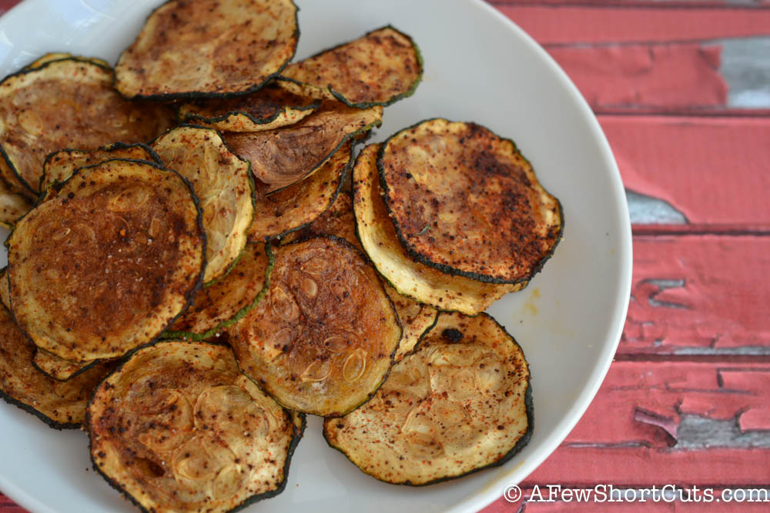

Barbecued Zucchini Chips
(You need a dehydrator with some fine mesh removable screens and a mandolin slicer.)

3 Zucchini Squash (about 9 inches long each)
This filled about 8 trays on my dehydrator (which are about 14” diameter rounds.)

Wet Mix:
2 Tbsp. Lemon/Lime Juice
2 Tbsp. Coconut or Raw Sugar
¼ c. Tomato Paste
½ tsp. Liquid Smoke
2 Tbsp. Olive Oil

Sprinkle Mix: (It does not always use the whole amount, so perhaps you could use the extra on popcorn or save for next time.)

2 Tbsp. Nutritional Yeast Flakes
1 tsp. Pink Salt or Sea Salt
1 Tbsp. Onion Powder
2 tsp. Paprika
½ tsp. Garlic Powder

- Get your dehydrator trays cleaned up, dry and ready. Be sure and use the fine mesh screens (available online) so the dried chips can be easily removed and not stick to the trays.
- Soak the sugar in the lemon/lime juice in a small bowl so that it can dissolve well.
- While that is soaking, measure and mix all the Sprinkle ingredients together and put into a shaker bottle (or empty out an herb canister with a sprinkler and borrow that.)
- Add the rest of the ingredients for the wet mix into the small bowl and cream it all together well. Set aside.
- Now wash and dry the zucchinis. Use a mandolin cutter to slice the zucchinis into thin rounds about 1/8 inch thick. Be careful not to slice your fingers!
- In a large shallow container add the wet mix to the zucchini slices and spread it evenly throughout all the slices. Go ahead and get your hands in there! Just be sure they are clean or use some disposable gloves. The slices will not seem to be very thickly coated and that is okay. When they dry, they shrink and the flavors will all become more concentrated.
- Spread out the wet slices on the trays making sure none overlap. They can touch side to side.
- Sprinkle on the sprinkle mix until all are evenly coated. Remember not to go too thickly as they are going to shrink down a lot and concentrate the flavors.
- Stack the trays and the cover and turn it on. I dried mine at 115° F for about 24 hours. This is the highest temperature you can use while still preserving the live enzymes. Just dry them until they are crispy.
- Store in a Ziplock bag or airtight container with a paper towel to soak up extra oil.
By Diana Adams

Chicken Style Seasoning (Non-Spicy No-Salt)
2 c. nutritional yeast flakes
1/3 c. onion powder
¼ c. Italian seasoning (no salt added)
1/6 c. dried parsley (half of a 1/3 cup measure)
1/8 c. Sucanat or cane juice crystals
1½ Tbsp. garlic powder
¾ tsp. celery seed

- Blend all ingredients in a blender until very fine.
- Store in an airtight container.
- To make broth, add 1 Tbsp. of Chicken Style Seasoning mix to 1 cup of water.
Adapted from “Give Them Something Better” by Sarah Frain & Stephanie Howard

Fabulous Crackers (super simple, super fast and super delicious!)
1 c. dark rye flour
½ c. steel cut oats
¼ c. millet, dry
¼ c. flaxseed, ground slightly or use flaxseed meal
¼ c. sunflower seeds
¼ c. sesame seeds
¼ c. pumpkin seeds
½ tsp. salt
1 c. water

- Mix all dry ingredients; add water & mix.
- Spread out on parchment-lined cookie sheet to about 12"x12". Score any way you like.
- Bake at 350° degrees for 1 hour, rotating pan half way through.
- Allow to cool before breaking apart.
From “Pure & Beautiful Vegan Cooking” by Kathleen Henry

Gluten- Free Vegan Apple Crisp
Vegan gluten free apple crisp that has all of the warmth, spice and sweet flavor of traditional versions. It's also ridiculously simple to throw together.
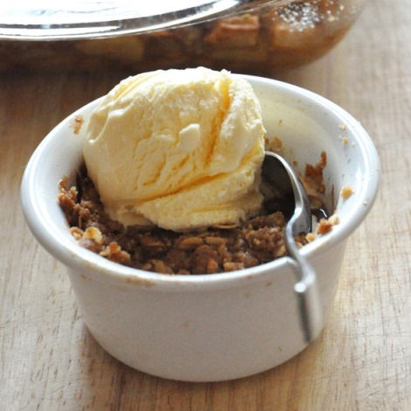
8 small-medium apples, peeled, cored and chopped (a variety of both sweet and tart - about 6 cups worth)
Dash lemon juice
1/3 c. sugar (or ¼ c. maple syrup)
1 Tbsp. cornstarch
Heaping ½ tsp. cinnamon
Pinch of salt

TOPPING
Heaping 1/3 c. packed light brown sugar (or coconut sugar)
¼ c. gluten-free flour blend (see recipe on page 2)
½ c. gluten free old fashioned or quick oats
¼ c. almond meal
¼ tsp. cinnamon
Pinch of salt
1/3 c. (a little more than 1/2 one stick) non-dairy butter melted, such as Earth Balance

- Preheat oven to 350° degrees and lightly grease a 9x9 baking dish.
- Add apples to a large bowl or plastic bag and sprinkle with lemon juice. Toss to coat with granulated sugar, cornstarch, cinnamon, and salt.
- Transfer to baking dish and set aside.
- Rinse and dry bowl and add brown sugar, flour, meal, oats, cinnamon and salt and stir. Add melted butter and mix until it resembles wet sand.
- Bake filling for 30 minutes, sprinkle topping over the apples and bake until apples are soft and topping is golden brown (usually another 20 minutes).
- Let rest 10-15 minutes before serving. Is great with vanilla ice cream.
Adapted from Barbara Bakes

Creamy Delicious Vegan Vanilla Coconut Ice Cream
We use a Cuisinart Frozen Dessert Maker which uses a pre-frozen bowl instead of ice.

In a blender combine the following until creamy:
1 can coconut milk (14 fl. oz.)
1 can non-dairy milk (use coconut milk can for measuring)
¼ c. melted coconut oil
½ c. mild honey (clover or orange is good)
2 tsp. vanilla (powdered white vanilla if you have it)
¼ tsp. salt

- Pre-freeze ice cream maker bowl for at least 12 hours.
- Place blender with mixture in refrigerator to chill.
- Pour into ice cream maker and turn it on. It should be ready in about 30 minutes.

Adapted from www.wholenewmom.com Vanilla Coconut Ice Cream

