Vegan Cooking Class Recipes Session 43 (November, 2016)
Fully Raw Thanksgiving Dinner

- Cranberry Salad (page 1)
- Tom Turkee (page 2)
- Cashew Gravy (page 3)
- Raw Mashed “Potatoes” (page 3)
- Pumpkin Cheesecake (page 4)
- Buttery Pie Crust (page 4)
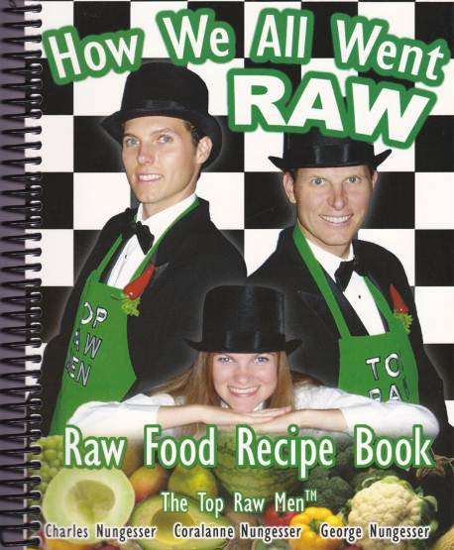

Unless otherwise indicated, all recipes are from “How We All Went Raw” by Charles, Coralanne and George Nungesser.

Cranberry Salad
20 minutes to prepare

In a blender, add:
1 cup cranberries
1 cup dates, pitted and soaked in 2 cups of water for 10 minutes, strain and discard water
½ teaspoon allspice
2 teaspoons cinnamon
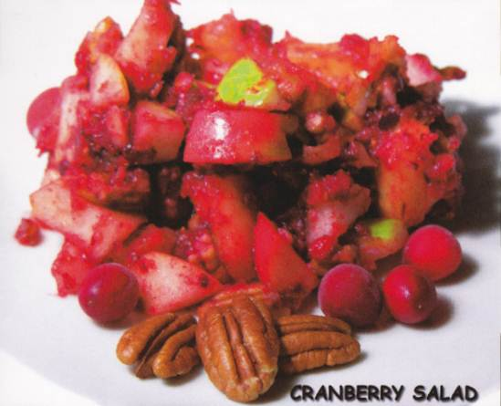
½ teaspoon ground cloves
2 teaspoons coconut butter, optional
Blend together well.

In a separate bowl, add:
2 pears, cored and chopped
2 apples, cored and chopped
1 cup pineapple, chopped
1 cup walnuts or pecans, chopped
½ cup raisins
Pour blender content s over fruit and mix well. Great to be serve at Thanksgiving and Christmas for dinner.

TOP HAT TI P: Coconut butter may be purchased at Nature's First Law at www.rawfood.com.

Tom Turkee
4 hours to soak nuts 20 minutes to mix together
5 minutes to shape dehydrate 10 hours at 105°F

Recipe is for a chicken size bird. You can double the recipe to make a turkey.

Soak the following nuts for 4 hours, then drain and rinse:
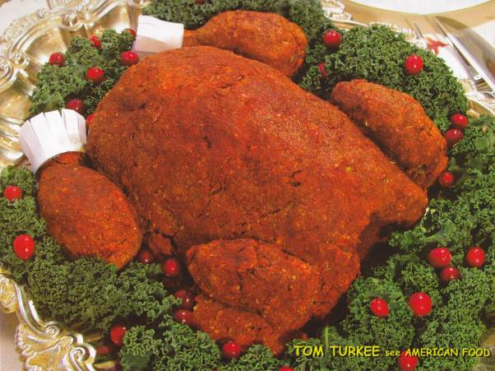
2 cups pecans
2 cups almonds
1 cup pine nuts
1 cup cashews

Other ingredients:
1 medium white onion
6 garlic cloves

Run the nut s, onion, and garlic cloves through a Champion® Juicer, GreenLife® Juicer, or Samson® Juicer, with a BLANK screen. Place "homogenized nuts" into a large bowl.

Mix the following ingredients together and then add them to the "juiced nuts."
2 celery stocks, hand sliced real fine
4 teaspoons lemon juice
1 tablespoon cumin powder
6 garlic cloves
2 tablespoons Rosemary
6 tablespoons psyllium husks
6 teaspoons Celtic Sea Salt

Mix well. Using clean hands with food handler gloves works great. Sculpture the ingredients into the shape of a turkey on a dehydrator tray with non-stick sheet. Make a large main body then add wings and drumsticks.

"Wishbone, anyone?"
If you "wish," you can make a "wishbone" out of jicama. Slice a large piece of jicama about ¼ inches thick. Carve a large wish bone shape. Dehydrate until it is shriveled and dry. Place wishbone inside the turkey (if you remember where to put it?).

Baste the turkey with the mixture of:
1½ tablespoons Nama Shoyu sauce (raw soy sauce)
1 cup extra virgin cold pressed olive oil
1-2 tablespoons of Paprika

Dehydrate about 10 hour s in an Excalibur® Dehydrator at 105°F. Time will vary depending on atmospheric conditions. Serve the turkey on a silver platter, knife, fork, & garnish.

Cashew Gravy
10 minutes to prepare

In a blender, add:
2 cups raw cashews, well rinsed
1½ cups distilled water
1 teaspoon sea salt or to taste
1 garlic clove

Blend until smooth. If gravy is too thick, just add more water till you get the thickness you desire.

Raw Mashed “Potatoes”
1 cup raw cashews (wash well and soak for at least 1 hour ahead of time)
1 medium jicama, peeled and chopped in 1” pieces (about 3 cups)
½ teaspoon sea salt
1/8 teaspoon garlic powder
1 teaspoon nutritional yeast flakes

- First, using the S blade, chop ONLY the jicama in a food processor until it has the consistency of mashed potatoes. Wipe down the sides several times to make sure it all gets “mashed.”
- Next put the mashed jicama in a strainer and push out as much of the liquid as you can.
- Return the mashed and drained jicama to the processor with the cashews and remaining ingredients. Work again as in the first step until the cashews are chopped super-fine and all is like mashed potatoes.
- Ready to place in a serving bowl and eat!
- They can be warmed in a dehydrator at 105° F for a while before the meal if desired.
By Diana Adams

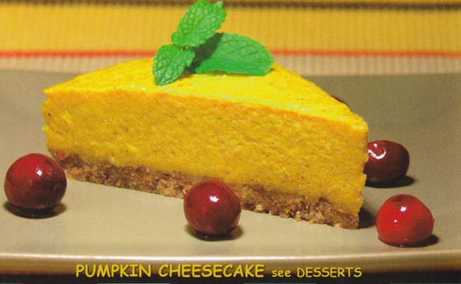
Pumpkin Cheesecake
1 hour to soak cashews
30 minutes to prepare

Needed: 1 Buttery Pie Crust (recipe below) Use a springform pan for cheesecake.

Pumpkin Cheesecake filling:
In a food processor using the S blade, add:
3 cups pumpkin, peeled and chunked
3 cups cashews, soaked for at least 1 hour

When smooth, add the remaining ingredients:
½ cup agave
¾ cup maple syrup
1 teaspoon cinnamon
½ teaspoon nutmeg
½ teaspoon ginger
¼ teaspoon clove
½ teaspoon sea salt

Pour mixture on top of the crust. Remove air bubbles by tapping the pan on counter top. Freeze for several hours or until firm. Remove the whole cheesecake from the pan and serve while slightly frozen.

Buttery Pie Crust
15 minutes to prepare

In a food processor using the S blade, add:
2 cups pecans or walnuts. Blend into small pieces.

Then add the following:
¼ teaspoon salt
¼ teaspoon vanilla
1 cup dates, soaked about 5 minutes to soften
¼ cup ground flax seeds
Blend until it turns into a ball. Be careful not to blend too long.

