Vegan Cooking Class Recipes Session 44 (December, 2016)
Holiday Goodies

- Fall Quinoa Butternut Salad (page 1)
- Melty Stretchy Vegan Mozzarella (page 2)
- Vegan Spinach & Artichoke Dip (page 3)
- German Apple Muffins (page 4)

Fall Quinoa Butternut Salad
3 c. butternut squash, peeled and cut into 1/4 inch cubes
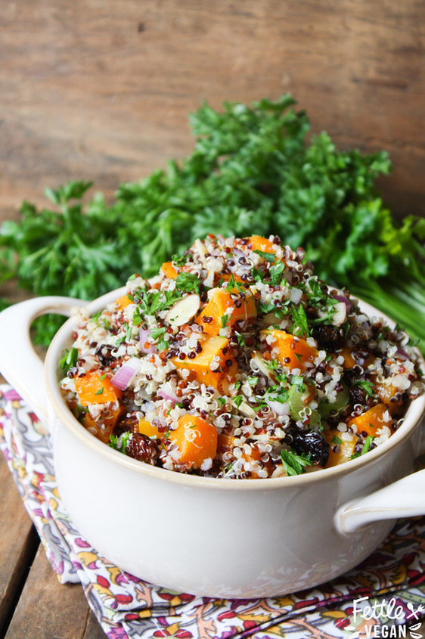
2 c. water
1 c. rainbow (or really any kind) quinoa
1/3 c. celery, sliced thinly
1/3 c. red onions, diced
1/3 c. golden berries, roughly chopped
1/3 c. sliced almonds
3 Tbsp. fresh parsley, chopped
2 Tbsp. lemon juice
1 Tbsp. olive oil
1 Tbsp. apple cider vinegar
1 tsp. mustard powder
1 tsp. maple syrup
½ tsp. salt

- Preheat oven to 400° degrees and line a baking sheet with parchment paper.
- Peel and cut butternut squash into ¼” cubes and place on the parchment paper-lined baking sheet. Drizzle with olive oil and a sprinkle of salt and bake about 30 minutes, flipping halfway through.
- While squash bakes, place quinoa and water in a medium saucepan. Bring to a boil, reduce to a simmer, then cover with a lid and cook until liquid is absorbed, about 20 minutes.
- Prepare celery, red onions, golden berries, sliced almonds, and fresh parsley and place it into a large bowl. Set aside.
- In another small bowl, whisk together lemon juice, olive oil, vinegar, mustard, maple syrup and salt.
- When squash and quinoa have finished cooking and cooled, pour the quinoa and roasted butternut squash into the large bowl of veggies and gently toss with a wooden spoon. Drizzle the vinaigrette mixture over the salad and toss again to combine.
Serve immediately or save in the fridge up to 3 days in an airtight container. Serves 6-8. Enjoy!

NOTES:
If you don't have or don't like golden berries or almonds or any other ingredient, sub it out for something you LOVE! This salad is super customizable and you should totally take advantage of that based on your preferences and what you have in the pantry.
Source:
www.fettlevegan.com/recipes/fall-quinoa-salad-with-roasted-butternut-squash-and-golden-berries

Melty Stretchy Gooey Vegan Mozzarella
¼ to ½ c. raw cashews (see notes below)
1 c. water
3 Tbsp. + 2 tsp. tapioca starch (also known as tapioca flour)
1 Tbsp. of nutritional yeast
1 tsp apple cider vinegar
½ tsp. salt
¼ tsp. garlic powder

- If you do not have a high-powered blender, you will first need to boil or soak the cashews to soften them. To Soak the Cashews: cover with water and soak for 4 hours or overnight. To Boil the Cashews: Cover with water and bring to a boil for 10 to 15 minutes until they are tender and can be easily broken between your fingers.
- Drain the cashews and add them along with the 1 cup of water and all the remaining ingredients to a blender. Blend until completely smooth. It will be very watery.
- Pour into a small sauce pan over medium-high heat, and continually stir as it cooks. As you stir, it will start forming clumps, and then all of a sudden it will become a cheesy gooey mass of yumminess. This takes about 5 minutes. Continue to cook and stir for an additional 2 minutes to make sure it has firmed up completely. Use for anything you like! Scoop up with tortilla chips, dollop onto pizza before baking, make a grilled cheese sandwich, or whatever your heart desires. Store in an airtight container in the fridge.

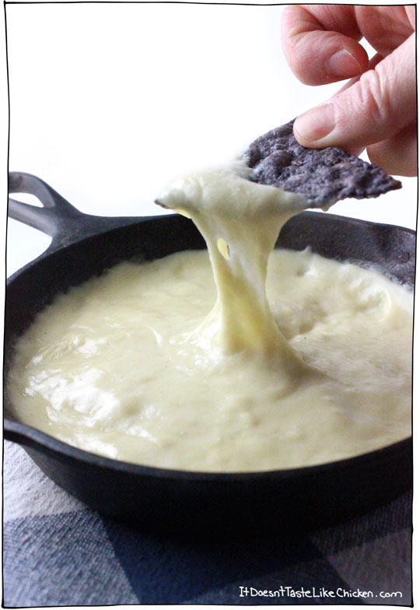
NOTES
*I originally went with ¼ cup of cashews, but lately I have been using a ½ cup for an even creamier consistency.
*Tapioca starch is essential for this recipe. It is what gives the cheese its gooey and stretchy texture.
*If you want to return the cold mozzarella back to dipping consistency, reheat over medium heat while stirring constantly so it doesn't burn. Once it is hot and bubbling, it might have thickened up too much. You can thin it out by adding a tablespoon of water at a time, stirring it in until desired consistency is reached.
*If you don't have a high powered blender, you may want to pour the liquid through a fine mesh strainer or cheesecloth before cooking to remove any cashew bits that didn't grind up. This will ensure a smooth cheese texture.

Source:
http://itdoesnttastelikechicken.com/2015/01/23/melty-stretchy-gooey-vegan-mozarella

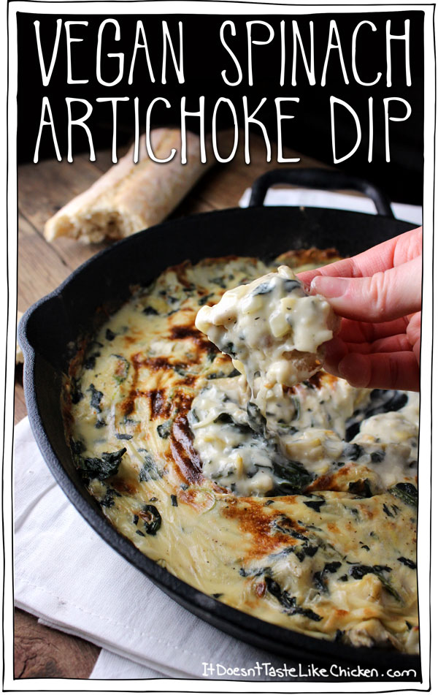

Vegan Spinach & Artichoke Dip
A double batch of the Melty Stretchy Gooey Vegan Mozzarella recipe. (Can be made in advance or right before making the dip).
2 6-oz jars marinated artichoke hearts (or 1½ cups)
½ medium yellow onion
3 cloves garlic
2 c. frozen spinach
½ c. unsweetened nondairy milk (more if needed)
¼ tsp. salt (optional)
Bread, chips, veggies, or whatever you want to use to dip!

- Preheat oven to 400°F.
- Make a double batch of Melty Stretchy Gooey Vegan Mozzarella. You can do this ahead of time and keep the mozzarella in an air tight container in the fridge until you are ready to use it, or you can make it right before creating this recipe. It only takes 15 minutes!
- Drain the artichoke hearts and roughly chop them. Finely chop the onion and garlic.
- Add all of the vegan mozzarella to an oven-safe dish, along with the artichoke hearts, onion, garlic, spinach, ½ cup non-dairy milk, salt, and pepper. Give it a stir. It will probably be lumpy and not really come together, but that's totally cool.
- Pop it in the oven for 20 minutes, stopping halfway to give it a stir. If it gets to thick, thin it by mixing in a bit extra non-dairy milk.
- Once fully cooked, you can brown the top if you like. Turn your oven to broil, and put under the broiler for 3 minutes. Check continuously so that it doesn't burn – it browns fast!!
- Serve right away with bread, chips, veggies, or whatever you like to dip with.

Source:
http://itdoesnttastelikechicken.com/2015/02/18/vegan-spinach-artichoke-dip

German Apple Muffins (makes 12)

3 apples, peeled and sliced and steamed for just a minute, then cooled

Preheat oven to 375°F

To make topping, mix well:
¼ c. coconut sugar
½ tsp. Ceylon cinnamon
½ tsp. ginger powder

In one bowl mix:
1½ c. whole wheat flour
½ c. oat flour
2 tsp. baking powder
½ tsp. sea salt
¼ c. plus 2 Tbsp. coconut sugar
2 Tbsp. of above topping mix

In another bowl mix:
1 c. applesauce
¼ c. melted vegan butter
¼ c. nut milk

- Next add the mix from the first bowl (the flour etc.) into the second bowl (applesauce etc.)
- Mix just until all is an even consistency
- Spoon into muffin cups, oiled or nonstick.
- Cover each with some apple slices – only one layer.
- Lastly, sprinkle with topping mix.
- Bake at 375°F for about 30 minutes.

By Diana Adams, inspired by a cake recipe in “The Joy of Vegan Baking”

