Vegan Cooking Class Recipes Session 45 (January, 2017)
New Year Variety

- Lentil Mushroom Spinah Burgers (page 1)
- Roasted Butternut Squash Cubes (page 2)
- Snickerdoodle Cookies (page 3)

Lentil Mushroom and Spinach Burgers

½ c. dry lentils
¾ c. cornmeal (add chicken style seasoning/italian, etc. to taste)
2 Tbsp. flaxseed, in ½ c. water. Cook on stove for 5 minutes. Then strain liquid. Toss the seeds.
1 Tbsp. chia seed (freshly ground)
1 tsp. Braggs Liquid Aminos
2 tsp. Lite Soy Sauce
½ tsp. apple cider vinegar
1 tsp. garlic powder
5 baby Portobello mushrooms (minced)
1 oz. fresh spinach (or one large handful) minced
½ red onion, chopped
1/3 c. quick oats (not instant, use 1-minute cooking oats; can add more later for consistency)
½ tsp. salt

- Cook lentils until tender, in about 1½ c. water for about 15 minutes. Set aside or refrigerate until needed.
- Add chia seeds to flaxseed liquid and set aside for 5 minutes.
- Meanwhile, in large bowl mix all above ingredients, except for flax liquid.
- Mix with hands, breaking up mushrooms and lentils. Add flax liquid and mix well.
- Make small patties and put on waxed paper for 15 minutes.
- Add 1 Tbsp. oil to pan and grill burgers on each side for 5-7 minutes.
Enjoy with bread, avocado, lettuce. Can use in a variety of dishes. Spaghetti sauce, etc.
Freeze and use as needed.

By Linda Lange

Roasted Butternut Squash with Lime and Rosemary

4-5 c. Butternut squash cubes
1½ Tbsp. olive oil
1 Tbsp. fresh squeezed lime or lemon juice
2 tsp. finely minced fresh or dried rosemary
¼ tsp. garlic powder
½ tsp. sea salt

- Preheat oven to 400° F.
- Peel squash and cut into cubes about ¾ inch square.
- Put squash into mixing bowl, add olive oil, lime juice, minced rosemary, garlic powder and salt and toss well so squash is all coated.
- Arrange squash on roasting pan in single layer.
- Roast for 40-50 minutes, or until squash is quite softened and getting browned on the edges.
- Turn after 35 minutes so squash will brown evenly.
- Serve hot.

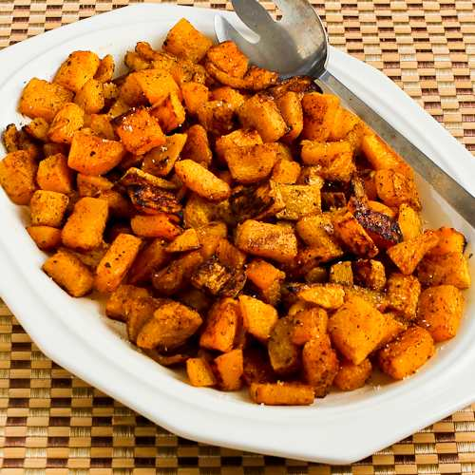

Snickerdoodle Cookies that are Dairy-free, Grain-free and Vegan
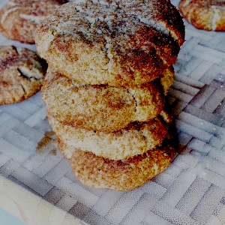
Makes 12 - 15 cookies

2 c. almond flour or meal
¼ c. coconut oil, softened
¼ c. maple syrup (at room temperature)
2 tsp. Ceylon cinnamon
1 tsp. vanilla extract
¼ tsp. salt
½ tsp. baking soda

Topping
1 Tbsp. coconut or other natural sugar
1½ tsp. Ceylon cinnamon

- Preheat oven to 350° degrees.
- Line a baking sheet with parchment paper.
- In a large mixing bowl, combine almond flour, cinnamon, baking soda, and salt, mixing until well combined.
- Add coconut oil, maple syrup, and vanilla, mixing until the dough starts to thicken and all the ingredients are combined.
- Add the toppings - cinnamon and sugar - to a small bowl.
- Scoop out a spoon full of the dough and form a ball.
- Then roll the dough ball in the cinnamon sugar and put it on baking sheet.
- Flatten the dough ball with your hand by gently pressing on the cookie. Repeat this with all the dough.
- Put cookies in oven and bake for 10 - 12 minutes. They should be a golden brown color.
- Remove from oven and allow to cool on sheet for at least 10 minutes.
- Serve and enjoy!

Benefits of this recipe include:
- Good source of fiber and protein
- Assists in reducing blood pressure
- Contains antioxidants and anti-inflammatory properties
- Helps lower bad cholesterol
- Will not spike your blood sugar levels like unhealthy desserts

Adapted from recipe by Megan Lawson at:
https://megunprocessed.com/2016/02/easy-grain-free-snickerdoodle-cookies

