Vegan Cooking Class Recipes Session 46 (February, 2017)
Soup, Rice & Beans, Cornbread and Chocolate Bars
- Collards and Cream Soup (page 1)
- Chicken Style Seasoning (page 2)
- Caribbean Rice and Beans (page 2)
- Vegan GF Corn Bread (page 3)
- GF Whole-Grain Flour Mix (page 3)
- Homemade Chocolate Bars (page 4)
- Almond Raspberry Cookies (page 5)

Collards and Cream Soup
(Makes about 6 cups of soup)

Cook greens first with:
1 – 2 bunches of collard greens, washed, cored and loosely chopped
1 Tbsp. oil
1 large onion, chopped
2-3 cloves garlic, minced
¼ c. vegan chicken-style seasoning (see next recipe)
2 c. water

To make the cream:
1 c. raw cashews, rinsed well
¼ tsp. liquid smoke
½ Tbsp. sea salt
2 c. water

- In a large pot, sauté the onion with the oil until golden brown.
- Add minced garlic at end and stir for another 30 seconds or so.
- Add 2 c. of water and ¼ c. of chick seasoning and stir well.
- Add the greens, stirring occasionally for the first few minutes to allow the greens to shrink down into the broth. Mix them well into the broth.
- Bring to a boil and simmer a long time, until the greens are tender.
- If you have an Instant Pot, pressure cook on low for 15 minutes.

While the greens are cooking, prepare the cream by blending the cashews, sea salt, and liquid smoke in 2 c. of water until very creamy.

When the greens are done, add the cream into the pot, stir and simmer another 10 minutes or until the cashew cream thickens up.

Enjoy!

By Diana Adams

Chicken Style Seasoning (Non-Spicy No-Salt)
2 c. nutritional yeast flakes
1/3 c. onion powder
¼ c. Italian seasoning (no salt added)
1/6 c. dried parsley (half of a 1/3 cup measure)
1/8 c. Sucanat or cane juice crystals
1½ Tbsp. garlic powder
¾ tsp. celery seed

- Blend all ingredients in a blender until very fine.
- Store in an airtight container.
- To make broth, add 1 Tbsp. of Chicken Style Seasoning mix to 1 cup of water.
Adapted from “Give Them Something Better” by Sarah Frain & Stephanie Howard

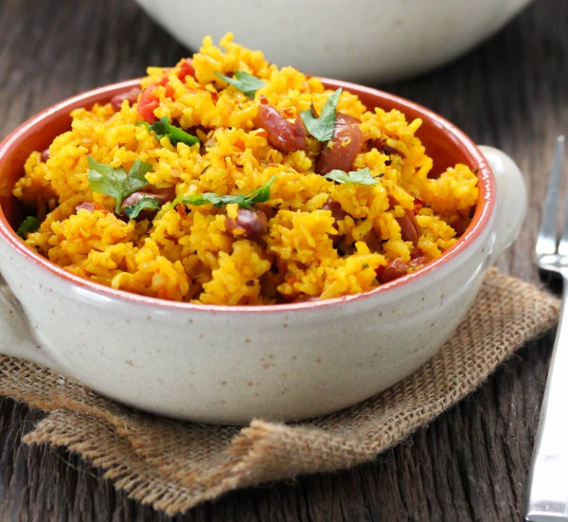
Caribbean Rice and Beans

2 c. quick-cooking brown rice, such as Della Rice brand
(or brown rice cooked until nearly done)
1 can red beans, drained
1 can chopped tomatoes
6 garlic cloves, chopped
2 Tbsp. olive oil
2 tsp. turmeric powder
2 tsp. thyme
1½ tsp. cumin powder
1½ tsp. Celtic salt
4 c. hot water

In a small skillet add the garlic and oil and cook for 1 minute until fragrant.
Add all the ingredients to the rice cooker and cook until done—about 20 minutes. If you don’t have a rice cooker, use a regular pot on your stove until flavors blend together nicely.

Serve immediately.

Adapted from recipe by Miryam of Eat Good 4 Life
www.yummly.co/recipe/Caribbean-Rice-And-Beans-1011774

No-Fuss Vegan Gluten-Free Corn Bread
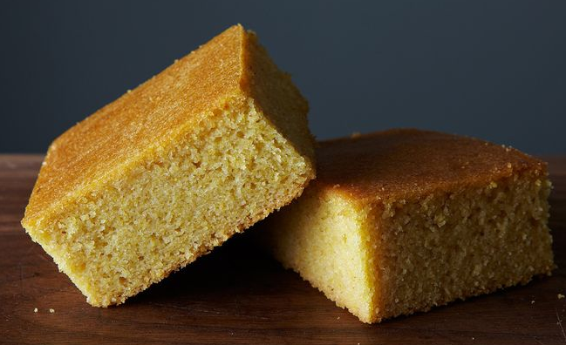
1-2/3 c. nondairy milk
1/3 c. applesauce
1 tsp. apple cider vinegar
2 tsp. chia seeds, ground
1½ c. corn flour
1 c. gluten-free flour mix (I used homemade version)
1 tsp. baking soda
1 tsp. sea salt
¼ c. raw sugar

- Preheat oven to 400° F.
- In a large measuring cup mix the non-dairy milk, applesauce, apple cider vinegar, and ground chia seeds. Allow to soak for 1 minute.
- In a separate bowl mix the flours, baking soda, salt, and sugar.
- Oil an 8”x 8” baking dish.
- When oven is at 400°F, add the liquid mix from the measuring cup into the bowl of dry ingredients and whisk quickly until well mixed.
- Pour into baking dish and put in oven. You want to get it in the oven as quickly as possible after it is mixed. Be careful and safe though. Just don’t dawdle!
- Bake for about 35 minutes, or until top is firm and edges begin to brown.

Adapted from https://food52.com/recipes/31697-no-fuss-vegan-cornbread

Gluten-Free Whole-Grain Flour Mix

This recipe makes a gluten-free whole-grain flour mix that’s a good substitute for whole-wheat flour — especially in gluten-free bread and dessert recipes. Having this flour baking mix on hand means you’ll be more likely to make breads or cakes because you can just reach for a mix instead of hauling out several bags of gluten-free flours. When possible, weigh these flours instead of measuring them by volume. You end up with much better results, and you find that with a little experience, weighing is faster than measuring by cups. 1 cup of this mix weighs 135 grams.

4½ c. minus 1 Tbsp. (600 grams) brown rice flour
4¾ c. plus 2 Tbsp. (600 grams) sorghum flour
3¼ c. minus 1 Tbsp. (400 grams) millet flour
1¾ c. (275 grams) sweet rice flour
- In a large bowl, combine all ingredients until the mixture is one color. Use a wire whisk to stir for best results.
- Store in an airtight container and use in baking recipes in place of flour.
By Jean McFadden Layton, Linda Larsen
www.dummies.com/food-drink/special-diets/gluten-free/gluten-free-recipe-whole-grain-flour-mix

Homemade Chocolate Bars

1 c. coconut oil
1 c. unsweetened dark cocoa powder
½ c. honey
2 tsp. vanilla extract

- Melt coconut oil over a very low heat. Remove from heat.
- Stir in cocoa, honey, and vanilla.
- Pour mixture into a pan (8” x 8” works well).
- Place in refrigerator. Check on it and when it begins to solidify, stir well and return to fridge. Repeat until too stiff to stir.
- Remove from pan, and cut into chunks of desired size with a good, solid knife.
- Store in the freezer until ready to use.

Optional: Add roasted almonds or other nuts, Rice Krispies, nut butters, peppermint extract or anything else you like in a chocolate bar. You can also dip cookies in the chocolate before it solidifies.

Note: We recommend eating this in moderation. Although it is rich in antioxidants, this dessert is also high in fat and calories.

By Diana Adams
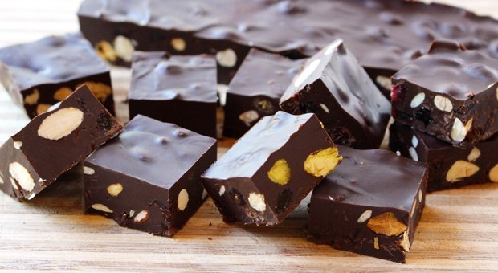

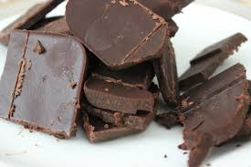

Ours look more like this:

Almond Raspberry Cookies
It’s almost Valentine’s Day, the time of year in which we are encouraged, especially by retailers, to show our love and appreciation for each other. So, why not make your loved ones something extra special this year? I love these beautiful cookies, they are “melt-in-your-mouth” delicious, and the fact that they are heart shaped just adds to the ambiance. What a perfect thing to bake for your loved ones.

½ c. all-natural cane sugar
1 c. vegan margarine (If using Coconut Oil, see note below)
1 tsp. pure vanilla
1¾ c. flour (whole white wheat or gluten-free mix)
¼ tsp. salt
1 c. almond flour
- Blend the sugar until fine in a blender.
- Cream together the butter and the sugar—it’s easier with an electric mixer.
- Once this mixture is creamy, add the vanilla extract and mix until incorporated.
- In a separate bowl sift the flour and salt and then mix together.
- While the mixer is running on low speed, add the flour to the creamed sugar mixture.
- Next add in the almond flour and mix until combined.
- Remove the dough from the mixer. Form into a ball.
- Wrap the cookie dough in plastic wrap and chill in the fridge for 20-30 minutes.
- Preheat Oven to 350 degrees.
- On a lightly floured Silicone baking mat or piece of parchment paper, roll out the dough and cut into shapes leaving space around each cookie so it will be easier to remove the extra dough.
- NOTE: If you are making the heart ones above you will need two different size heart shape cookie cutters. Only cut the small heart shape for the top of the cookie and not the bottom or you will have a sticky mess on your hands (half with holes and half without).

- Remove the extra dough from around the cookies and bake for 9-10 minutes or until golden brown on the edges. Let cool on a wire cooling rack.

Raspberry Maple Filling:
2 cups frozen raspberries
1/3 c. maple syrup
½ tsp. pure vanilla extract

In a small sauce pan, add the frozen raspberries, maple syrup, and vanilla extract, and simmer for 15-20 minutes, until it reaches a jam like consistency.
NOTE: This filling will thicken as it cools, so don’t let it cook so long that it gets too thick to spread onto your cookies. “Ask me how I know that one!”

Assembling the Cookies:
- Spread a small amount of raspberry filling on the cookie (without the hole) and space another cookie (with the hole) on top. If you want the dusted powder sugar look, then dust the top cookie before placing it on top of the cookie.
- These cookies are best if assembled right before serving. They store better if filling is kept separate, as it tends to soften the cookies when covered.
Note: If using Coconut oil instead of vegan margarine, do not refrigerate dough, or at least not for more than 5 minutes or so, it will harden very quickly. Coconut oil is a little harder to work with, but it yields a wonderful cookie. The coconut oil cookie is also a little more fragile so be extra careful when assembling the cookie. By Anika Perry (Chef Ani) https://chefani.com/almond-raspberry-cookies

