Vegan Cooking Class Recipes Session 47 (March, 2017)
Recipes from India (mostly)
- Aloo Matar (page 1)
- Garam Masala (page 2)
- Avocado Parathas (page 2)
- GF Chapati Flour (page 3)
- Chickpea Coconut Curry (page 3)
- Thousand Island Dressing (page 4)
- Vegan Mayo (page 4)
- Healthy Ketchup (page 4)
- Almond Yogurt (page 5)
- Tofu Scrambled “Eggs” (page 6)
- Ranch Dressing (page 6)
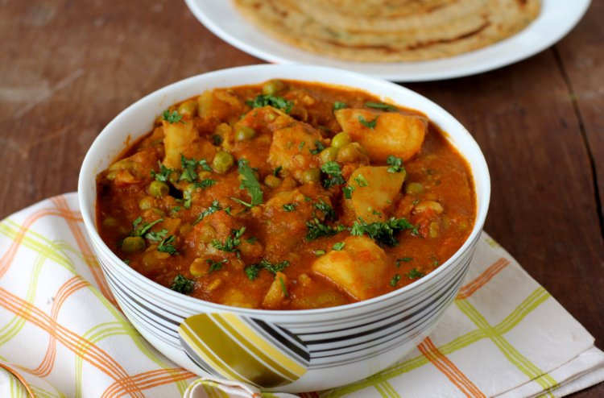

Aloo Matar (Indian Potatoes and Peas)

2/3 c. chopped onions
1 Tbsp. minced garlic
1 Tbsp. minced ginger root
1 Bay leaf
1 Tbsp. or to taste garam masala (See next recipe to make your own)
2 Tbsp. paprika or smoked paprika to taste (smoky, and more spicy)
1 tsp. raw sugar (or a little more to balance hotness if desired)
1 tsp. sea salt
4 c. tomato sauce
4 medium potatoes, peeled, cut in chunks and steamed with a little sea salt until just tender, but not falling apart
1 c. frozen peas
2 Tbsp. fresh chopped cilantro for garnish

- Get the potatoes steaming first. Sprinkle with some salt so they will not taste bland later. Be sure to check on them and stop cooking when they are tender, but not mushy.
- In a separate skillet sautée the onions in a little oil until they become translucent. Then add the minced garlic and ginger and bay leaf and cook briefly, stirring so it doesn’t burn.
- Then add in the garam masala, paprika, sugar, and salt and stir and cook briefly, just until the spices become fragrant.
- Now carefully add in the tomato sauce, slowly at first as it may spatter. Let simmer until the sauce reduces a bit and gets thicker. Remove the bay leaf.
- Add the potatoes and peas and cook for just a few more minutes until the peas are cooked.
- Take off the heat and sprinkle the cilantro on top.

This is really yummy served with plain homemade almond yogurt!
By Diana Adams, adapted from www.allrecipes.com

Garam Masala (Easy, quick)
1 T. ground cumin
½ T. ground coriander
½ T. ground cardamom
1 t. ground Ceylon cinnamon
½ T. red pepper flakes or smoked paprika
½ t. ground cloves
½ t. ground nutmeg

Mix all together and store in an empty spice shaker. Be sure to label it.
For a more authentic Garam Masala, start with whole spices, toast them and then grind them yourself before mixing.

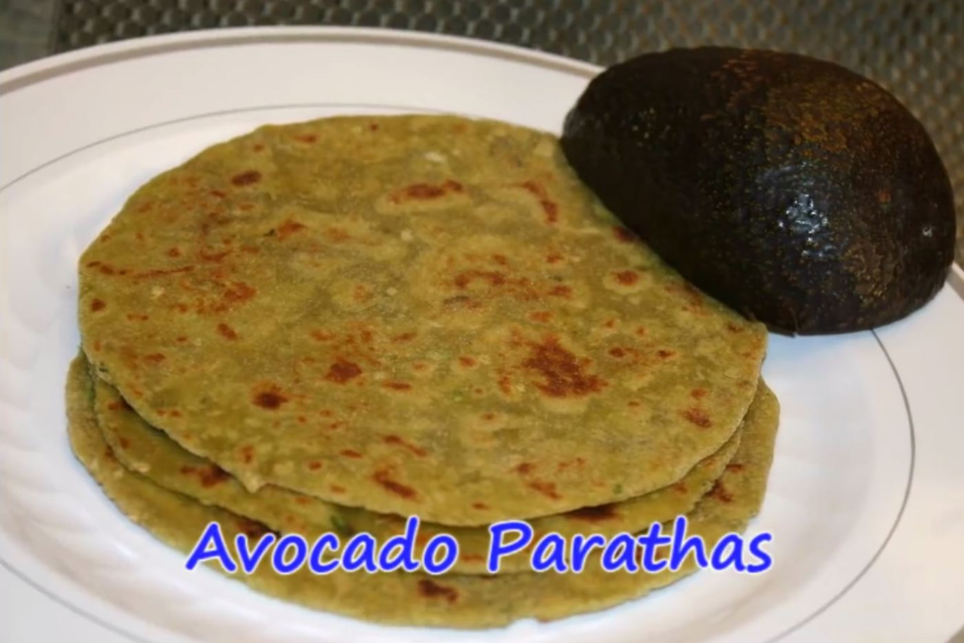
Avocado Parathas (Gluten-Free)
2 avocados, peeled and mashed (about 1½ c. pulp)
2 Tbsp. fresh lemon or lime juice
½ tsp. sea salt
2 Tbsp. minced garlic (or ½ tsp. garlic powder)
Green chilies to taste, minced
Cilantro - about 5 sprigs, chopped finely
½ tsp. ground cumin, roasted briefly in a dry skillet

About 2 c. gluten-free flour (see next recipe for make-it-yourself version)

- Mix the first 7 ingredients together, just as if you’re making guacamole.
- Next, mix in the flour. Start with 1 c., and then add a little more at a time, mixing as you go until it comes together nicely and doesn’t stick to everything. The amount for this will vary. The consistency will be like Play Dough.
- Form into balls, roll into circles like tortillas and cook on a hot dry skillet. You will know it is ready to turn when you see bubbles forming and the edge starts to change color – somewhat like when you cook pancakes.
- After the initial cooking on each side, brush or spray with a tiny bit of oil or water spritzer, and give each side a second heating. Sometimes they will really puff up more when you do this! But they are still yummy even they don’t, so don’t stress about it.

These can also be made with whole-wheat flour if you don’t need them to be gluten-free.
Adapted from http://showmethecurry.com/breads/avocado-parathas.html

Gluten-Free Chapati Flour
1 c. amaranth flour
1c. sorghum flour
¾ c. cornstarch OR tapioca flour
1 tsp. xanthan gum
½ tsp. sea salt
Mix all ingredients together well and store in a Ziplock bag in the fridge. Remember to label it. You can make a bigger batch if you find you use it often, so you won’t have to mix up your flour every time.

Adapted from http://showmethecurry.com/allergy_free/gluten-free-basic-flour-mix.html

Delicious Coconut Chickpea Curry
This recipe is absolutely wonderful! It was developed for a friend’s wedding, but it is simple and healthy enough for every day too.
½ head of cauliflower, divided into small pieces
2 c. chopped onion (small dice)
2 Tbsp. olive oil
4 large garlic cloves, minced
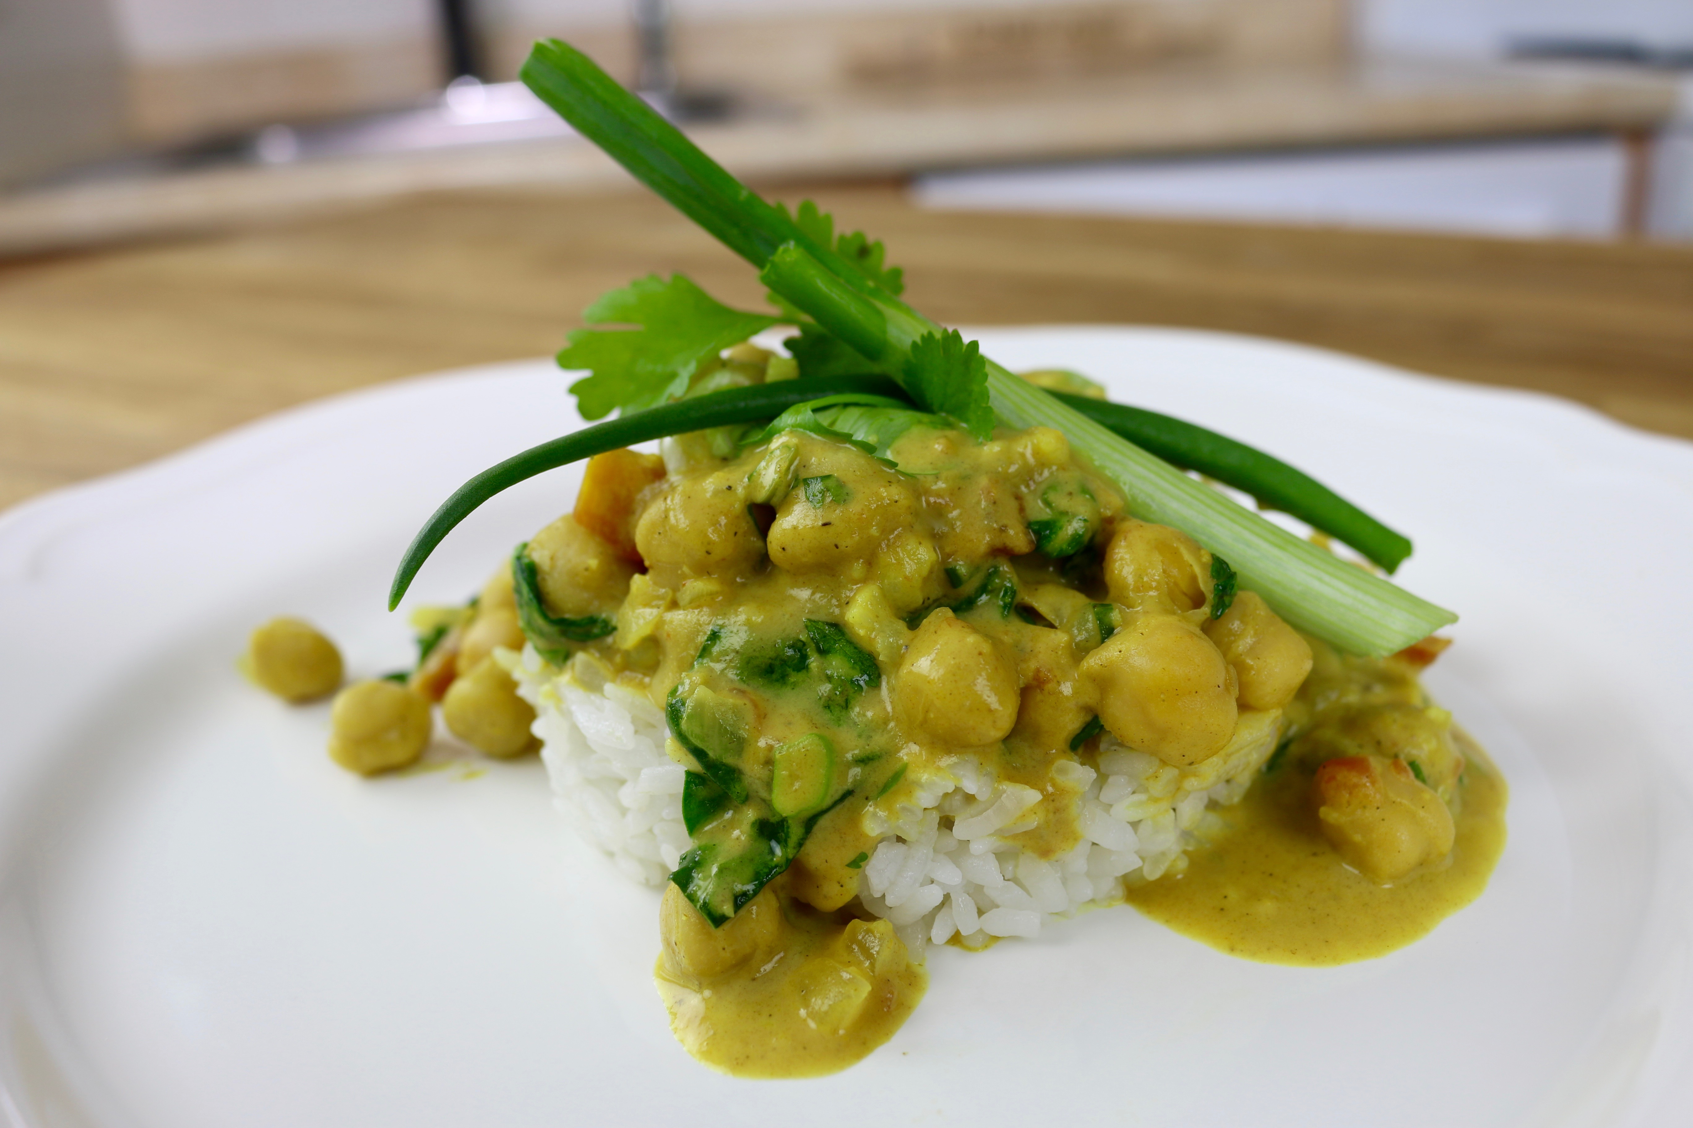
1 can coconut milk
1½ tsp. ground cumin
1½ tsp. ground coriander
2 Tbsp. nutritional yeast flakes
½ tsp. turmeric
1/8 tsp. crushed red pepper (optional)
pinch of celery seeds (optional)
2 tsp. Italian seasoning
1 tsp. natural cane sugar (optional)
2 tsp. sea salt
1 can petite diced tomatoes
2 cans chickpeas, drained and rinsed
Fresh Greens:
1 c. fresh cilantro, chopped
1 c. fresh spinach, chopped
1/3 c. green onion, sliced
- In a saucepan, cook ½ head of cauliflower in a little water, until soft (about 5-6 minutes). Drain the cauliflower, mash into small pieces and set aside.

- Sautée chopped onions in olive oil until soft. Once the onions are soft, add the minced garlic and cook for 1 minute.
- In a blender, add 1 c. cooked cauliflower (if you have more than 1 cup of cauliflower, do not blend the remainder, but add for texture at the end), coconut milk, and seasonings. Blend till smooth and add to the onion and garlic mixture in saucepan. Add petite diced tomatoes (including liquid), and bring to a soft boil. Reduce heat to low, add the chickpeas and simmer for 7-10 minutes.
- Right before serving, add the fresh greens and serve over rice. Enjoy!
By Anika Perry (Chef Ani) https://chefani.com

Vegan Thousand Island Dressing
½ c. Vegan Mayo
½ c. Healthy Ketchup
2 Tbsp. sweet relish

Mix all together and serve. Simple!
By Theresa Clifton

Homemade Vegan Mayo
½ c. homemade almond milk
½ tsp. sea salt (or less)
1 tsp. mustard powder
1½ tsp garlic powder
2 tsp. apple cider vinegar or lemon juice
2 tsp. agave nectar
1 Tbsp. mushroom powder (optional – but good if using this mayo for Ranch Dressing)
1 c. avocado oil OR avocado/coconut oil blend

- Place almond milk, sea salt, ground mustard, garlic powder, vinegar, agave and mushroom powder in a blender.
- Place the lid on the blender and turn to slow.
- Take the middle part of the blender’s lid out while the blender is still running and slowly pour in the oil.
- Place the lid back on and blend until the mayo is thick and creamy.
Adapted from recipe at www.onegreenplanet.org

Healthy Homemade Ketchup
Two 12-oz cans tomato paste
1/3 c. maple syrup
3 Tbsp. lemon juice
1 garlic clove, minced
2 tsp. fine ground sea salt
1/8 tsp. cayenne pepper OR smoked paprika

Mix all ingredients together well. Done!
Can be diluted with a little water if too thick or too strong.
By Diana Adams
Homemade Almond Yogurt (Theresa’s method)
4 c. freshly made almond milk (Homemade is with 2 c. water/1c. raw almonds whizzed up and then strained through a clean cloth.
2/3 c. (heaped) raw cashews (pour boiling water over in a strainer and stir up well to get really clean)
1/3 c. potato starch (Yogurt made from almond will not thicken as nicely as dairy milk. Therefore, if you want a thick yogurt, you need to add something in to help it.)
3 Tbsp. or so of plain unsweetened yogurt for starter (you can also order powdered starter online or buy it at the health food store). Important: only add this to the mixture after it has cooled.

Heat the milk up first in a pan until steamy – it doesn’t need to boil.

Since you will be adding the milk quite hot to your blender, make sure your blender is break-proof or warm it first with very hot tap water. Then you are ready to begin!

First place the washed cashews in the blender. Then add about 1 cup of the hot milk. Whiz until very creamy. Then add 3 more cups of the almond milk, turn on medium speed and add the potato starch slowly until all is blended in.

Allow to cool until it is just comfortably warm (110° F. is good if you have a cooking thermometer, but you can go by feel too. It’s okay if it is cooler than 110°.) Just make sure it isn’t hotter than 120° since that will kill the starter. During this time you can get out your yogurt starter if it’s in the fridge and allow it to warm to room temperature. When the milk mixture is cooled off, add in the 3 Tbsp. of yogurt and mix well with a spoon. Often there is a skin that forms on top while it is cooling. If you don’t want lumps, stir often. Or you can spoon this off. Or just leave the skin in. You could also blend everything briefly in the blender one more time.

Put the mixture into glass cups or jars and set in a warm, dark place (again – no warmer than 120°). There are many creative ways to do this. In an insulated food box with a warming pad, or some jars of warm water. Wrap in a towel in a sunny window. An electric yogurt maker keeps it at a nice temperature without any guesswork (often found in thrift stores).

Let the yogurt culture for several hours or overnight. Taste it now and then after about 5 hours (using a clean spoon each time) until it reaches the right tartness for you. This can happen in about 5 hours or up to 12 or even 24 hours, depending on the starter you use, how warm it is, or how tart you like it. Refrigerate. The yogurt will thicken a little more as it chills.

For those who don’t care for plain yogurt, this can be sweetened with maple syrup, jam, honey and fruit, etc. It doesn’t take much, so add it in a little at a time.
By Theresa Clifton

Fruit Sauce (for yogurt)
1 12 oz. pkg. of mixed berries
2 Tbsp. of Agave
1 Tbsp. of Flax/Chia blend
Mash berries and add remainder of the ingredients. Allow to sit and thicken. For a warm sauce, heat until warm. By Theresa Clifton

Tofu Scrambled "Eggs"
15 oz. water-pack tofu, firm
½ tsp. onion powder
½ tsp. garlic powder
¼ tsp. black salt, or to taste
¼ tsp. turmeric powder

- ​Drain the water from the tofu.
- Heat a medium skillet over a medium heat.
- Add tofu and spices together. Chop up to the texture of scrambled eggs.
- Cook until begins to steam.
- Serve immediately.

To add veggies, cook them first, and then add tofu and spices.
By Theresa Clifton

Ranch Dressing
It’s a never-ending quest to find the perfect ranch dressing!
This one is vegan as well as oil and soy free!

1 c. almond milk, plain unsweetened (homemade works great!)
1 T. potato flour, Bob’s Red Mill has it (this is NOT the same as potato STARCH)
2 T. canned mushroom slices
¼ t. onion powder
1/8 t. garlic powder
1/16 t. powdered thyme
1/16 t. powdered fennel
1/2 t. sea salt

2 drops liquid stevia (or to taste with other sweetener)
½ t. dried parsley
1/8 t. dried basil
1/8 t. dried dill
1 T. lemon juice (fresh is best)

- In a blender, mix well the first 8 ingredients (almond milk through sea salt)
- Next place the mixture in a saucepan and heat until thick – just before it boils
- Take the pan off the heat and add the rest of the ingredients.
- Stir well. Let cool. Store in the refrigerator.
- The flavor improves even more after several hours and it will get thicker too.
I give credit to Karrie at www.happymoneysaver.com for the idea of blending in mushrooms. It really gives the dressing that elusive “something” that has been so hard to find.
By Diana Adams

