Vegan Cooking Class Recipes Session 48 (April, 2017)
Sandwich Spread, Butternut Soup and Forbidden Rice Pudding

- Garbanzo “Chicken” Salad (page 1)
- Roasted Butternut Squash Soup (page 2)
- Vegan Chicken-Style Seasoning (page3)
- Fat-free Vinaigrette (page 3)
- Black Rice Pudding (page 4)

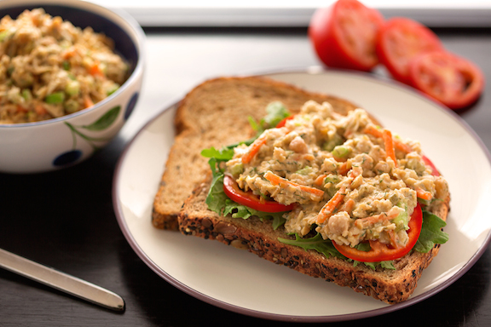

Garbanzo “Chicken” Salad
Can be used as a sandwich spread, topping, dip, etc.

1 15 oz. can garbanzo beans (drained-not rinsed)
¼ c. chopped onions
¼ c. chopped celery
¼ tsp. turmeric
Pinch of celery seed
¼ c. vegan mayonnaise
Salt to taste

Place garbanzo beans in a pot and mash with a potato masher (don’t use a food processor) until most of the garbanzo beans are broken apart. Add the rest of the ingredients and mix well.
You can add more or less of any of the above.

Variations:
Add jalapeños, olives, pickles, or any other item that you would like.
Serve on bread for sandwiches, in salads or as a dip for tortilla chips or crackers.

Replace the turmeric with finely chopped, dried seaweed for “tuna” salad.
Provided by Laura Llamas & Karen Fryksell

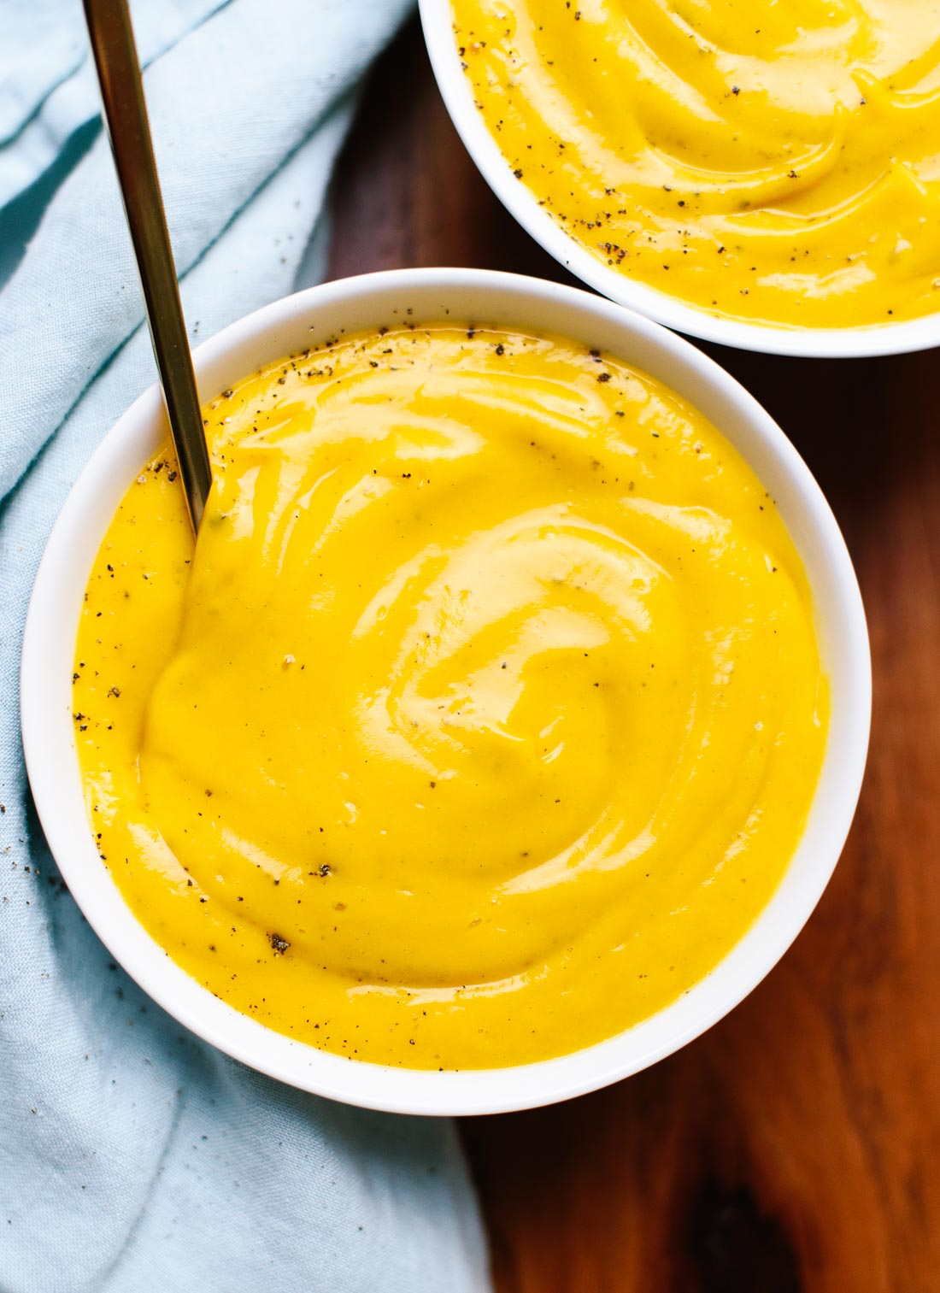
Roasted Butternut Squash Soup
Recipe yields about 4 bowls or 6 cups of soup.

1 large butternut squash (about 3 pounds), halved vertically and seeded
1 Tbsp. avocado oil, plus more for drizzling
½ c. chopped shallot (about 1 large shallot bulb)
1 tsp. salt
4 garlic cloves, pressed or minced
1 tsp. maple syrup
⅛ tsp. ground nutmeg
Up to 4 c. (32 ounces) vegetable broth
1 to 2 Tbsp. vegan butter, to taste

- Preheat the oven to 425 degrees Fahrenheit and line a rimmed baking sheet with parchment paper.
- Turn the squash face down and roast until it is tender and completely cooked through, about 45 to 50 minutes. Set the squash aside until it is cool enough to handle, about 10 minutes. Then use a large spoon to scoop the butternut squash flesh into a bowl and discard the tough skin.
- Meanwhile, in a medium skillet (or large soup pot, if you’ll be serving soup from that pot), warm 1 tablespoon oil over medium heat until shimmering. Add the chopped shallot and 1 teaspoon salt. Cook, stirring often, until the shallot has softened and is starting to turn golden on the edges, about 3 to 4 minutes. Add the garlic and cook until fragrant, about 30 seconds, stirring frequently.
- If you have a high performance blender like a Vitamix (see notes if you're using an immersion blender instead), transfer the cooked shallot and garlic to your blender. Add the reserved butternut, maple syrup, and nutmeg. Pour in 3 cups vegetable broth, being careful not to fill the container past the maximum fill line (you can stir in any remaining broth later). Secure the lid and select the soup preset. The blender will stop running once the soup is super creamy and hot.
- If you would like to thin out your soup a bit more, add the remaining cup of broth (I used the full 4 cups, but if you used a small squash, you might want to leave it as is). Add 1 to 2 tablespoons vegan butter or olive oil, to taste, and blend well. Taste and blend in more salt if necessary.
- Serve immediately. Let leftover soup cool completely before transferring it to a proper storage container and refrigerating it for up to 4 days (leftovers taste even better the next day!). Or, freeze this soup for up to 3 months.
NOTES
IF YOU ARE WORKING WITH AN IMMERSION BLENDER, add the reserved squash to the pot, then add the broth, maple syrup, and nutmeg. Bring the mixture to a simmer and cook, stirring occasionally, for 15 to 20 minutes so the flavors have a chance to meld. Carefully use your immersion blender to blend the soup completely, and then add 1 to 2 tablespoons butter or olive oil, to taste, and blend again. Taste and blend in more salt if necessary.
Source: http://cookieandkate.com/2015/roasted-butternut-squash-soup

Chicken Style Seasoning (Non-Spicy No-Salt)
2 c. nutritional yeast flakes
1/3 c. onion powder
¼ c. Italian seasoning (no salt added)
1/6 c. dried parsley (half of a 1/3 cup measure)
1/8 c. Sucanat or cane juice crystals
1½ Tbsp. garlic powder
¾ tsp. celery seed

- Blend all ingredients in a blender until very fine.
- Store in an airtight container.
- To make broth, add 1 Tbsp. of Chicken Style Seasoning mix to 1 cup of water.
Adapted from “Give Them Something Better” by Sarah Frain & Stephanie Howard

Fat-Free Vinaigrette

½ c. vinegar (apple cider or balsamic; may use less if desired)
½ c. water
¼ c. raisins or dates (soaked if you don’t have a high-speed blender)
1 tsp. maple syrup
1 large clove garlic
1 tsp. basil
1 tsp. oregano
2 Tbsp. Meyer lemon juice or 1 Tbsp. regular lemon juice
2 tsp. chia seeds
1 tsp. white miso (or more to taste)

Combine all ingredients and refrigerate until slightly thickened. Shake before using.

To add spiciness, mix in a teaspoon of spicy mustard. To add creaminess, add a teaspoon of tahini or a tablespoon of cashews when blending.

Provided by Edith Tsacle; inspired by Susan Voisin of www.fatfreevegan.com

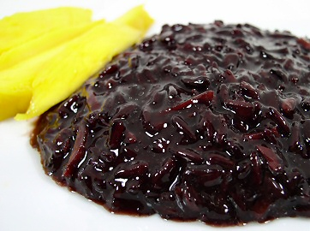

Black Rice Pudding

1 c. black rice (or forbidden rice)
2½ c. coconut water
Pinch of salt
1 stick cinnamon
2 cloves
2 cardamom pods (or use about ½ tsp. cinnamon, ¼ tsp. cloves and ¼ tsp. ginger in
powdered form directly in the pot)
1 tsp. vanilla
½ c. soy or other non-dairy milk
¼ - ½ c. maple syrup (or agave)

- Combine rice, coconut water, spices (tied in a square of cheesecloth) and salt in pressure cooker and cook for 35 minutes at high pressure. Let the pressure come down naturally.
- Remove lid and add the non-dairy milk and sweetener and vanilla, and stir constantly over low heat a few more minutes until gelatinous and a bit thicker.
- Remove spice bag. Cool and serve as is, or topped with mango pieces.

Inspired by Jill Nussinow, “The New Fast Food” and Susan Voisin of www.fatfreevegan.com

