Vegan Cooking Class Recipes Session 49 (May, 2017)
Enchiladas, Cheese and other good foods

- Mozzarella Aquafaba Cheese (page 1)
- Enchilada Sauce (page 2)

- Soy Curls Sources (page2)
- Spinach Layered Enchiladas (page 3)
- Almond “Feta” Cheese (page 4)
- Easy Rejuvelac (page 5)
- Raw Tiramisu Dessert (page 6)

Mozzarella Aquafaba Cheese

¼ c. raw cashews soaked (will be about 1/3 c. after soaking)
1 c. aquafaba (juice from canned or cooked garbanzos - if you are using from a can, it might come short just a tad. Fill up to 1 cup with another liquid such as almond milk or even just water)
3 Tbsp. tapioca flour
1 Tbsp. carrageenan powder
1 tsp. lactic acid powder (or lemon juice or apple cider vinegar)
1 tsp. nutritional yeast flakes
¾ tsp. salt
6 Tbsp. refined coconut oil, melted

- Blend all until smooth and creamy.
- Put mixture in a saucepan and heat and stir until it thickens and begins to bubble around the edges. Will look like really silky biscuit dough. Don’t cook any longer or the oil will separate out.
- Scrape all into a bowl or mold for it to harden.
- Can be kept in the refrigerator for slicing. Or keep in the freezer and thaw just slightly for shredding.
Adapted from www.AvocadosAndAles.com

Enchilada Sauce

First get your tomato puree ready. Blend and then set aside:
1 qt. of canned tomatoes
2 dried mild (or not so mild – your choice) red chili peppers that have been soaked until soft and the seeds removed. I used California chili peppers.

In a skillet, mix the following together and cook briefly:
3 Tbsp. oil
3 Tbsp. flour (can use gluten-free)

Next add the following and cook another half minute until very fragrant:
1 Tbsp. chili powder
1 Tbsp. Chicken Style Seasoning
1 tsp. cumin powder
1/2 tsp. garlic powder
¼ tsp. oregano
¼ tsp. salt or more depending on if there is salt in your Chicken Style Seasoning
Pinch of Ceylon cinnamon (optional)

- Then add in your tomato puree you made at the beginning. Add the puree a bit at a time and stir quickly and carefully so that you can stir out any lumps that might form.
- Cook until thick and bubbly. Take off heat.
- Lastly, add 1 tsp. apple cider vinegar and stir well.
- Taste and adjust salt.
Adapted from www.cookieandkate.com
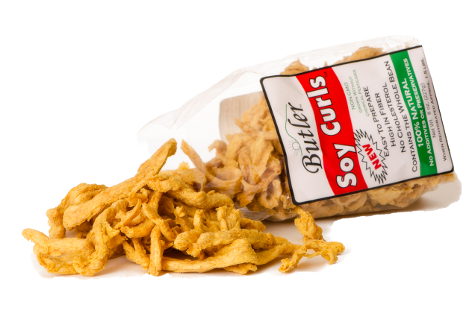

Soy Curl Sources:
www.ButlerFoods.com (Best bulk prices)
Non-GMO, pesticide-free, no additives, whole bean

www.Amazon.com

Adventist Book Center
5207 Madison Ave. Suite G
Sacramento, CA 95841
1-800-400-1844 or 1-916-486-7730
The ABC Bookmobile comes to El Dorado Adventist School in Placerville several times a year. You can call their toll-free number above to request Soy Curls and other vegetarian foods they sell.

Weimar Market
20601 West Paoli Lane
Weimar, CA 95736
Toll-Free Order Line: 1-877-WeiMart (934-6278)
www.WeimarMarket.com

Spinach Layered Enchiladas
(Great for using up those tortillas in your freezer)

2 Tbsp. avocado oil
1 c. chopped onion
1 tsp. sea salt
4 cloves garlic, minced
4 oz. can chopped green chilies, drained
1 c. soy curls that have been soaked and then squeezed dry and chopped in bite size pieces
12 oz. fresh or frozen spinach (or other greens such as beet greens etc.), chopped.
15 oz. can black beans, drained
½ c. vegan sour cream or plain almond yogurt or soy yogurt

3 c. enchilada sauce (for homemade see recipe)
8 small corn tortillas (5½ in.)
2 c. shredded vegan mozzarella (bought or homemade – see our recipe!)

- First make the filling. In a skillet, cook the oil, onion and salt until the onions are soft and just starting to turn brown. Add the garlic for the last half minute or so. Also add in the green chilies and mix well.
- Now add in the soaked and squeezed soy curls, mix well, cover and let simmer a while, turning now and then so that the flavors can soak into the soy curls. If you have time, let the soy curls even brown a tiny bit on the bottom – but don’t let them burn!
- Next mix in the greens and let simmer without the lid until the extra juices are evaporated.
- Then add and mix in the black beans and simmer without the lid another few minutes.
- Turn off the heat.
- Add in the yogurt and mix it all up well.
- Turn oven on to 400° F.
- Bring the filling mix to your work area for preparing the enchilada casserole. Also have the enchilada sauce, tortillas and shredded vegan cheese handy.
- In an 8” x 8” casserole dish, spread about ½ c. of enchilada sauce.
- Next place a layer of tortillas. About 2½. You can tear them into pieces to fit.
- Now spread out about ½ of the filling mix.
- Top that with about ¾ c. of the enchilada sauce.
- Then do another round of the tortillas, filling and sauce again.
- Now add one last layer of tortillas/pieces on top.
- Followed by the rest of the sauce (about 1 cup)
- Save the cheese for the end of the baking.
- Bake at 400° F. for about 15 minutes or until it begins to bubble.
- Take out of oven briefly and add the shredded cheese to the top.
- Return to oven for about another 10 minutes. The vegan cheese will not look the same as dairy cheese when it melts and may dry out if left to bake too long. So when the sauce is nice and bubbly and hot, it is done!
- Be sure to let it cool first so you don’t burn your mouth!
- Can be garnished with black olives or cilantro or green onions
Adapted from Spinach Artichoke Enchiladas by www.CookieandKate.com

Almond “Feta” Cheese
I had almost forgotten the joy that feta cheese can add to dishes. For example, the wonderful Greek spinach pie, spanakopita—I had basically given up on this entirely. I’d made and had many vegan versions of it, but without the briny flavor of feta, the flavors just fell flat. After much knocking around in my noggin, I came up with the perfect vegan substitute. Salty and briny, this feta works beautifully crumbled over salads or slightly melted in all of the traditional dishes. Best of all, stored in brine, it keeps for weeks, getting stronger in flavor and more delicious as time goes by (in fact, it vastly improves after a month, so make this weeks ahead of time if you can). Miyoko Schinner
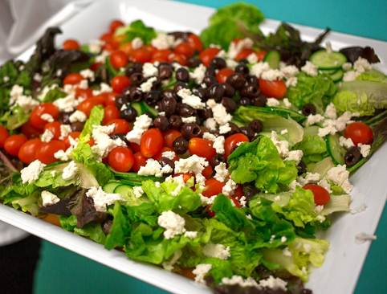
2 c. blanched almonds, soaked in water for 12 to 24 hours
2/3 c. water
2 Tbsp. agar powder
1 c. Easy Rejuvelac or juice from sauerkraut
½ tsp. sea salt

BRINE
6 c. water
¾ c. sea salt or kosher salt

- Drain and rinse the almonds. Place them in a high-speed blender with the rejuvelac and salt, and process on the highest setting for 1 to 2 minutes until smooth and no longer grainy to the tongue.
- Pour the mixture into a clean container and cover with a nonpermeable lid or plastic wrap. Leave on your kitchen counter for 1 to 2 days to culture, making sure you taste it each day, until it begins to get tangy.
- Keep in mind there is no hard and fast rule about how long it needs to culture—your taste buds will have to guide you in determining the right length of time. In warmer weather, it could be just a day, while in cooler weather, it could take 2 days or even longer.

Once the cheese is slightly tangy, you can move onto solidifying it.
- First, prepare the mold for the cheese by lining an 8-inch square pan with cheesecloth.
- Combine the water and agar in a medium saucepan and whisk well.
- Cover the pan with a lid and bring to a simmer over low heat. Don’t peek for 3 to 4 minutes, then check to see if it is bubbling away. At first, if you peek too early, it may look as if it has solidified. However, if you let it simmer over low heat for a couple of minutes more, it will start to liquefy again and bubble away.
- When the agar is fully dissolved, pour in the cultured almond mixture and whisk immediately until fully combined.
- Pour the cheese mixture into the cheesecloth-lined pan. Refrigerate for several hours, until hard.

Prepare the brine by whisking together the water and the salt in a large bowl until most of the salt is dissolved. Cut the cheese into four pieces and place in the brine. Cover and let sit for 8 hours at room temperature. Transfer the cheese to a storage container and pour the brine over the cheese until it is halfway submerged. Add more plain water to completely cover the cheese and dilute the brine. Store in the refrigerator for up to 3 or 4 months. The flavor vastly improves after the first 3 to 4 weeks.
MAKES 1 POUND
By Miyoko Schinner in “The Homemade Vegan Pantry”

Easy Rejuvelac
Fear not—making rejuvelac is really not that complicated or scary.
½ cup quinoa or wheat berries

- Put the quinoa or wheat berries into a 1-quart wide-mouth jar. (Make sure that the grains aren’t already pre-sprouted).
- Cover them with water and let sit for 8 to 12 hours, then drain. (Quinoa only takes 2 hrs.)
- Secure the top with cheesecloth or a clean dishcloth and rinse and drain the grains twice a day until you see sprouts—quinoa sprouts in less than 24 hours (sometimes only 8), whereas wheat berries generally take about 2 days. Faster at warmer temperatures.
- Now fill the jar with filtered water, screw on a lid, and leave at room temperature (out of direct sunlight) for 2 to 3 days, until the water is cloudy and bubbly. Loosen the lid a little to let any CO₂ buildup escape 2 or 3 times a day. Take out any pieces that refuse to sink. Pieces exposed to air can mold. And if using quinoa, check after 8 hours for doneness. See if it tastes slightly tart like lemon water and slightly fizzy. It might taste strange to you, if this is your first time, but should not taste foul. If you see any green or blue mold, throw it out. White foam is normal.
- Strain out the seeds and refrigerate the liquid, which is now lactic acid-rich rejuvelac. It is rich in protein, carbohydrates, phosphates, digestive enzymes, lacto-bacillus, and aspergillus (friendly bacteria essential for a healthy gut). It also contains the entire B complex, as well as vitamins C, E and K. You can turn the strained sprouts into another batch of rejuvelac by filling the jar with water and letting it sit for another round. The second batch will take less time.
The rejuvelac keeps in the refrigerator for 3 to 4 weeks.

MAKES ABOUT 4 cups
Adapted from Miyoko Schinner “The Homemade Vegan Pantry”

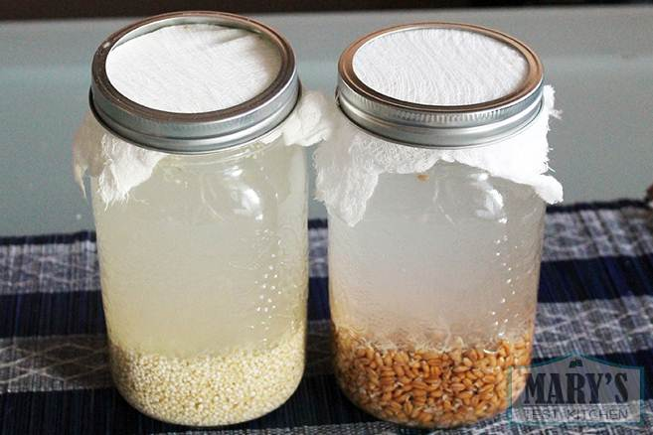

Raw Tiramisu (Free from: gluten & grains, dairy, eggs, and refined sugar)
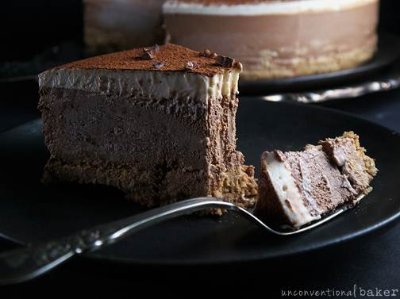
"Ladyfinger" Layer Ingredients:
1 c. walnuts
¾ c. dates, pitted (soft Medjool work best for this layer)
¼ tsp coffee substitute powder
2 Tbsp. coconut oil, liquefied
2 Tbsp. warm water
1 tsp. pure vanilla extract
dash salt

Chocolate Mousse Layer:
¾ c. walnuts, pre-soaked and strained
¾ c. raw cashews, pre-soaked and strained
¾ c. dates, pitted
6 Tbsp. maple syrup
6 Tbsp. unsweetened vanilla almond milk
4 Tbsp. coconut oil, liquefied (sub in 1 Tbsp. melted cacao butter instead of 1 of the Tbsp. coconut for an intense and deep chocolate flavor)
3 Tbsp. cacao powder
½ Tbsp. unsulphured blackstrap molasses
1 tsp. pure vanilla extract (or ¼ tsp. raw ground vanilla bean)
1½ tsp. coffee substitute powder (or more to taste)
½ tsp. salt

Cream Layer Ingredients:
½ c. raw cashews, pre-soaked and strained
¼ c. unsweetened vanilla almond milk
2 Tbsp. coconut oil, liquefied
2 Tbsp. maple syrup
1 tsp. pure vanilla extract (or ⅛ tsp. raw ground vanilla bean)
dash salt

Toppings:
A bit of extra cacao powder for dusting
Optional: 2 Tbsp. cacao nibs for sprinkling
- Process all base layer ingredients to combine into a fine sticky mixture in a food processor. Scoop out into a 6" spring form pan and press down into an even crust, going up the edges a little all around. Place in the freezer while working on next step.
- Blend all chocolate mousse layer ingredients in a power blender until smooth. Pour into the pan over the crust, tap the pan lightly on the counter and even out the top. Place the pan in the freezer while working on the next step.
- Clean out your blender and blend all cream layer ingredients together into a smooth mixture. Spoon this mixture over the previous layer in the cake pan, being careful not to pour it in all at once so the layers don't mix. Smooth out the top. Cover the pan and freeze for 6 hours or overnight.
- Prior to serving, dust the top with a bit of additional cacao powder, sprinkle with some cacao nibs and enjoy! Keep the cake frozen until serving.
Adapted from: www.unconventionalbaker.com/recipes/gluten-free-vegan-tiramisu

